Welcome

To

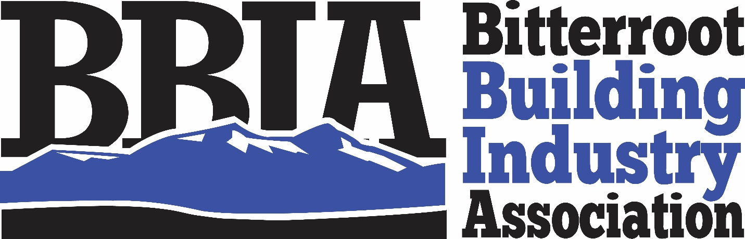

Building Community since 1995

Bitterroot Building Industry Association
215 Marcus St, Suite 104
PO Box 1299
Hamilton, MT 59840
www.bitterrootbia.com

Jenna Wiediger
Executive Officer
Info@BitterrootBIA.com

Welcome to the Bitterroot Building Industry Association (BBIA)!
We’re excited to have you join our association and become more engaged with the building industry. As with all associations, the more you’re an active and engaged participant in the association, the more you will benefit! We assembled this packet to assist you in understanding the numerous benefits and help you make the most out of your membership.

When you’re a member of the BBIA, you’re also a member of the Montana Building Industry Association (MBIA) and the National Association of Home Builders (NAHB). Please see pages 6-7 for more information on how to take advantage of the benefits at the state and national level.
Our mission is “Serving to unify and enhance the building industry in the Bitterroot Valley through education, community involvement and quality construction practices.”
We want to build a better building industry through promotion, advocacy, and education. What does this mean for you?
- Our job is to help you succeed in business by providing you with opportunities to educate yourself, grow your business, and increase your contacts by networking.
- Some of your membership dollars are spent on political advocacy at the national, state, and local levels to help your business succeed. The NAHB focuses on lobbying for pro-small business policies and works with lawmakers to prevent over regulation that creates undue burdens on the home building industry. The MBIA focuses on state codes and laws that affect the home building industry and is involved in lobbying and building relationships with state officials. Locally, the BBIA focuses on building relationships with our local legislators and working with other local government officials.
- We offer fun events for you to both meet potential customers and/or connect with other professionals in our industry!
We’re here to help you succeed!
We encourage you to review the details enclosed in this packet to help you make the most out of your membership. We’ve also enclosed a checklist on page 8 to help make sure you’re on track!
If you have any questions, please feel free to call us at (406) 375-9411! Thank you for your membership!

The Bitterroot Building Industry Association (BBIA) was organized in 1995 by a small group of builders who saw a need for an association to be the voice for the home building industry in the Bitterroot Valley. The BBIA is designed to help builders and associates involved in the home building industry to better contend with their challenges through collective action. All members of the BBIA must abide by a standard code of ethics.
We represent around 120 members throughout the Bitterroot Valley. The BBIA is governed by a Board of Directors and managed by a dedicated Executive Officer, both are to assist both members and the general public. We have two signature events each year that showcase our members, including the Home & Ranch Expo held in January/February and the Tour of Homes held in August.
In addition to services for BBIA members, we are a resource for general public by assisting them in finding the right professional for their project. Providing the latest information on building trends and answering questions they have on the home building or remodeling process.

Our members consist of home builders, remodelers, electricians, plumbers, painters, building supply centers, financial institutions, title companies, realtors, marketing professionals, insurance providers, numerous different types of product suppliers, plus much more!

Types of Memberships

Builder
A Builder member is a company that is engaged in the business of building or remodeling homes, multi-family, commercial, industrial, and other structures in the Bitterroot Valley. The Builder business must be licensed and insured. A Builder member will receive all communications and be listed in the directory as a builder/remodeler for the public to find.

Associate
An Associate member is a company that is engaged in a trade or profession related to building in the Bitterroot Valley. The Associate member is licensed and insured. The Associate member will also receive all communications and be listed in the directory under appropriate category for the public to find.

Affiliate
An Affiliate member is an employee of an existing BBIA Builder or Associate member. The Affiliate member has the opportunity for increased visibility and can have a leadership role in the association. Affiliate members receive communications and can serve as the chair on one of our several committees.

Communications
Our job is to keep you informed of upcoming events along with current events and information related to the home building industry.
- Monthly e-newsletters
- Email communications from the Montana Building Industry Association (MBIA) & National Association of Home Builders (NAHB)
- Quarterly printed bulletin member newsletter
Building Relationships
We provide many networking opportunities to meet other BBIA members, build professional & personal relationships and promote your business. Our annual events include:
- Builder Breakfasts: An educational networking opportunity that provides our associate members a chance to talk in front of our builder members and present their business and how they can be an asset to each builder.
- Bowling Tournament: A fun night to network and show off your bowling skills whether you are a beginner, expert, or any skill level.
- Trap Shoots: We hold a Spring and a Fall trap shoot. All are welcome to join, have some fun, and network.
- Golf Tournament: Again, a fun event where any skill level is welcome. Come have fun and network.
- General Membership Meetings (GMM): Educational classes where all members are welcome to come learn and network. Topics are scheduled ahead of time so that you may decide if you want to come based on what is being taught at that GMM.
- Christmas Party/ Annual Awards Banquet: This December/January event installs the Board of Directors, gives out the annual awards, and is catered by a fabulous local restaurant or caterer.
Continuing Education
We have a GRIP program that offers trainings throughout the year on important topics to our industry such as Forklift Certification, Manlift Certification, CPR Certification, Fall Protection/Scaffold User, and Chemicals on Site/HAZCOM
Advocating For You
Recognized as an advocate for housing and development issues, we keep you up to date with the latest proposed legislative and regulatory changes that affect you. We make sure you “have a seat at the table.”
Promote Your Business
There are numerous ways to promote your business from participating in events to sponsorships to advertising.
- Tour of Homes: As a BBIA member, you can enter a house into the Tour of Homes or promote your products or services in any Tour house you were a part of. Average attendance is around 900 and is growing every year.
- Home & Ranch Expo: As a BBIA member you get a discounted rate in the Home & Ranch Expo. Average attendance is around 600 and is growing every year.
- Write an Article, Blog, or Be Interviewed- We seek members willing to write articles for our member2member emails, newsletters, Tour of Home magazine, and our Home & Ranch Expo magazine.
- Member Events: We look for sponsors for all our member events including: Bowling tournament, trap shoots, and golf tournament
- Host a General Member Mixer (GMM): Host a GMM and bring members to your place of business and tell members about yourself and what your business can provide for them.
- Advertising: Our members get a discounted rate for advertising in our Tour of Home Magazines which are distributed all over the valley.
- Ask Jenna how else you can advertise to the members, we can work out something that works best for you!
Member Discount Programs
Reduce your business costs with member—only discounts.
Visit www.nahb.org/members/member-savings for more information (See member saving page attached)
Get Involved
COMMITTEE & VOLUNTEER OPPORTUNITIES
MBIA- As a member of the Bitterroot Building Industry Association, a portion of your membership dues goes to the Montana Building Industry (MBIA) and provides you with the following benefits:
Access to Contracts & Forms
Helping you to run your business without a fuss, these forms worth thousands of dollars combined are free to use by members.
Government Affairs
The MBIA is committed to advocacy at the state level that ensures the government officials hear our perspective and take into consideration the burdens on the new homes when considering new regulations.
Member Rebate Program
Builder members of the Montana Building Industry Association have access to rebate program for materials you’re already using. This simple program gives you cold, hard cash back on purchases you already make for your business, often enough to cover your dues and then some!
What’s the catch? No catch. Manufacturers recognize that the small to mid-size builder is the largest segment of the industry, so the Member Rebate Program combines these builders across the country to negotiate the same rebates that a “Top – 5 “ builder would receive. This is a gimmick-free program that allows you to collect rebates for products you used in completed homes, remodeling, or multi-unit family projects—you don’t even have to keep track of your receipts.
NAHB- As a member of the Bitterroot Building Industry Association, a portion of your membership dues goes to the National Association of Home Builders and provides numerous benefits, below is some of the most popular:
- International Builders Show: This annual event is the largest builders show in the country and includes educational sessions, hundreds of exhibitors, networking opportunities, and the NAHB annual meeting and Board of Directors meeting.
- Access to NAHB Expert Advisors: Have specific business questions? When you become an NAHB member, you get instant access to our distinguished economists, tax specialists, legal research staff, financial experts and regulatory and technical specialists.
- Important News & Information: NAHB delivers important news through NAHB Now, Eye on Housing, specialty e-newsletters, social media, alerts and exclusive website content. For more than 70 years NAHB has been the nation’s leading source for housing industry information. Up-to-date information, when you want it, how you want it!
- A Strong Voice in Washington: Advocacy, Legal Services and BuildPac all work to help you defeat excessive regulations and defend affordable housing initiatives on Capital Hill, in your state and in the communities where you do business. That puts money and time back in your pocket.
- Membership Discounts: As stated before membership comes with many discounts. For a full description of all benefits visit www.nahb.org/members/member-savings

Checklist
First 30 Days:
- Make sure you are receiving the BBIA monthly emails. If not, please contact the BBIA office.
- Check your listing in the membership directory and make sure your category listings and information are correct.
- Use the BBIA logo in your marketing materials
- Connect with us on social media
- www.facebook.com/bitterrootbia
- www.instagram.com/bitterroot_bia

Within 60 days:
- Attend a BBIA networking event
- Review the Membership Discount Opportunities
- Set-up your log in information on NAHB

Within 90 Days:
- Look into advertising & sponsorship opportunities

- Attend an event and introduce yourself to 5 people you don’t know.
- Join a committee
- Ask Jenna how you can be more involved to get more out of the association.

