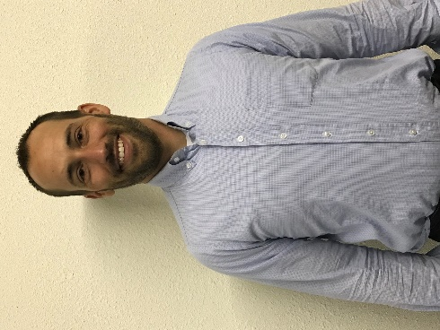
Job Springer, Board President
Follower of Christ
He is currently the Chief financial officer at Southeast Kansas Mental Health.
Job is married to Katrina and has three children, Rohan, Moira and Declan.
Mr. Springer holds a Master of Science degree from Kansas State University in Agribusiness Economics.
Currently serving on the following boards and committees: Treasurer and Board member of Southwind Extension, Board Member of Iola Industries, Bowlus cultural attractions committee, Iola High School agricultural advisory committee.
Job is involved in ranching and property management and enjoys traveling around the world and being in the great outdoors.

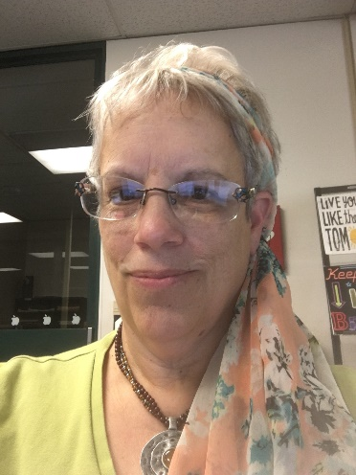
Susan Michael, Board Vice President

Executive Director - Community Foundation (Aug 2012-Sept 2015)
Administrator - Community Foundation (Oct 2015-Sept 2016)
Board Member - YCF (Feb 2017 - current)
Student Support Technician at Allen Community College
Married to Stephen Michael, one son, Justin lives in California with his wife and 5 children.
Originally of Westphalia KS now of Colony KS
Marine Corps Veteran (1978-1992)
Worked at Haldex Brake (1992-2010)
Board member of Colony Library Board
Allen Community College Graduate (2014)

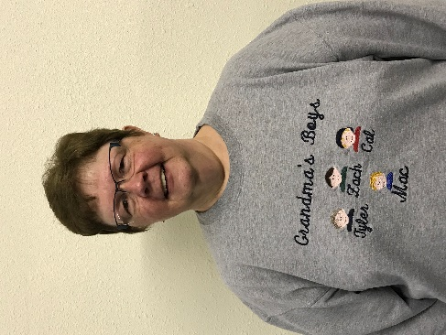
Linda Leonard, Board Secretary

I am presently secretary of Your Community Foundation. Being a 5th generation family to live in Allen County, I feel a Community Foundation is a great asset to our county. A community foundation is a vehicle for people of all means to make a lasting difference in their community. The central purpose of a community foundation is to serve the needs and philanthropic aims of donors who wish to better their community, now and in the future.

I have lived in Humboldt basically all my life. I graduated from Humboldt High School and Allen Community College. I earned a bachelor’s in business in Education from Pittsburg State University. I worked for the Monarch Cement for over 30 years, retiring as administrative assistant to the President.

I married my high school sweetheart, Doug Leonard. We have a grown daughter and son and 5 grandsons. My pastimes include spending time with my family, reading and working on the computer.

Carol Sager, Board Treasurer

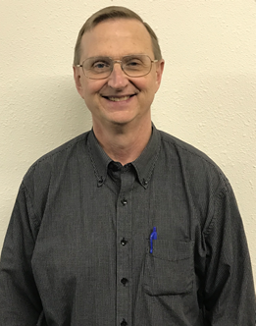

Alan Weber, Legal Counsel
Mr. Weber is a graduate of Iola High School (Class of ’70), Allen County Community College (Class of ’72), The University of Kansas (Class of ’74) and the University of Kansas School of Law (Class of ’77). Mr. Weber has practiced law in Allen County for over 40 years in both private practice and for the last 25 years as County Counselor and is a member of the Allen County Bar Association, The Kansas Bar Association and the Kansas County Counselors Association. Mr. Weber has a daughter, Katie, who is a graduate of Humboldt High School and the University of Kansas.

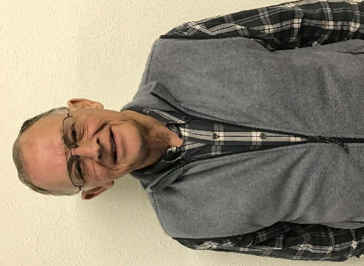
Gary McIntosh, Advisor

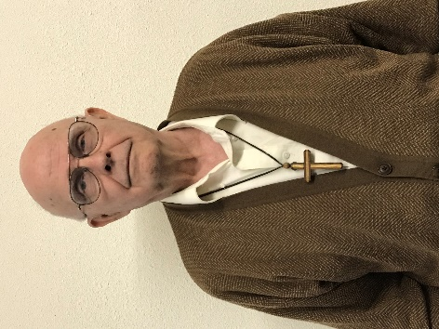
Don Copley
Rev. Donald D. Copley was born in Alliance, Nebraska. He graduated from high School in 1956 at Eagle Point, Oregon. He served 22 years in the Air Force, retiring as Master Sargent. He worked another 22 years at Purchasing Supervisor for Monarch Cement Company. During his time at Monarch he received his BA and MA degrees from Friends University in Wichita, KS. He also is a licensed private pilot with instrument rating and a licensed Ham radio operator "NOTSX".
Rev Copley and his wife Dodie have been married 45 years. Together they have 3 living children: Braxton and Lawson Copley and Wendy den Herder. They have 4 grandchildren, Daniel Houston and Ben, Austin and Ellis Rose Copley, and 1 great grandson Jeffrey Houston

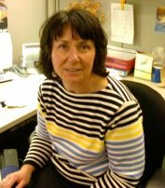
Robin Schallie
2017- Market Manager Allen County Farmers’ Market
Professional Background:
2015-2017: Adjunct professor at Neosho County Community College, Chanute, KS
1986- 2014: Marketing and Business professor at Fox Valley Technical College, Appleton, WI.
Academic Background:
• Master’s Business Administration, Bachelor of Science Degree, Associate of Arts Degree

Awards/Recognitions/Affiliations
• Advisor of the year FVTC
• Teacher of the year FVTC
• H. Victor Baldi Nominee FVTC
• DECA advisor of the year
• Sales and Marketing Managers
• Allen County Animal Rescue Facility-ACARF- Board of Directors
• Your Community Foundation- Board of Directors

In my free time I enjoy gardening, traveling and reading. My husband and I live on 80 acres and currently have chickens, guineas, and heritage turkeys as well as Australian shepherds.

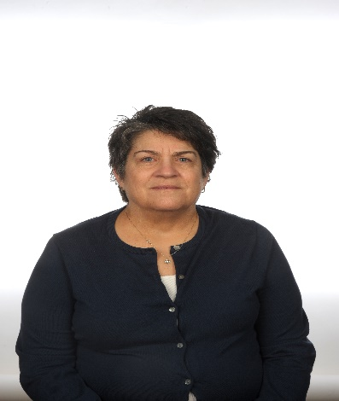
Lori Stone
Former 5th Teacher, Iola USD 257
Elem Ed degree from Emporia State Univ.
MS Degree in Instructional Design & Technology from Emporia State Univ.
Have lived in Iola since 1990.
Currently on the board at Hope Unlimited, Allen County Reg. Hospital Auxiliary, Co-treasurer, Board of Trustees Wesley United Methodist Church

