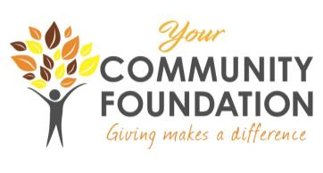

**YCF COMMUNITY GRANT CYCLE  
GRANT APPLICATION FORM**

**Calendar Year 2025**

Legal Name of Organization: ______________________________________________________

Address: ______________________________________________________________________

City: __________________ State: __________________ Zip: ___________________

Website (if available): _________________________________________________________

CEO Name and Title: ____________________________________________________________

Contact Name and Title (if different form CEO): _____________________________________

Telephone Number: ___________________ Fax Number: _____________________________

Email Address: ______________________________________

Organization Mission Statement: ______________________________________________________________________________

______________________________________________________________________________

Year Organization was Founded: __________ Current Year operating Budget: ______________

Name of Project: _______________________________________________________________

Start Date: _________________ End Date: _______________________

Proposed Number of people directly served by the project: Allen County: ___ Other County: ___

Please list the communities where this project will take place: ______________________________________________________________________________

Requested Amount: $_____________ Total Project Cost: $_______________

Authorized Signature and Endorsement:

The Board of Directors of our organization has approved the submission of this proposal. If we receive a grant, we agree to use the funds as specified in this request. We will allow the Your Community Foundation to use the information provided in this request in its publications and news releases, and will mention the Foundation's support in any publications, news releases or other publicity related to the project.

We acknowledge that acceptance of this grant also entitles the Your Community Foundation to send a representative to one of our board meetings to present the grant check, hear a little more about our organization and receive information about the Foundation.

**We acknowledge that if our organization receives this grant or any part thereof, we must submit photos and text reports documenting the project's implementation and completion. All such photos and reports may be used by YCF to publicize its grant activities.**

_________________________________________ ____________________

Signature and Title Date

**Please be sure to attach all required documents as provided in the Grant Application Instructions. Incomplete applications will not be considered.**