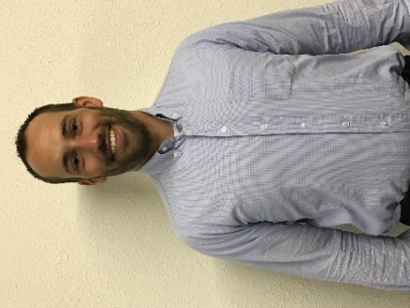

**Job Springer, Board President**

Follower of Christ

He is currently the Chief financial officer at Southeast Kansas Mental Health.

Job is married to Katrina and has three children, Rohan, Moira and Declan.

Mr. Springer holds a Master of Science degree from Kansas State University in Agribusiness Economics.

Currently serving on the following boards and committees: Treasurer and Board member of Southwind Extension, Board Member of Iola Industries, Bowlus cultural attractions committee, Iola High School agricultural advisory committee.

Job is involved in ranching and property management and enjoys traveling around the world and being in the great outdoors.

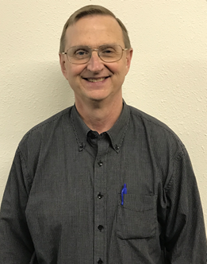

**Alan Weber, Secretary/Treasurer**

Mr. Weber is a graduate of Iola High School (Class of ’70), Allen County Community College (Class of ’72), The University of Kansas (Class of ’74) and the University of Kansas School of Law (Class of ’77). Mr. Weber has practiced law in Allen County for over 40 years in both private practice and for the last 25 years as County Counselor and is a member of the Allen County Bar Association, The Kansas Bar Association and the Kansas County Counselors Association. Mr. Weber has a daughter, Katie, who is a graduate of Humboldt High School and the University of Kansas.

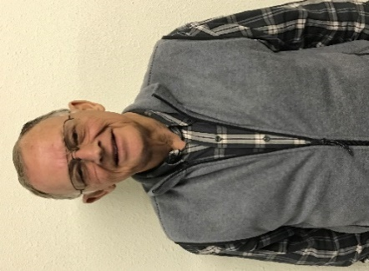

**Gary McIntosh, Advisor**

Gary McIntosh is a graduate of Iola Junior College and Dallas Institute College of Mortuary Science. He is also past president of the Iola Jaycees and Chamber of Commerce. Mr. McIntosh served as the Utility Commissioner at the City of Iola and on the USD #257 School Board as well as Allen Community College Board of Trustee, Board Vice President and Foundation Vice President.

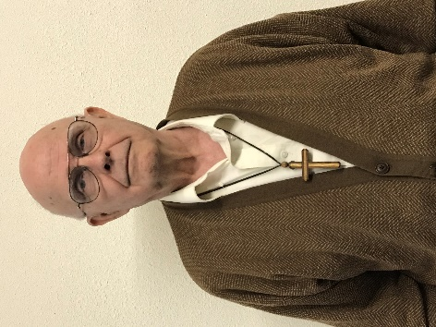

**Don Copley**

Rev. Donald D. Copley was born in Alliance, Nebraska. He graduated from high School in 1956 at Eagle Point, Oregon. He served 22 years in the Air Force, retiring as Master Sargent. He worked another 22 years at Purchasing Supervisor for Monarch Cement Company. During his time at Monarch he received his BA and MA degrees from Friends University in Wichita, KS. He also is a licensed private pilot with instrument rating and a licensed Ham radio operator "NOTSX".

Rev Copley and his wife Dodie have been married 45 years. Together they have 3 living children: Braxton and Lawson Copley and Wendy den Herder. They have 4 grandchildren, Daniel Houston and Ben, Austin and Ellis Rose Copley, and 1 great grandson Jeffrey Houston

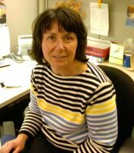

* 

**Robin Schallie. Vice President**

2017- Market Manager Allen County Farmers’ Market

Professional Background:

2015- Adjunct professor at Neosho County Community College, Chanute, KS

1986- 2014: Marketing and Business professor at Fox Valley Technical College, Appleton, WI.

Academic Background:

• Master’s Business Administration, Bachelor of Science Degree, Associate of Arts Degree

Awards/Recognitions/Affiliations

• Advisor of the year FVTC

• Teacher of the year FVTC

• H. Victor Baldi Nominee FVTC

• DECA advisor of the year

• Sales and Marketing Managers

• Allen County Animal Rescue Facility-ACARF- Board of Directors

• Your Community Foundation- Board of Directors

In my free time I enjoy gardening, traveling and reading. My husband and I live on 80 acres and currently have chickens, guineas, and heritage turkeys as well as Australian shepherds.

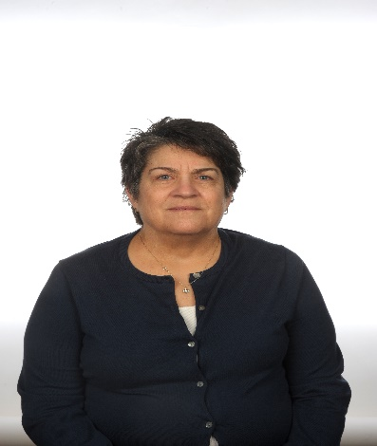

**Lori Stone**

Former 5th Teacher, Iola USD 257

Elem Ed degree from Emporia State Univ.

MS Degree in Instructional Design & Technology from Emporia State Univ.

Have lived in Iola since 1990.

Currently on the board at Hope Unlimited, Allen County Reg. Hospital Auxiliary, Co-treasurer, Board of Trustees Wesley United Methodist Church

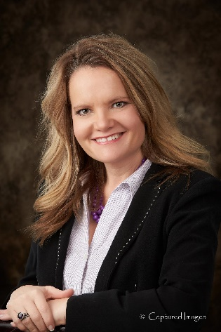

**Carla Nemecek**

Carlais the Southwind Extension District Director for K-State Research & Extension in Allen, Bourbon, Neosho and Woodson Counties. She received her BS and MS degrees from Kansas State University in Animal Science and has a 21-year career with Extension in Kansas. Carla is married to Jeff Nemecek, and they have 2 sons - Brody (16) and Kyser (12) who are active 4-H members. They enjoy raising and showing livestock and cheering for the KSU Wildcats.