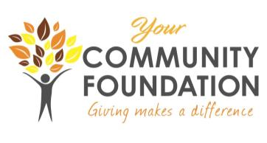
YCF COMMUNITY GRANT CYCLE
GRANT APPLICATION FORM
Calendar Year 2026
Legal Name of Organization: ______________________________________________________
Address: ______________________________________________________________________
City: __________________ State: __________________ Zip: ___________________
Website (if available): _________________________________________________________
CEO Name and Title: ____________________________________________________________
Contact Name and Title (if different form CEO): _____________________________________
Telephone Number: ___________________ Fax Number: _____________________________
Email Address: ______________________________________
Organization Mission Statement: ______________________________________________________________________________
______________________________________________________________________________
Year Organization was Founded: __________ Current Year operating Budget: ______________
Name of Project: _______________________________________________________________
Start Date: _________________ End Date: _______________________
Proposed Number of people directly served by the project: Allen County: ___ Other County: ___
Please list the communities where this project will take place: ______________________________________________________________________________

Requested Amount: $_____________ Total Project Cost: $_______________

Authorized Signature and Endorsement:
The Board of Directors of our organization has approved the submission of this proposal. If we receive a grant, we agree to use the funds as specified in this request. We will allow the Your Community Foundation to use the information provided in this request in its publications and news releases, and will mention the Foundation's support in any publications, news releases or other publicity related to the project.
We acknowledge that acceptance of this grant also entitles the Your Community Foundation to send a representative to one of our board meetings to present the grant check, hear a little more about our organization and receive information about the Foundation.
We acknowledge that if our organization receives this grant or any part thereof, we must submit photos and text reports documenting the project's implementation and completion. All such photos and reports may be used by YCF to publicize its grant activities.

_________________________________________ ____________________
Signature and Title Date

Please be sure to attach all required documents as provided in the Grant Application Instructions. Incomplete applications will not be considered.

