Month Date, Year
Ranch Sorting
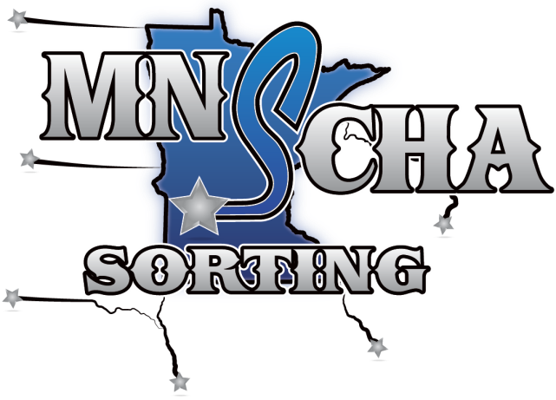 | Place farm/producer logo here
Minnesota Sorting Cow Horse Association | Place Farm/Producer Name Here

Farm/Producer Name Here
Street Address, City, State ZIP
--------------------------------
Written location/directions here…
--------------------------------
Registration begins at X:XX a.m./Start time at XX a.m.

Class | Entry Fees* | Payback %
Junior Horse (4yo or under) | $ 25* | 50%
Open | $ 25* | 50%
#6 | $ 25* | 50%
Ranch Hand (1 cap on sorter) | $ 25* | 50%
Youth | $ 10* | Points toward year end
#10 | $ 25* | 50%
#4 | $ 25* | 50%
*Entry Fees include $2.50 per ride sanctioning fees
Payback based on entries less sanctioning fees
For More Information | Contact
General show info | Name – phone number
MNSCHA President | Steve Jordan – 307.746.5280
Rules, MNSCHA, other info | www.mnscha.com

$5 office fee per rider – MNSCHA western dress code required
Announcements and postings at the event take precedence over all printed material
*Entry Fees include $2.50 per ride sanctioning fees

