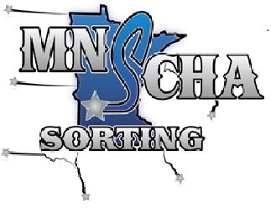

**The MNSCHA rules are under construction and will be open for discussion and voting at the   
January 6, 2019   
MNSCHA Member Meeting.**

**Please plan to attend. We are interested in hearing your feedback and look forward to an exciting 2019 sorting season.**