1. MNSCHA Sorting
Numbered rules 1-18 apply to all 2 Man and 3 Man 2 Gate Sorting classes. Current MNSCHA rider ratings will be used for all classes.

2. Judges and Help
Event producers must use officials and announcers familiar with all MNSCHA rules for any shows or classes. There will be one MNSCHA judge and one split timer. The judge and person operating the split timer for Sorting must be the same person(s) the entire go-round (at minimum), if not the whole class.

3. Cattle Guidelines
There will be at least 10 cows in the sorting pen. At producer’s discretion, there may be two (2) additional blank numbered cows in the herd for a total of 12 cattle. The blank numbered cows must remain in the cattle pen throughout the run. If any blank numbered cows are allowed through the gate any time during the run, the team will be disqualified.

A producer may choose to run fewer than 10 runs per herd based on the size of the pen. This includes all goes including the final go.

4. Readable Numbers
All cattle must have MNSCHA approved numbers.

5. Bunching Cattle
All cattle will be bunched on the cattle side of the gate within the designated area before the time begins. Judges will designate the need to bunch cattle.

6. Time Limits
There will be a 60-second clock for each class.

7. Display Clock-Split Timer
It is recommended that MNSCHA approved classes and shows use an electronic display clock or a split timer. The electronic display-split timer clock, set at 60.01 seconds, shall be the official clock for Sorting. The official time of each run is determined by the amount of the time used until all 10 cattle are sorted or the time limit has expired.

8. Split Time
The official clock for Sorting shall be the Display Split Timer. A Display Split timer is to be used in all Sorting classes to designate the placing of the class. Split times are cumulative in multiple go round events, as well as the number of cattle sorted. Teams that sort 10 head in one or more go rounds will place higher than teams with equal # of cattle and go rounds but who did not sort 10 head in any single go round. Any team that sorts 1 or more head in a go round has an official time, if less than 10 head are sorted, the official time is 60 seconds. If 10 head are sorted, the actual time on the clock is the official time. Lap time will only be used to break ties if needed. In case of promoters who own electronic display clocks without a split timer, a stop watch will be used. The stop watch used for split time purposes will also be the back-up timer in the event of a malfunction of the electric display clock. Split times are cumulative in multiple go round events, as well as the number of cows sorted, but do not replace the official time of each run. Split times only come into play when the cattle counts and the official times are identical. Prior to starting the next run, the back-up timer/judge needs to confirm that their record of cattle sorted matches the Display Split Timer record of the split timer judge.

9. Starting the Run
The judge will raise the flag to signal when the arena is ready. The flag will drop when the nose of the first horse crosses the start/foul line. The announcer will instantly provide the number to be sorted first. Any delay greater than 3 seconds in crossing the foul line may result in a "no-time" for the team. The next team has 30 seconds to enter the arena and cross the time line after the previous team sorts, and after the announcer calls the team to ride. If a horse or participant rides back to back, they will have 60 seconds to rest between runs. Upon the decision by the judges, the announcer will call the team a no-time unless waived for a good cause. No team member may enter the arena after the time has started.

10. Random Start Number
The order of Sorting is determined by the picking of a random number by the Announcer/Timer and then that cow must be sorted first; for example, if 7, is drawn as the first number, then the 8 cow must be sorted, 9, 0, 1 and so on.

11. Sorting the Cattle
The cows are sorted in number sequence. A cow is considered sorted when the entire cow is completely
across the start/foul line. The judge/timer will use a split timer to track time at each sorted cow.

If any part of a sorted cow crosses the start/foul line prior to its correct order, then the team receives a no time. If any part of a sorted cow re-crosses the start/foul line the team will be disqualified. If any part of any unnumbered or wrong numbered cow crosses the foul line before the 10th cow is cleanly sorted, it will result in a no-time.

12. Stopping Time
Time will continue until all cattle are sorted in the correct order or the time limit is reached, either of which becomes the official time for that team.

13. Re-Ride Situations
Should a herd be mis-numbered or have too many or too few non-numbered cattle, only the team that is in the arena at the time the problem is identified will receive a re-ride. The re-ride will be a clean slate and will be done immediately.

If a team observes an unfit, injured, or unidentified animal before committing to the cattle, the team must notify the judge. Once the team is committed to the cattle, no re-ride will be given. Participants are committed to the herd once they start working the cattle and no re-rides will be given because the ‘luck of the draw’ will apply.

In the rare instance that a team rides out of order, their time and number of cattle will stand. No re-ride will be given for teams riding out of order. Once the problem is identified, the going forward teams will be correctly aligned, and in the case of Sorting, placed in the proper arena and follow the order as posted. All go's must be posted before the round starts.

14. Cow Leaving the Arena
If there is a malfunction of the Sorting pen, or a numbered cow jumps any fence and either leaves the arena, or ends up in the opposite pen, but did not pass through the gate, it will result in a re-ride for that team immediately, (assuming either instance was not caused by roughing of the cattle). In the instance of a re-ride, exhibitors will receive a full 60-second clock but the exhibitor’s time cannot be improved. However, the number of cattle sorted during the allotted time can be improved. [Example: If a team has sorted 5 head in 55 seconds (with a 60 second clock) when the cow jumped the fence, they would get a re-ride with the full 60 second clock. In the re-ride, the same team sorted 10 head in 50 seconds. Their official time would be 10 head in 55 seconds.

15. Must Sort Clean to Advance
Teams must sort cleanly to advance to the next go-round. Producer has the option of implementing progressive time when the number of teams meets the requirements to advance to the next go-round. A cutoff time plus number of cattle sorted can be used, being the highest time and lowest number of cattle available to progress to the next round.

16. Final Placings
The winner is the team sorting the highest number of cattle combined in all go rounds. Teams sorting in 3 go rounds will place higher than teams sorting in 2 go rounds. Teams sorting in 2 go rounds will place higher than teams sorting in one go-round regardless of how many cattle were sorted. All ties (if lap timers are not used) will be brought back to the finals unless greater than 5 additional positions are created. All ties that are run off will be drawn for position of go.

17. Go-Rounds, Percent Returning and Payouts
All MNSCHA approved events will have go-rounds based on the number of teams in each class. All go rounds and payout schedules will be setup in the show by MNSCHA personnel in advance of the show in the SortArena software program. Adjustments can be made at producer discretion. All go-round draws at MNSCHA approved events will be determined in the SortArena software.

18. Following MNSCHA General Guidelines
All other general MNSCHA sportsman and cattle handling rules and guidelines apply that are not covered in this section. The objectives and pen setups on the following pages apply specifically to 2 Man Ranch Sorting classes and then 3 Man 2 Gate Sorting classes.

2 Man Ranch Sorting - Objectives and Pen Setup

Objectives of 2 Man Ranch Sorting
The basic concept of Ranch Sorting is that there are ten numbered cattle, 0-9, at the beginning of a run behind a foul line in an arena with 2 riders mounted on the opposite side. Ranch Sorting will take place between 2 pens of approximately equal size with the event producer's option of working cattle back and forth or only one way. If sorting back and forth, the two pens must be of equal size. If cattle are to be worked back and forth then they need to be moved to the opposite pen and back before each new herd entering the arena is worked. If sorting one-way, the catch pen shall be a minimum of 30 feet in diameter.

Recommended Pen Sizes – See Figure 1
Recommended arena size is 50’ to 60’ diameter. Sorting area must be a minimum of 50’ in diameter with no 90-degree corners (e.g., 60’ round pen or octagonal "stop sign" design).

Gate Opening
The start foul line will be a 12’-16’ opening between the two pens using producer’s discretion.

Figure 1 - Arena Arrangement for 2 Man Ranch Sorting
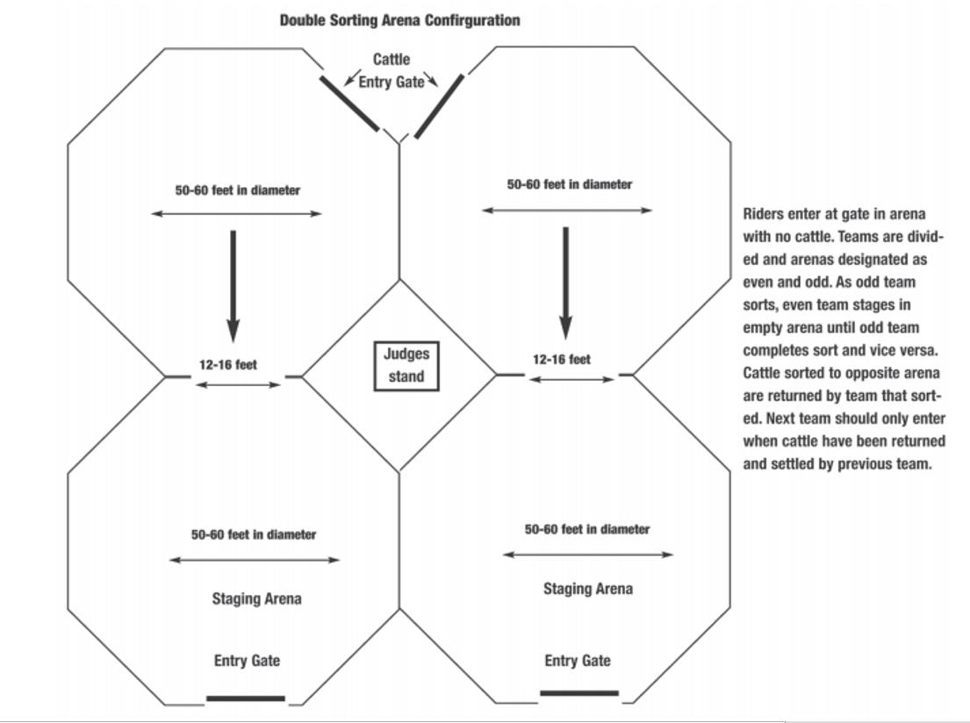
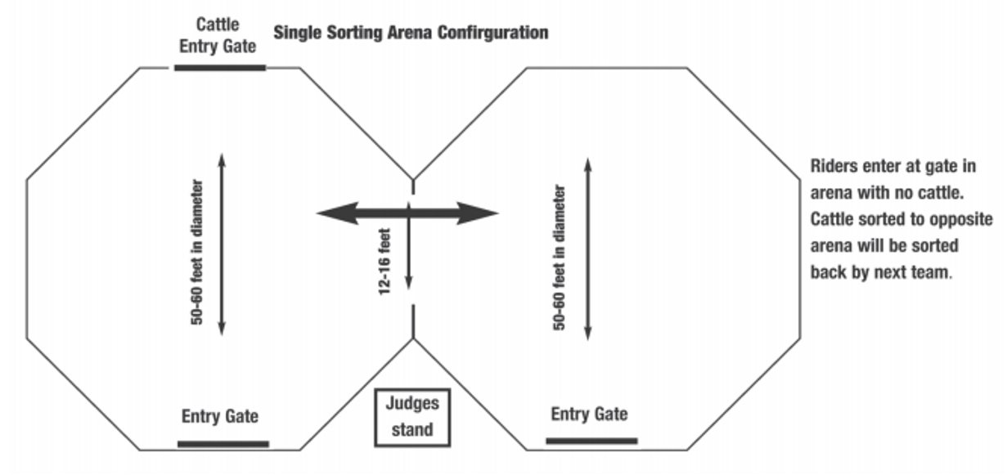
3 Man 2 Gate Large and Small Arena Classes
Objectives and Pen Setups
- Objectives of 3 Man 2 Gate Sorting
MNSCHA will have 2 different 3 Man 2 Gate Sorting classes. The primary difference between these classes is the size of the arena.
A run starts with team members on the opposite side of the start/foul line at each gate opposite from the cattle. The judge will raise the flag when the cattle are ready. The judge will signal the start of time when the nose of the first horse crosses the start/foul line by dropping the flag and the first number will be announced. The announcer will draw a number to determine the first cow to be sorted. Each team on a herd will be given a different first number. Sorting of cattle will be:
  - In numerical order starting with either gate and then alternating from one gate to another gate until all numbered cattle are across the line or time runs out. For example, the number 3 can start and go through the left side gate and number 4 through the gate on the right. OR

Recommended Pen Sizes
  - “Large Arena” shall take place in a pen from 80’ to 120’ wide and 50’ to 60’ deep. The two gate openings will be two 12’ to 16′ gates on one side of the pen. Corners must be angled. See Figure 2
  - “Small Arena” shall take place in a pen from 50’ to 80’ wide and 60’ to 70’ deep. The two gate openings shall be equal size and proportionate to the arena size with gates on one side of the pen. Corners must be angled. See Figure 3
- Note of Caution
With the added speed in this class, roughing will be strictly enforced for the safety of the riders, horses and cattle. If a judge concludes that rider drives a cow into the wall without giving it adequate room to escape, he will be disqualified for roughing. All other MNSCHA roughing rules apply.

Figure 2 - 3 Man 2 Gate Sorting LARGE Arena
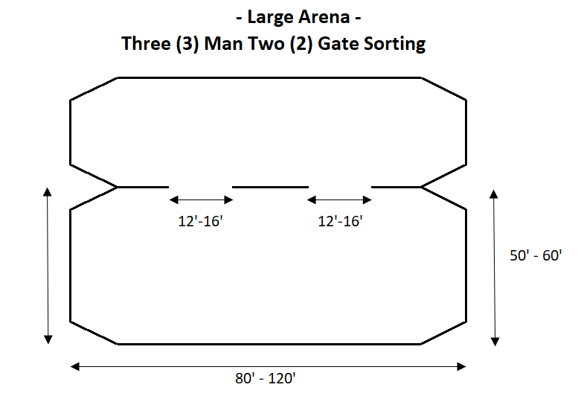

Figure 3 - 3 Man 2 Gate Sorting SMALL Arena
