March 30 & 31, 2019
3 Man 2 Gate & Pen to Pen Ranch Sorting
  - 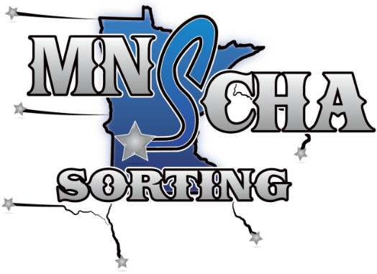
Minnesota Sorting Cow Horse Association
HIGHVIEW RANCH & STABLE
32908 285TH Ave, Le Sueur, MN 56058
Get directions from our website; highviewstable.com
Saturday, March 30th
Registration closes at 10:30 a.m./Start time at 11:00 a.m.
Class  3 Man, 2 Gate  #10 | Entry Fee  $25* | Payback  50%
Junior Horse  (4 yr or under) | $25* | 50%
Open | $25* | 50%
Ranch Hand  (1 cap on sorter) | $25* | 50%
#6 | $25* | 50%
Youth | $10* | Points toward year end
#8 | $25* | 50%
#4 | $25* | 50%

Sunday, March 31st
Registration closes at 10:00 a.m./Start time at 10:30 a.m.
Class | Entry Fee | Payback
Junior Horse  (4 yr or under) | $25* | 50%
Open | $25* | 50%
Ranch Hand  (1 cap on sorter) | $25* | 50%
#6 | $25* | 50%
Youth | $10* | Points toward year end
#8 | $25* | 50%
#4 | $25* | 50%

*Entry Fees include $2.50 per ride sanctioning fees
Payback based on entries less sanctioning fees
For More Information | Contact
General show info | Linden Hermel - 612-868-8583
MNSCHA President | Steve Jordan – 307.746.5280
Rules, MNSCHA, other info | www.mnscha.com

$5 office fee per rider – MNSCHA western dress code required
Announcements and postings at the event take precedence over all printed material
*Entry Fees include $2.50 per ride sanctioning fees

