The Narcissist’s Ent.

Founded by Aryanna Gilliland

May 2nd 2023

# Mission

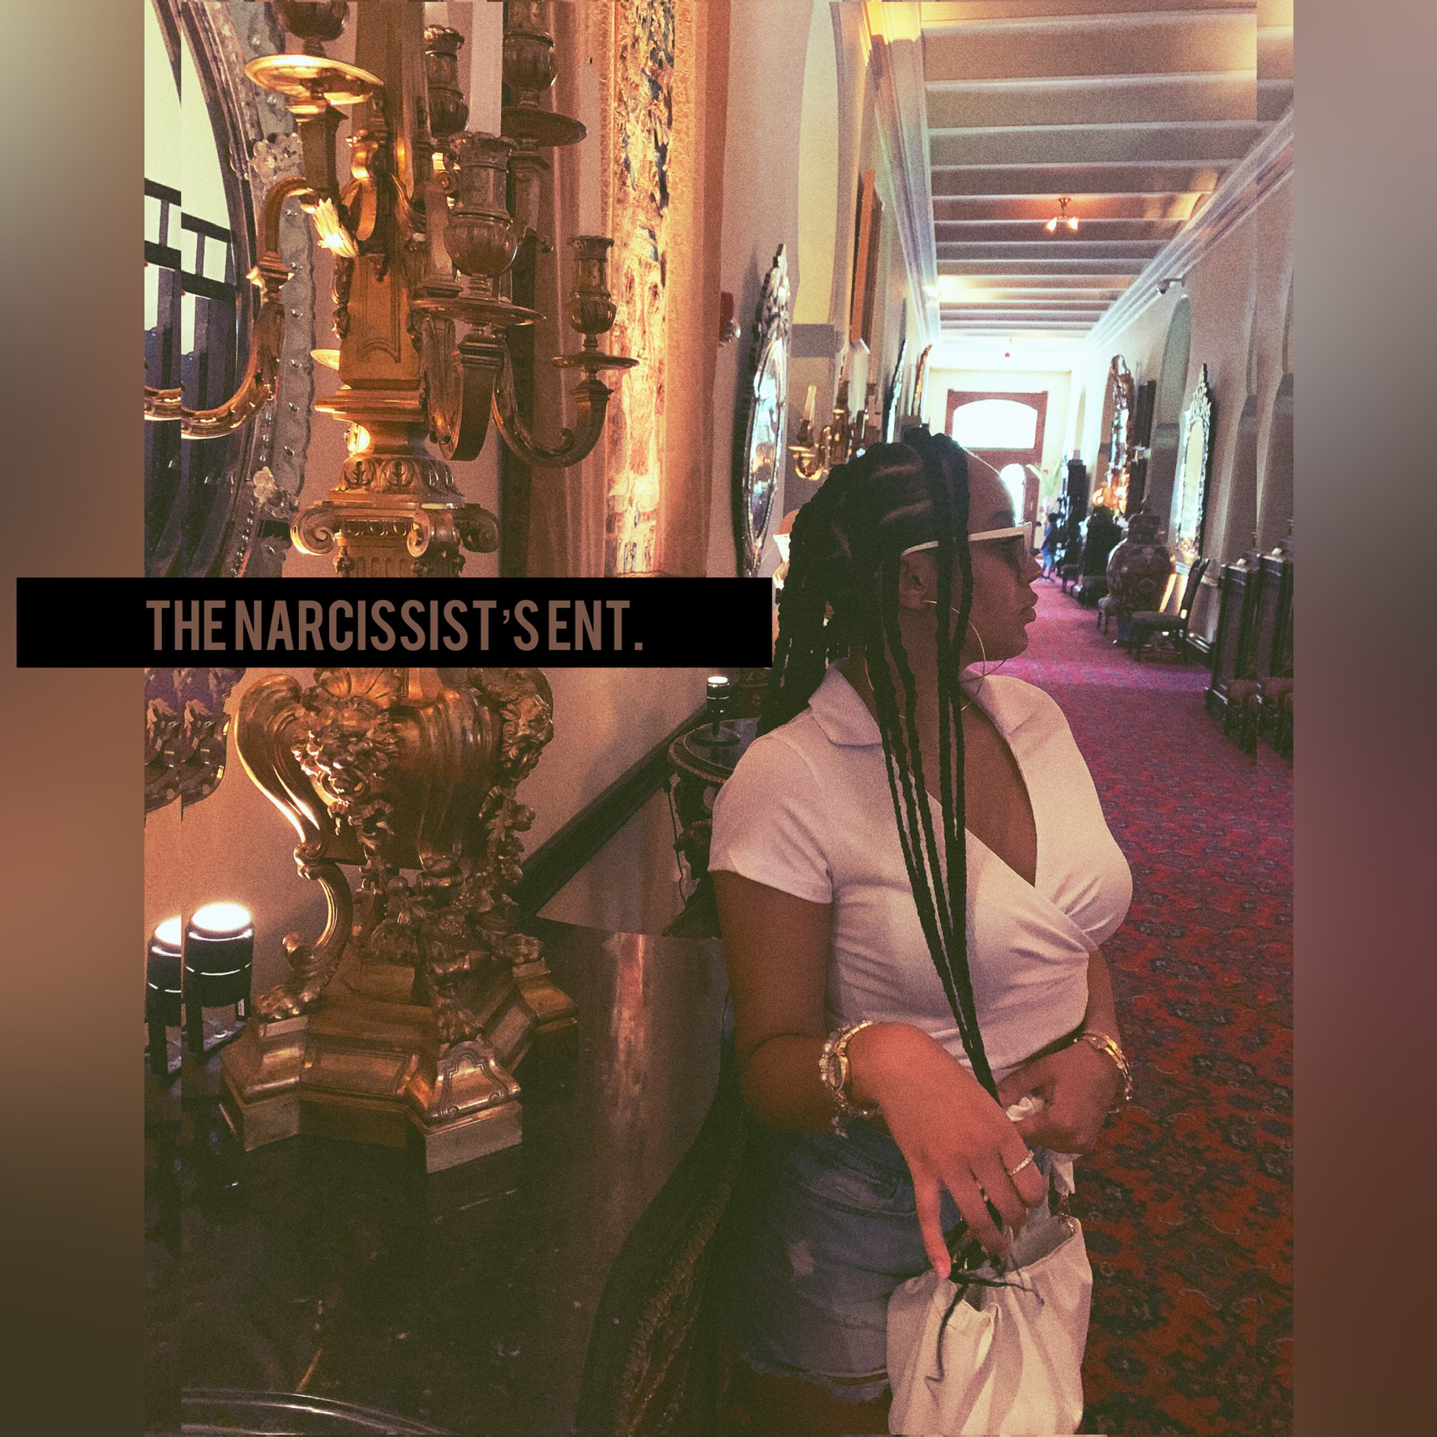The Narcissist’s Ent., is a Film and Entertainment Company producing a wide variety of Digital Content throughout the Film, Dance, Music, Fashion, and Beauty Industries.

The Narcissist’s Ent., was founded for the upbringing of unique digital videos called “ARIDANCE”. ARIDANCE is a twist on dance films. Instead of Feature Films of dance such as “Honey” or “Step Up”, ARIDANCE is a shortened version split into mini cinema films posted on the YouTube Platform.

GOALS

The Narcissist’s Ent., is hoping to dominate the mainstream creative e-commerce with our NEW! Exciting videos to be enjoyed from all around the world. One of our goals is for the company to become an LLC, as it’s currently operated by a Sole Proprietor. Another goal is to create a space for under represented black creatives in Dance, Film, Music, and more. The Film Industry does not provide opportunities for Black Directors, Screenwriters, and Artists, as they do for others. The Narcissist’s Ent., is changing this unfair advantage and shedding light on creatives from diverse communities.

OUR VALUES FOR SUCCESS

The Narcissist’s Ent., thrives off integrity, hard work, honesty, and high performance excellence.

KEYS TO SUCCESS

At The Narcissist’s Ent., the key factors for exceptional growth is…

• understanding the mainstream culture/ trends and then capturing the most highlighted moments of those trends in order to grow our audience and reach.

• having a strong commitment to the culture, community, and fans by providing content they’ll enjoy and share with friends and family members.

• stable management with proven success and marketing strategies to create a loyal fanbase of dedicated people to Art and Hip Hop Culture.

MARKET

Since The Narcissist’s Ent., is an online service for content and not a traditional goods and services company. Our market is the Creative Economy such as Instagram, Facebook, Twitter, YouTube, TikTok, and other social media outlets. The Narcissist’s Ent., targets passionate users who indulge in huge amounts of interests in Pop Media. Usually ranging from 18-24, however all ages are considered. The Narcissist’s Ent., is a brand new company and since then options for capital have been slim. Websites such as GoFundMe and Indiegogo have been attempted but failed due to not enough people knowing about us. We are now looking at loans in order to jumpstart our business. This jumpstart will allow us to spread economically throughout the United States giving us leverage to start making revenue, initially scaling the company.

PRODUCTS AND SERVICES

The Narcissist’s Ent., is an upcoming Entertainment Company providing content throughout some of the biggest industries in the world. Content as such that is scalable and able to expand into multiple platforms for growth. However, one of the biggest outliers when it comes to The Narcissist’s Ent., making the brand so different is the unique, new approach into the industry. Creating custom content, products, services, and merchandise to the young audience of today’s generation. Custom content such as..

ARIDANCE- New, eye- capturing videos made for entertainment to pop culture.

Prollegy’s- mini Broadway like shows on YouTube with Dance, Music, Acting, and Film themes like Western, Romantic, Comedy, and more.

A Narcissist Video- A directors cut of music if The Narcissist a.k.a Aryanna Gilliland was the initial producer, writer, or singer of the performed music. Basically, if the song was to be The Narcissist, how she would direct the music video.

#NARSPromo- If brands want to connect through partnerships and brand deals, it would have to go through NARS Promo. Where The Narcissist would direct a killer commercial Ad video for your business, service, or Artists.

TikTok #nunspecial, Dance #nunspecial, & Music #nunspecial- Today’s audience want more then just a company or a brand. They want people, personalities, and fun. They want to get to know who they are supporting. All of these #nunspecial’s are a way for The Narcissist’s Ent., loyal fans getting to know who the creator is, and more about their personal life/history. These #nunspecial’s are a fun way of interacting with our viewers/ supporters.

NARS YouTube Movie & Feature Films- A NARS YouTube Movie is a short to medium film posted on YouTube for practice and development. Strengthens screenwriting skills, directing skills, working on set, with scripts, actors and actresses, while showcasing a more creative style to the fans. Feature Films are films backed by Film Production Studios made for Expeditions and Distribution. Movie theaters and streaming networks.

Skincare/ Beauty Brand- Under The Narcissist’s Ent., in the future will be a subsidiary company (name not disclosed for protection purposes) creating Makeup products, cosmetics products, skincare accessories, and custom sets for people of all ages.

Clothing Line- Under The Narcissist’s Ent., as well, is a clothing line. The Narcissist a.k.a Aryanna Gilliland is also an aspiring Fashion Designer and loves making clothes. Soon one day making a clothing line into a high fashion designer brand.

MARKETING PLAN

Local Radio Stations, Media, and Newspapers. Booking interviews in and out of state. Sales Literature, email marketing/direct mail, internet marketing, word of mouth, and Ad Agencies promoting The Narcissist’s Ent., into the YouTube Platform. Services and platforms knowledgeable in Marketing Tactics plus Social Media exposure.

Thank you for overlooking my Business Overview. Contact The Narcissist by email at aryannagilliland05@gmail.com