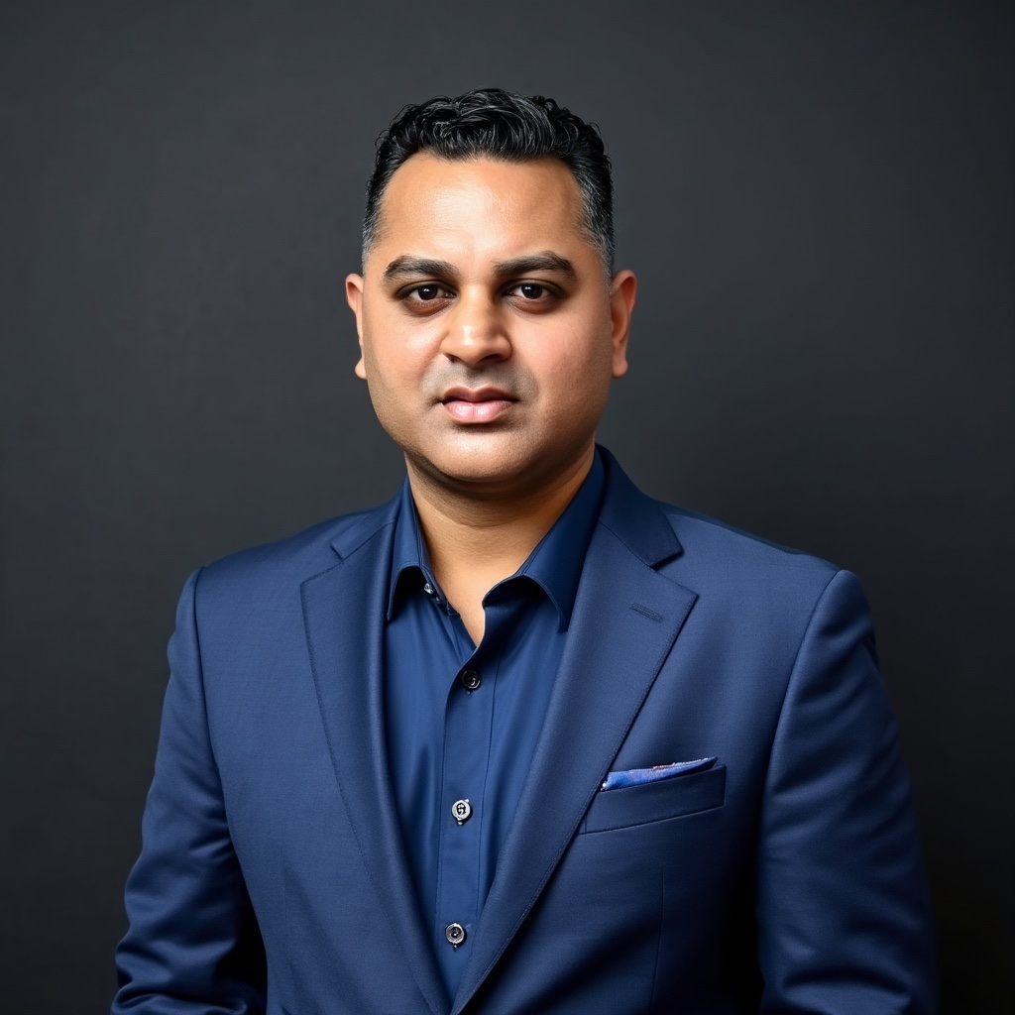 | DINESH SUBBARAYA SASTRY, J.D.  Investment Strategist | Deal Maker | Political Advisor | Cultural Diplomat  dinesh@illuminantcap.com • illuminantcap.com • dineshsastry.com  San Francisco Bay Area • (650) 787-7967

EXECUTIVE PROFILE

Dinesh Subbaraya Sastry is one of America's most uniquely positioned strategic leaders — a rare fusion of Silicon Valley venture capitalist, Wall Street deal architect, Washington power broker, and global diplomatic asset. Over a career spanning more than three decades across North America, Asia, Africa, and the Middle East, he has raised hundreds of millions in capital, shaped geopolitical history, and built an unrivaled network bridging technology, government, and international finance.

As Founder & President of Illuminant Capital Holdings LLC and Venture Partner at Redwood Collective, Dinesh advises sovereign wealth funds, Fortune 100 executives, family offices, and heads of state. He brings to every engagement the credibility of a UC Berkeley engineer, the precision of a Georgetown-trained securities attorney, and the instincts of a lifelong deal maker who has operated at the highest levels of power.

CURRENT ROLES & LEADERSHIP

Founder & President — Illuminant Capital Holdings LLC | San Francisco, CA (2009–Present)
Boutique advisory and capital introduction firm specializing in cross-border transactions, M&A, sovereign fund advisory, and emerging market strategy across the U.S., Asia, Europe, and EMEA.

Venture Partner — Redwood Collective | San Francisco, CA (2024–Present)
Stewards a high-performance Fund of Funds delivering 5x+ ROI (Fund I), granting investors access to elite Silicon Valley VC firms — including KPCB, Founders Fund, Lightspeed, 8VC, and Westly Group — at a $1M entry threshold vs. the typical $10–20M minimum.

Vice Chairman — Simba Fiber | Uganda/Pan-Africa (2023–Present)
Spearheads capital formation and strategic partnerships for Africa's most ambitious fiber-optic rollout, connecting 54 nations and bridging the digital divide for the continent's fastest-growing youth population.

Chief Strategy Officer — ReXDeX | San Francisco Bay Area (2025–Present)
Co-Founder of a groundbreaking AI + blockchain ticketing platform targeting the $85B global ticketing industry — eliminating fraud, scalping, and opacity through SoulBound Token (SBT) infrastructure and AI-driven personalization.

Senior Strategic Adviser — Computing Concepts Inc. (CCI) | NJ/Global (2023–Present)
Guides growth strategy for a 900-person global digital transformation leader serving Morgan Stanley, the Federal Reserve, NY Times, and multiple federal agencies in AI, cybersecurity, and workforce management.

Additional Active Advisorships:
- Senior Business Advisor, Falkon Systems Inc. — Healthcare & Defense AI/Edge Computing
- Senior Business Advisor, SecondWind Pro — NIL Sports Management & Athlete Representation
- Senior Advisor (Global Markets), Metalloid Media & Entertainment — Film, TV, Sports Media Rights
- Senior Advisor, Multiplier AI — India Export Tech & Global Trade AI Platform
- Advisory Board Member, Red Gate Elite — Wealth Transfer & Legacy Planning for HNW Families
- Senior Advisor, Authentical (Sydney) — Blockchain Credentialing & Anti-Forgery Technology
- Senior Advisor, Delta Cognition — Predictive Analytics & Industrial AI

FINANCE & DEAL-MAKING EXPERTISE

Dinesh has structured multimillion-dollar transactions across the full capital spectrum — LBOs, Series A through D venture rounds, sovereign fund investments, and international defense contracts. He raised the initial private equity capital for Blackstreet Capital (formerly Milestone Capital Partners), associated with Carlyle Group founders and Gov. Haley Barbour. He secured a majority of the $30M Series B for Ample Communications, a leading chip-design hardware company, and orchestrated the landmark first U.S.–India defense technology transfer — a $200M Firefinder Night Radar deal for the Indian Army, deployed on the Kashmir border, a system credited with preventing accidental border conflicts between India and Pakistan.

Mentored by Edward Mathias of The Carlyle Group and entrepreneur Jon Ledecky, and having worked alongside legends including John Doerr, Sandy Robertson, and Ambassador John Roos, Dinesh brings institutional-grade judgment and a Rolodex that spans Wall Street, Silicon Valley, and international capital markets. He has advised family offices, sovereign wealth funds, and institutional LPs in the U.S., Europe, and Asia.

POLITICAL INFLUENCE & GLOBAL NETWORK

Few private citizens in America command the bipartisan political capital that Dinesh Sastry has cultivated across three decades. As a former Trustee of the Democratic National Committee (DNC) and Trustee of the Democratic Senatorial Campaign Committee (DSCC) — where he chaired the High Tech Council — Dinesh ranked among the top five national fundraisers for the DNC and Al Gore in 2000, hosting events at $50K and $100K per person with President Clinton and Vice President Gore.

He has raised double-digit millions for Democratic causes, serving presidents, senators, and governors including Clinton, Gore, Biden, Obama, Kamala Harris, Jerry Brown, Tom Daschle, John Kerry, and Harry Reid. He led the Biden Victory Fund (2024) and served as a key finance operative for the Harris presidential campaign. Simultaneously, he has maintained close relationships across the aisle — briefly working with renowned Republican strategist Frank Luntz — and has informally advised the Trump White House on North Korea, Iran, China, India, Pakistan, and Russia.

On the world stage, Dinesh's most remarkable diplomatic feat occurred in 1998: following India and Pakistan's nuclear tests and subsequent U.S. sanctions, he personally established the back-channel between the Vajpayee government and the Clinton administration — a quiet conversation that ultimately enabled Strobe Talbott and Jaswant Singh to negotiate a formal détente and the removal of sanctions. He is also widely credited as the person who persuaded President Clinton to become the first U.S. President to formally acknowledge Diwali — a recognition that has since become an annual White House tradition.

His advisory portfolio spans heads of state across two continents:
- India: Prime Ministers P.V. Narasimha Rao, Atal Bihari Vajpayee, Manmohan Singh, and Narendra Modi; Deputy PM L.K. Advani; Chief Ministers Jerry Brown, Chandra Babu Naidu, and the late Y.S. Rajashekhara Reddy
- USA: Presidents Clinton, Obama, Biden; VP Al Gore; Senators Biden, Kerry, Reid, Daschle, Edwards; Governor Jerry Brown
- Global: Middle East sovereign funds, Indian American community leaders, Fortune 100 CEOs across Silicon Valley and beyond

TECHNOLOGY & INNOVATION LEADERSHIP

Rooted in his UC Berkeley engineering training and early career at National Semiconductor — Silicon Valley's oldest major chip company — Dinesh has remained at the frontier of technology throughout his career. He has championed AI, blockchain, data analytics, green energy, and digital infrastructure ventures, and currently holds strategic roles across the AI, fintech, edtech, and entertainment technology sectors.

He pioneered the launch of a dozen Indian language channels on the Dish Network satellite platform in the United States and launched IPTV services with DishWorld (now Sling TV), demonstrating an early and prescient understanding of digital media distribution. He has served as an Advisory Board Member for Iron Pillar, a prominent India-focused venture growth fund, and is a Member of the Arie Guard International Investment Banking Platform.

As a prolific author and thought leader, Dinesh has published in The National Interest and New India Abroad on subjects ranging from America's energy cloud future, the operating system of influence underlying U.S. power, hybrid capitalist economic models, and the strategic potential of Indian-American political identity in a new geopolitical era.

EDUCATION

B.S. Electrical Engineering & Computer Science  University of California, Berkeley | J.D. Banking, Corporate, Finance & Securities Law  Georgetown University Law Center

CORE COMPETENCIES

- Capital Raising & Private Equity Syndication  - Venture Capital & Fund of Funds Strategy  - Mergers, Acquisitions & Cross-Border Transactions  - Deal Sourcing & Structured Finance  - Sovereign Wealth Fund & Family Office Advisory  - AI, Blockchain & Frontier Technology Ventures | - Political Strategy & High-Level Fundraising  - Global Business Development & Market Entry  - U.S.–India & Cross-Cultural Diplomacy  - Public-Private Partnerships & Government Relations  - Marketing, Branding & Strategic Communications  - Green Energy, Defense & Emerging Market Infrastructure

SELECTED PRESS & RECOGNITION

Dinesh's career has been recognized by the Economic Times of India, Times of India, SF Gate, Los Angeles Times, Asian Week, and National Interest. He has been profiled as a 'Democrat Kingmaker,' featured in analyses of Indian-American political influence, and cited in discussions of U.S. immigration policy reform. He is also the author of The Mysterious Story of God, a spiritual-political memoir currently in feature film development with interest from HBO, Magnolia Pictures, and Warner Bros. Discovery.

dinesh@illuminantcap.com • illuminantcap.com • dineshsastry.com • linkedin.com/in/dinesh-sastry

