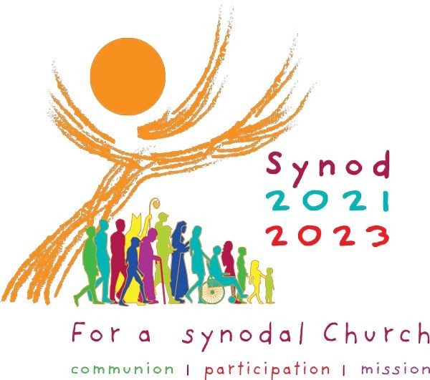

2022 Lenten Synodal Meetings.
You may like to organise five meetings during Lent this year as an experience for you and your people and any religious within your parish family to begin an experience of Synodality. Lent is a favourable time to invite people to meet for prayer and discussion. It could be proposed as a parish Lenten Exercise. Groups would need to be small, no more than 6 or 7 people. They could be organised in parish accommodation, in people homes or indeed as several small groups meeting at the same time, in the parish hall. All meetings would be subject to current COVID restrictions- peoples safety is our paramount concern.
A synthesis of parish findings/responses should be forwarded to the Dean for the Deanery Synthesis in Eastertide.

All Meetings.
should begin with the same prayer.
Opening Prayer(from Second Vatican Council)
We stand before You, Holy Spirit,
as we gather together in Your name.
With You alone to guide us,
make Yourself at home in our hearts;
Teach us the way we must go
and how we are to pursue it.
We are weak and sinful;
do not let us promote disorder.
Do not let ignorance lead us down the wrong path
nor partiality influence our actions.
Let us find in You our unity
so that we may journey together to eternal life
and not stray from the way of truth
and what is right.
All this we ask of You,
who are at work in every place and time,
in the communion of the Father and the Son,
forever and ever.
Amen.

Within your group, the leader should enthrone/open the bible/scriptures, open at the coming Sundays Gospel. A candle should be lit before the scriptures.
A group of no more than 6/7 keeps it intimate and allows everyone to speak and share.
A leaflet for each week should be printed off for each participant.
The leader or another person should be appointed to take notes.
To emphasises the prayerful nature of the meeting call the people to attention, play some gentle music or use a “stilling exercise” see over.

Part One: Firmly in Prayer.
Stilling Exercise.
Invite the people to get comfy. – back straight, feet on the ground.
Invite them to become aware of the sound of their own breathing.
Beginning at the top of your head and passing down through the body to the feet be attentive to each part of the body in turn. Gently focus in turn on each part … head … face … eyes …neck … shoulders….legs….feet set firmly on the floor… consider and be aware of your whole self …. you as a person made in God’s likeness … you in whom God chooses to dwell…and through whom he can speak.

After a period of deep silence(don’t rush it-try to be comfortable with it)
Have someone (Previously arranged to read the gospel text slowly-very slowly)

Then have them read it slowly again…………..
After some silence each person is asked to mentioned what struck them…..a verse…..a single word……… Everyone is encouraged to speak…….. If someone stays silent, leave them in peace.

Then invite people to speak at more length at what struck them.
After everyone has spoken, stay in contemplative silence for a at least 3 minutes… don’t rush the silence. Silence is central to the process since it gives people time to process what is going on deep within them.

Time for Tea!
Part Two: Prayerful Deliberation.
Re-establish the prayerful atmosphere. Call the people to silent attentiveness.
Slowly read out the theme and questions, just as you did the gospel passage.
After a period of silence ask the people to share their thoughts.
(There should be no discussion across the room)
Re read the questions and invite non-confrontational discussion.
We should have the love to listen to and respect those who think differently from us.
Ask have we come to a consensus about anything. Don’t worry if we haven’t.
Finish with everyone reading the concluding prayer.

Invite everyone to the next meeting reminding them of the date and time.
Notes taken should be kept until a group synthesis can be given to PPC/PP at the end of Lent to form the parishes report to the Deanery.


