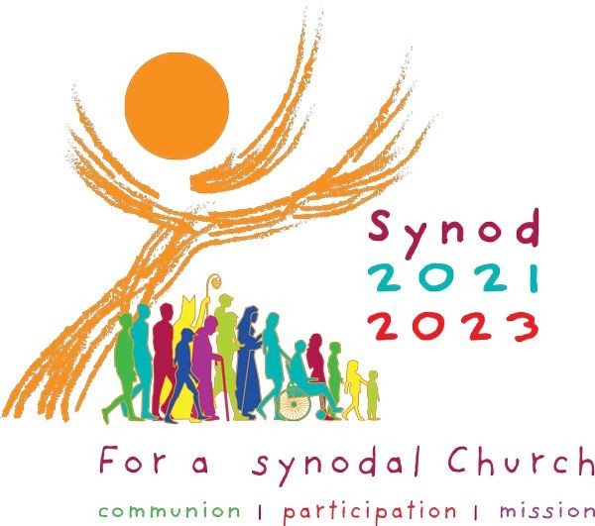
Dear all,
If you haven’t already seen these, here are two notices that concerning the Synod and synodality. Please remember the diocesan synod site(rcagsynod.org) has some resources available as do the web pages of most other diocese.
https://www.vaticannews.va/en/vatican-city/news/2021-10/theologian-luciani-synod-turning-point-for-church.html
Podcast from Rafael Luciani, a member of the Theological Preparatory Commission.

Also
“Synodality in the Life and Mission of the Church”
2pm Saturday 12th February 2022.
Keynote Speaker Cardinal Mario Grech.
Who is the General Secretary of the Synod of Bishops.
with
Catherine Joseph Droste OP
Ed Morgan
Sara Parvis
Guy Mancini OSB
Anna Marie Mc Guan RSM

Watch live at bit.ly/BCOSYouTube

