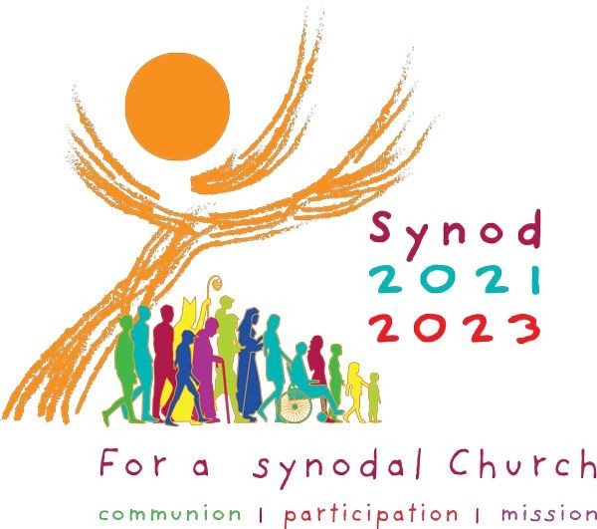

Dear Monsignor/Canon/ Father/ Deacon, 14th March 2022.
Recently, I had a meeting with Archbishop Nolan regarding the Synodal Process in our Archdiocese. He is delighted with the progress many parishes and religious communities are making and indeed with the creative way many have approached this opportunity with enthusiasm and ingenuity.
We are asking that your synthesis of your parish returns would be returned asap to your Deanery for the Deanery Synthesis to give the Diocesan team time to prepare its report and present it to the Archbishop and the Diocese before the Archbishop goes off to Rome to receive the Pallium.
The parish reports, like the Deanery report and the Diocesan report should be no longer than ten A 4 sheets. Each sheet should contain a synthesis of the responses under the ten headings proposed by the Holy See.
- Companions on the journey.
- Listening.
- Speaking out.
- Celebration.
- Responsibility for our common mission.
- Dialogue in church and society.
- Ecumenism.
- Authority and participation.
- Discerning and deciding.
10.Forming ourselves in synodality.

“The synthesis should be faithful to the people’s voices and to whatever emerged from their discernment and dialogue, rather than a series of generalized or doctrinally correct statements. Points of view that are contrary to one another need not be omitted but can be acknowledged and stated as such. Views should not be excluded simply because they were expressed by a small minority of participants. Indeed, sometimes the perspective of what we could call the “minority report” can be a prophetic witness to what God wants to say to the Church.” ( Vademecum appendic C)
Any responses that do not fit easily into the requested headings may be included in an appendix.

The Diocesan event to present the report to the Archbishop and the Archdiocese will take place on the Solemnity of Corpus Christi 19th June.
- A video presentation of the ten topics can be found Roman Catholic Diocese of Galloway (gallowaydiocese.org.uk)

Many thanks

John.

