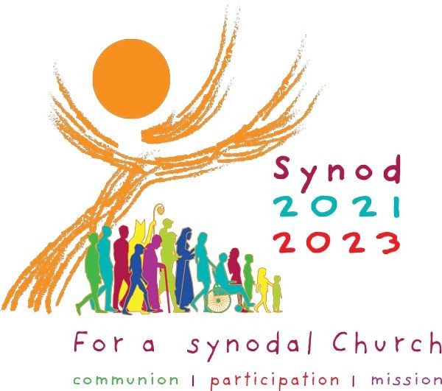
Dear Monsignor/Canon, 7th March 2022.
Yesterday, I had a meeting with Archbishop Nolan regarding the Synodal Process in our Archdiocese. He is delighted with the progress many parishes and religious communities are making and indeed with the creative way many have approached this opportunity with enthusiasm and ingenuity.
As Dean, we are asking that your Deanery Synthesis of the parishes returns would be returned asap after Easter(Although the original date was Pentecost) to give the Diocesan team time to prepare its report and present it to the Archbishop and the Diocese before the Archbishop goes off to Rome to receive the Pallium.
Perhaps as an idea for your Deanery Synthesis, we could adopt the previous Extended Deanery Meeting Model, with one or two lay people, with priests and deacons coming together to discern and act upon any local initiatives that have surfaced in the parish reports and indeed to gather and synthesise the parish reports, under the ten headings proposed by the Holy See.
- Companions on the journey.
- Listening.
- Speaking out.
- Celebration.
- Responsibility for our common mission.
- Dialogue in church and society.
- Ecumenism.
- Authority and participation.
- Discerning and deciding.
10.Forming ourselves in synodality.

The synthesis of each topic should be no longer than a side of A4 paper typed. “The synthesis should be faithful to the people’s voices and to whatever emerged from their discernment and dialogue, rather than a series of generalized or doctrinally correct statements. Points of view that are contrary to one another need not be omitted but can be acknowledged and stated as such. Views should not be excluded simply because they were expressed by a small minority of participants. Indeed, sometimes the perspective of what we could call the “minority report” can be a prophetic witness to what God wants to say to the Church.” ( Vademecum appendic C)
We would also ask that from your deanery you provide one Member to be part of the Archdiocesan Team who will prepare the Diocesan Report early in June. In the interests of diversity and in hoping to keep a gender and age balance, I would ask if:
City East- would provide a young male.
Dumbarton- would provide young female.
East End- would provide a young male.
North- would provide a middle aged female.
North East- would provide a middle aged male.
North West- would provide a middle aged female.
South- would provide a mature male.
South East- would provide a mature female
West End- would provide a mature male.
Could you also provide their email address please and send it to Synod@rcag.org.uk- thankyou.

I include a prayer service that you may with to use for your “Extended Deanery Meeting.” The Diocesan event to present the report to the Archbishop and the Archdiocese will take place on the Solemnity of Corpus Christi 19th June.
Many thanks

John.

“Extended Deanery Meeting- to synthesise parish responses.”
Opening Prayer(from Second Vatican Council)
We stand before You, Holy Spirit,
as we gather together in Your name.
With You alone to guide us,
make Yourself at home in our hearts;
Teach us the way we must go
and how we are to pursue it.
We are weak and sinful;
do not let us promote disorder.
Do not let ignorance lead us down the wrong path
nor partiality influence our actions.
Let us find in You our unity
so that we may journey together to eternal life
and not stray from the way of truth
and what is right.
All this we ask of You,
who are at work in every place and time,
in the communion of the Father and the Son,
forever and ever.
Amen.

Scripture Luke 24:13-33.

On the Road to Emmaus
¹³ Now that same day two of them were going to a village called Emmaus, about seven miles^{[a]} from Jerusalem. ¹⁴ They were talking with each other about everything that had happened. ¹⁵ As they talked and discussed these things with each other, Jesus himself came up and walked along with them; ¹⁶ but they were kept from recognizing him.
¹⁷ He asked them, “What are you discussing together as you walk along?”
They stood still, their faces downcast. ¹⁸ One of them, named Cleopas, asked him, “Are you the only one visiting Jerusalem who does not know the things that have happened there in these days?”
¹⁹ “What things?” he asked.
“About Jesus of Nazareth,” they replied. “He was a prophet, powerful in word and deed before God and all the people. ²⁰ The chief priests and our rulers handed him over to be sentenced to death, and they crucified him; ²¹ but we had hoped that he was the one who was going to redeem Israel. And what is more, it is the third day since all this took place. ²² In addition, some of our women amazed us. They went to the tomb early this morning ²³ but didn’t find his body. They came and told us that they had seen a vision of angels, who said he was alive. ²⁴ Then some of our companions went to the tomb and found it just as the women had said, but they did not see Jesus.”
²⁵ He said to them, “How foolish you are, and how slow to believe all that the prophets have spoken! ²⁶ Did not the Messiah have to suffer these things and then enter his glory?” ²⁷ And beginning with Moses and all the Prophets, he explained to them what was said in all the Scriptures concerning himself.
²⁸ As they approached the village to which they were going, Jesus continued on as if he were going farther. ²⁹ But they urged him strongly, “Stay with us, for it is nearly evening; the day is almost over.” So he went in to stay with them.
³⁰ When he was at the table with them, he took bread, gave thanks, broke it and began to give it to them. ³¹ Then their eyes were opened and they recognized him, and he disappeared from their sight. ³² They asked each other, “Were not our hearts burning within us while he talked with us on the road and opened the Scriptures to us?”
³³ They got up and returned at once to Jerusalem. There they found the Eleven and those with them, assembled together ³⁴ and saying, “It is true! The Lord has risen and has appeared to Simon.” ³⁵ Then the two told what had happened on the way, and how Jesus was recognized by them when he broke the bread.

After a period of silent prayer, discussion on parish responses to each of the ten questions should take place, noting areas of agreement and disagreement. Please finish with a note on where people feel the Holy Spirit is leading us now.

Concluding Prayer.
The Our Father

Gracious Father, we thank you for the opportunity to meet together today. As we leave this place, surround us with your love. May we see your beauty, feel your love, know your wisdom and experience your power. May we find the comfort we desire in you and the strength we need in your name. May your presence be with us every hour of the day. May your love be the passion in our hearts. May your joy be our strength when times are hard. May your presence be the peace that overflows in our lives. Through Jesus Christ, our Lord, Amen.

