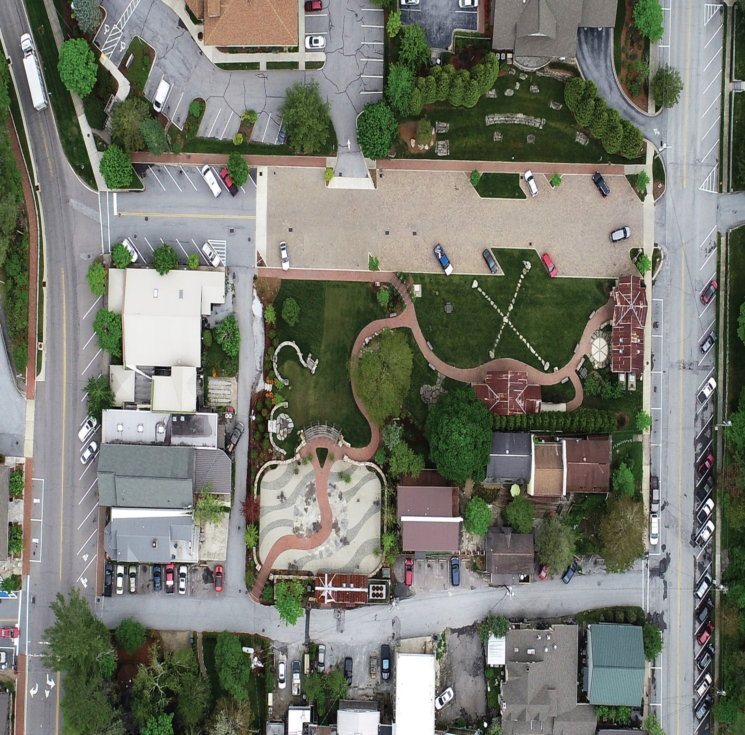
`
Euro (3)
Italian (10)
Porsche (9)
Pre War British (2)
Post 67 Corvette (4)
C2 Corvette (6)
C1 Corvette (5)
Corvette Racers (3)
Jag Touring (5) Racing (5)
E-Types (5) XKs (4)

Hickory Ridge (0)
America Muscle (7)
British (8)
BRITISH (8)
Merch #1 & #2 BHMHS Hagerty Ferrari/ATL (3)
HotWire
Flow (3)

Food
Toy Barn
Volunteer/Info Desk
Rec (3)
Check-In First Bank Carolina Way
Am Post War (6)
Am Pre War (4)
2026 Highlands Motoring Festival Show Field

