ADDISON AUZA SCHOLARSHIP – 2021

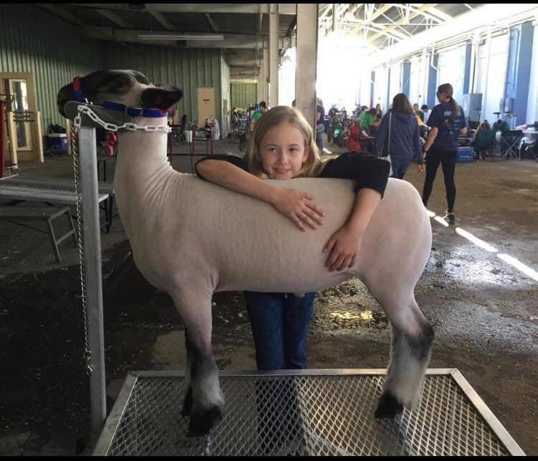

The ADDISON AUZA SCHOLARSHIP was established in 2019, for Maricopa County Fair 4-H and FFA graduating high school senior participants.

ADDISON AUZA was a beautiful 11-year-old young lady; she showed sheep in 4-H for two years, 2016 through 2018, in Maricopa County. On October 27, 2018, one week after participating in her first Arizona State Fair, she was admitted into Phoenix Children’s Hospital; she was diagnosed with an Arteriovenous Malfunction (AVM - a bursting of blood vessels) in her brain. Addie was unable to recover from the damage and passed on December 3, 2018. Addie became an organ donor and saved the lives of four people. She was able to donate both of her kidneys, her pancreas, and her liver.

Addie loved showing her sheep and, during her two show years, she participated in SAILA Shows, Arizona Nationals, the Maricopa County Fair, and the Arizona State Fair. Addie was also on a performance dance team; she played the guitar and was a straight-A student at ACP in Chandler.

Addie learned that raising a market lamb for show is hard work. She learned about nutrition, exercise, grooming, and how to show. Through her wins and losses, both inside the ring and out, she learned about sportsmanship and gained friendships. Showing was very important to Addie.

Early in 2019, shortly after her passing, Addie’s parents, David and Jill Auza, and close friends, decided to keep her spirit alive and honor her memory by creating a scholarship fund for graduating high school seniors who participated in the Maricopa County Fair. In response to the overwhelming donations in Addie’s name during the first two years, David and Jill have decided to expand the scholarship opportunities to other counties in Arizona. Addie loved people of all ages and was always willing to help others. We have created this scholarship to honor and remember her; this will help other 4-H and FFA participants by assisting them in furthering their educations.