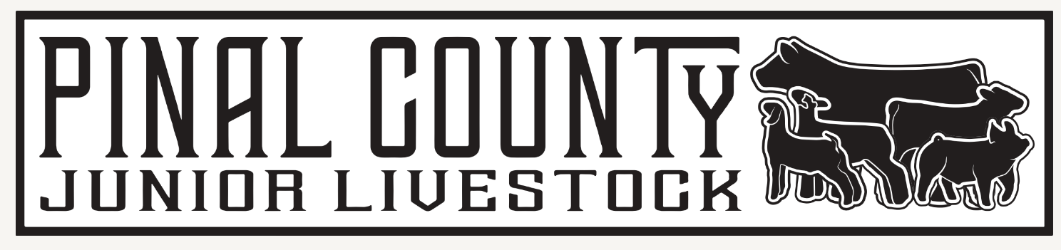

Dear Friends and Family of the PCJLC,
The 2023 Pinal County Fair is just around the corner. We would like to take this opportunity to thank you if you have supported the Pinal County Livestock Show and auction in the past and welcome our new supporters. Our awards program could not exist without continued support from local sponsors.
The 4-H, FFA and Association members in our community put forth a lot of hard work and dedication from one year to the next. We rely solely on the sponsors (individuals/businesses), and parents to keep our show and auction a success for the youth exhibitors; therefore, we are asking for your support.
You and/or your business will be recognized in the show barn to be viewed by all in attendance at the Pinal County Fair and through continuous announcements of your company name on the PA system when the award is presented. In addition, this donation is completely tax deductible.
If you are able to support the 2023 PCJLC Awards Program with a donation of any denomination, please email Woehlecke10@gmail.com or mail the enclosed form and donation by March 1st to:
Pinal County Junior Livestock
P.O. Box 12535
Casa Grande AZ 85130
In turn you may expect and invoice from the PCJLC Committee. If not received within 2 weeks please reach out to me via email. We would also like to invite you to the champion drive for the presentation of your sponsored awards.

Thank you so much for your continued support for our youth exhibitors!

If you have any questions, please call Beth Woehlecke at (520) 705-9991 or send an email to Woehlecke10@gmail.com or pcjuniorlivestock@gmail.com

Sincerely,
Beth Woehlecke
PCJLC Executive Board Vice President

