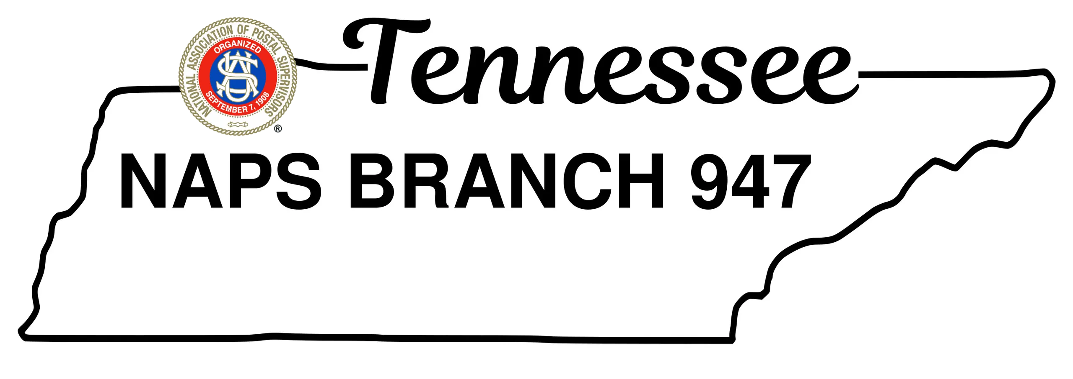

Minutes of the 84th
Tennessee State Convention

The 84th TN State Convention was held on April 20-22, 2023 in Gatlinburg, TN with the Smoky Mountain Branch 165 as hosts.

Friday, April 21, 2023

The convention was called to order at 8:18 by TN State President, Donna Aaron. Opening remarks were made by:

Kathy Shoemaker, President of Host Branch 165
Shri Green, Cottonbelt Area Vice President
Jaimie Elizondo, Southern Region Vice President
Jimmy Warden, National Secretary Treasurer
Chuck Mullidore, National Executive Vice President

At 8:32, Branch 165 president Kathy Shoemaker, turned the gavel over to State President Donna Aaron.

President Aaron introduced the theme of the convention as Portraits of Success. An open discussion took place on what success looks like.

Mary Johnston, EAP consultant, spoke on the subject called, “Understanding Your Employees”. She also shared valuable information that can be obtained on the EAP website.

Sharon Young, Area Plant Operations manager spoke about the tragedy in Chattanooga on the importance of Leading with Respect.

Beginning at 10:00AM, keynote speaker for the convention, Greg Gray gave an excellent presentation to the delegates on Why People Aren’t Doing What You Want Them to Do.

After lunch, the delegates were given presentations what success looks like from a NAPS perspective. Jamie Elizondo, Shri Green, Jimmy Warden and Chuck Mullidore made the presentations.

At 4:30, Vice President and State Legislative Chair, Robert McMurry gave an update on legislative matters and the success of LTS.

The Friday Session adjourned at 5:03PM.

Saturday April 22, 2023

Starting at 8:07AM, State President Donna Aaron called the convention to order. Invocation by Larry Shropshire, President Branch 245.

Writing for Success was presented by Shri Green. She discussed the importance of making the most on eCareer.

Dillard Financial spoke about retirement planning.

Convention Business

Registration Committee Report
Total Registered – 46
First Timers – 7
Resident Officers – 2
Out of State Visitors – 3

Total in Attendance – 44
Tom O’Connor, Branch 97 moved to accept the Registration report, seconded by Kevin Proctor Branch 32; motion passed.

Audit Committee – Denise Macke Branch 41 Chair, Michelle Edmondson, Branch 32 and Donald Swoopes Branch 97, audited the financial statements from 2021-2023 and found that all expenditures and deposits were accounted for.

Constitution Bylaws Committee – no changes were submitted.

Election – there were no challengers for the state offices.

Officers serving 2023-2025 are:

President – Donna Aaron
Vice President – Robert McMurry
Secretary/Treasurer – Robert Wakefield

Our thanks to Branch 165 for hosting an excellent State Convention. Next convention to be held in Nashville, with Branch 32 as the host branch.

Tom O’Connor, Branch 97 motioned that the convention be adjourned; seconded by John Cushenberry seconded. Motion Passed.

Respectfully submitted,
Robert Wakefield
Secretary Treasurer, Branch 947

