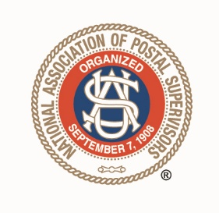Greetings NAPS Members!

Another two years have passed, and so much has happened. PMG DeJoy’s ideas of revolutionizing the postal service have disappointed those of us who worked under a commitment to service as a priority. Before his resignation, I sent him an invitation to attend our State Convention, but he had prior commitments and sent his regrets that he could not attend. He was committed to exiting the building, leaving his mess for others to clean up. Now we move on to Doug Tolino for our Acting PMG. It remains to be seen how Mr. Tolino will guide the ship. He has given us some good things in the past, with instructions on handling emergency placements, but he has been reluctant to settle our lawsuit. So it remains to be seen what direction he will lead us in.

On the positive side, several branches in our state are seeing a remarkable increase in branch meeting attendance. I am encouraged by this trend and hope that it will continue. The district has finally resumed our quarterly meetings. If you want an issue discussed at these meetings, you must provide specifics; Mr. Coleman does not allow general questions. In the future, I hope that as we move forward, we can begin to publish the results of these meetings on our state website. If you haven’t checked out the website that our talented State Secretary/Treasurer has created, please go look that up!

We have dealt with issues over the past two years, some of which are the same old stories. As for sharing passwords/logons, I have two words for it: STOP IT! You take a cyber safe course every year, and it is difficult to impossible to defend yourself doing this. Regarding timekeeping issues, please pay attention to your TACS and GATS, adjust pay training, and follow those rules. Always have paperwork to back up any entries you make in these programs. Remember, there are retention rules on all paperwork connected to pay; if you don’t know, ask or look it up. If you are given verbal instructions that you question about being safe, illegal, or immoral, push back and question in writing if you are clear on what you are being ordered to do.

Remember, working together, supporting each other, sharing knowledge, and standing up as a group, we can make positive improvements. Thank you for trusting me to serve as your State President the past years!

Donna Aaron, Tennessee State President