WELCOME TO THE TOP 40
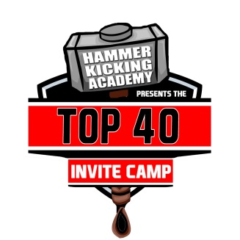

Congratulations,
This is your official invitation to the National TOP 40 event this July in Orlando, Florida. The Top 40 Camp is the ultimate recruiting and instructional camp for the top specialists across the country. The camp is invitation only for the top kickers, punters, and snappers in the sophomore and junior classes.
Through the first two years, the TOP 40 has established itself as THE LEADING recruiting and training camp in America. The camp has produced:
- 113 FBS/FCS offers
- 98 percent commitment rate
- 300+ d1 visits
- 100 percent of snappers have committed to D1 schools
- 12 All American Game Participants
- The Number 1 ranked kicker and punter in the country in 2018
- Had 10 of the top 15 ranked specialists in 2018 at last year’s event
- Every 2017 that attended had an FBS visit
WHEN: June 27th – July 1st, 2018
LOCATION: ORLANDO, FL – EMBASSY SUITES JAMAICAN COURT

FIELD: Dr. Phillips High School - 6500 Turkey Lake Rd, Orlando, FL 32819
COST: $875
Camp will include:
- 4 Night Hotel Stay (WEDNESDAY – SUNDAY)
- All meals starting with dinner on Wednesday (4 Breakfasts, 3 Lunches, 4 Dinners)
- Meals
- Transportation to and from the airport
- Transportation to and from the field
- 6 sessions of instruction and charting
- Individualized recruiting skills film from all 6 sessions, including competition
- Recruiting Seminar
- Exposure to colleges (Through 2 years 98 percent of TOP 40 members committed to a college)
- Competition
- 24 Hour Supervision
- Official Top 40 UNDER ARMOUR Gear AND Strideline Socks (Backpack, Shirt, Socks, Wristband, Long Sleeve Shirt, and more)

The HKA Top 40 Camp is a platform for the top specialists to perform against each other in a five day developmental and instructional camp. Please call us with any questions at 516-330-3252. We look forward to working with you.

WEDNESDAY
8AM – 12:30PM – Specialists landing and transportation from Orlando International Airport
***HKA Staff Members will be in the airport to meet each specialist at their Gate. They will then be taken to baggage claim and taken to our bus transportation to the Hotel***
1:00PM – 2:00PM – Orientation and staff introduction
2:10PM – Kickers Group 1 in lobby for field transportation
2:30PM – 3:45PM – KICKER GROUP 1 SESSION 1
3:15PM – Kicker Group 2 in lobby for field transportation
4:00PM – 5:15PM – KICKER GROUP 2 SESSION 1
4:50PM - Punters in lobby for field transportation
5:30PM – 6:45PM – PUNTER SESSION 1
6:15PM – Snappers in lobby for field transportation.
7:00PM – 8:15PM – SNAPPER SESSION 1
8:15PM- DINNER – PAPA JOHNS
9:45PM – CAMP MEETING
11:00PM – Bed check/ Lights out

THURSDAY
6AM – 10AM – BREAKFAST – Conference Center
8:15AM – Kickers group 1 in lobby for transportation to the field
8:40AM – 9:55AM –KICKER GROUP 1 SESSION 2
9:15AM – Kicker Group 2 in lobby for transportation to the field
10AM – 11:15AM – KICKER GROUP 2 SESSION 2
10:30AM – Punters in lobby for transportation to the field
11:25AM – 12:40PM – PUNTER SESSION 2
12:10PM – SNAPPERS in lobby for transportation to the field
12:50PM – 2:05PM – SNAPPER SESSION 2
2:15PM –LUNCH –CHICK-FIL-A
4:30PM – 6PM – POSITION MEETINGS
7:30PM – DINNER IN CONFERENCE CENTER – MOE’S
9:00PM – CAMP MEETING
11:00PM – Bed check/ Lights out

FRIDAY
6AM – 10AM – BREAKFAST – Conference Center
9:00AM – Kickers in lobby for transportation to the field
9:45AM – 11:15AM – KICKER GROUP 1 AND GROUP 2 SESSION 3
KICKER GROUP 1 ON FIELD 1
KICKER GROUP 2 ON FIELD 2
10:30AM – Punters and Snappers in lobby for transportation to the field
11:10AM – 12:40PM – PUNTER and SNAPPER SESSION 3
1:15PM - LUNCH – WENDYS
3:15PM – GROUP A IN LOBBY FOR BUSES TO CHARTING SESSION (KICKER GROUP 1 AND 2)
4:00PM – 5:30PM – GROUP A CHARTING SESSION
5:00PM – GROUP B IN LOBBY FOR BUSES TO CHARTING SESSIONS (PUNTERS AND SNAPPERS)
5:45PM – 7:00PM – GROUP B CHARTING SESSION
7:30PM – DINNER – SUBWAY
8:30PM –Positions meeting
9:15PM – CAMP MEETING
11:00PM – Bed check/ Lights out

SATURDAY
6AM – 10AM – BREAKFAST – Conference Center
10:45AM – Everyone in lobby to board buses to field
12:00PM – 2:00PM – CAMP GAMES – IN SHIRT SOCKS AND BACKPACK FOR CAMP PICTURE
2:30PM – LUNCH IN LOBBY – CHICK-FIL-A
2:30PM – 5:30PM – FREE TIME
5:50PM – 6:50PM – RECRUITING MEETING
6:50PM – 7:50PM – KICKING PILATES SEMINAR
8:00PM – Dinner by the Pool/CAMP TRIVIA
9:30PM – Nightly positions meeting Bracket Revealed
11:00PM – Bed check/ Lights out

SUNDAY
6AM – 9AM – BREAKFAST – Conference Center
8:45AM – Kickers, Punters, Snappers in the East and Midwest Bracket in lobby for field transportation
9:15AM - Kickers, Punters, Snappers in the South and West Bracket in lobby for field transportation
9:45AM – East and Midwest Bracket Competition begins
10:15AM – West and South Bracket Competition begins
11:30AM – Finals and Awards
1:00PM – First bus run to Orlando International Airport
2:30PM – Second bus run to Orlando International Airport

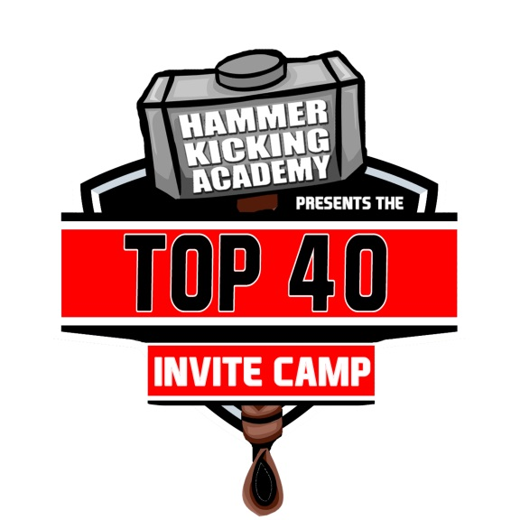
TOP 40 PLAYER ACCEPTANCE FORM

NAME: _______________________________________________________________________________
HIGH SCHOOL: ________________________________________________________________________
EMAIL: ______________________________________________________________________________
PHONE NUMBER: ______________________________________________________________________
PARENT NAME: _______________________________________________________________________
PARENT EMAIL/PHONE NUMBER: ________________________________________________________
_____________________________________________________________________________________
SHIRT SIZE: S M L XL XXL
LONG SLEEVE SHIRT SIZE: S M L XL XXL
SOCK SIZE (YOUR SHOE SIZE): _____________________

Frequently Asked Questions
Who is running instruction?
- Instruction is being conducted by the Hammer Kicking Academy led by Adam Tanalski. HKA has had great success as a high end camp, with smaller recruiting classes, and a 100 percent commitment rate. In the classes of 2014 and 2015, 128/128 seniors have committed to play in college. In 2016, EVERY TOP 40 SENIOR committed to a college before January 15th, 2016. HKA focuses on hands on recruiting and training and tries to match players with a school not a school with a player.
What is included?
- EVERYTHING. From the time you land, to the time you take off, the Top 40 Camp covers all of your transportation, food, snacks, drinks and lodging. Snappers will room with snappers, kickers will room with kickers and punters will room with punters. Breakfast is served by the hotel and will be a hot buffet with eggs, sausage, biscuits, waffles and more; including a cook to order omelet station. Lunches and Dinners will be provided by local restaurants surrounding the camp.
Can parents attend?
- Parents can always attend and are welcome on the field, as always, at our camps. The hotel we use will have limited parent rooms, but we will have hotels in the area with a TOP 40 rate.
How will this camp help my son’s recruiting?
- THIS IS THE CAMP FOR RECRUITING AND TRAINING. 100 PERCENT OF THE SENIORS AT THIS EVENT COMMITTED. THE TOP 40 HAS SET A PLATFORM FOR RECRUTING TO SEE THE BEST COMPETE AGAINST EACH OTHER OVER A 5 DAY PERIOD. This camp is to bring the best of the best together, not just the best of one camp. We want to bring together the top specialists in the country to train and compete and achieve their goals of going to a school where they can PLAY (not just be on roster) college football while getting a good education. We will make film and assist all players at the camp by teaching them how to contact colleges and create maximum exposure.
How do I pay?
- After you receive your invite, YOU MUST RSVP BY MAY 21st, 2018. After we receive your RSVP, we will invoice the parent contact via email. Checks can be mailed with the acceptance forms and should be made out to: Adam Tanalski/HKA.
- HAMMER KICKING ACADEMY
PO BOX 964
GETZVILLE, NY 14068

******THERE WILL BE PARENT ROOMS AVAILABLE AT THE EMBASSEY SUITES******

