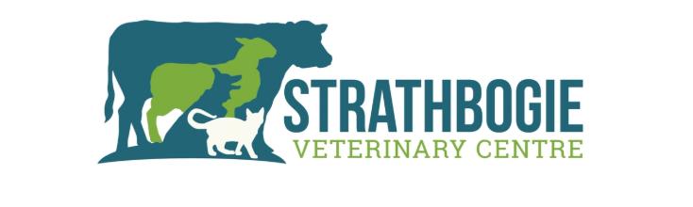
Strathbogie Veterinary Centre LTD – Mixed Vet Job Vacancy

We are an independent, progressive mixed practice in Huntly, Aberdeenshire and require an additional veterinary surgeon to join our established and supportive team.
About us
We offer a true mix of small animal, farm animal and equine with a case load comprising of 50% farm animal (beef/sheep) and 50% small animal and equine. We are an experienced supportive team (consisting of 6 full time, 2 part time vets and 3 nurses) with an emphasis on good work life balance, caring and fun work place culture.
Team work is an essential part of the job, the clinical team work closely with each other to provide excellent, contextualised clinical care across species.
Our generous holiday allowance, 4 day week and out of hours rota allows our team to have a good work life balance and enjoy all Aberdeenshire has to offer.

What we offer:
- 4 day week
- Generous 7.4 week holiday allowance
- 1:5 rota
- Competitive salary dependent on experience
- Private health care
- RCVS and VDS fees paid
- Cpd paid and areas of interest encouraged

To apply
Please send your CV and cover letter to Alasdair and Olivia at strathbogievets@gmail.com
Below is a link to our website:
Strathbogie Veterinary Centre LTD

