Two-Year, Bachelors & Masters Degree Programs in ADJ & Criminal Justice
Virginia Association of Criminal Justice Educators
AVERETT UNIVERSITY--DANVILLE, VA
Travis McKinney Cybersecurity Network Analyst
Danville Hall P (434)791-5863 Email tmckinney@averett.edu
Brian Webb Associate Professor of Political Science
Frith 417 P (434)791-7103 bwebb@averett.edu
Adrienne Brune Associate Professor of Sociology (989) 400-9143 abrune@averett.edu
Remote
BLUE RIDGE COMMUNITY COLLEGE, WYERS CAVE, VA
Matthew O’Quinn Associate Professor of Administration of Justice
(540) 453-2245 oquinnm@brcc.edu J 120B
John Wilt Sociology Adjunct Professor
(434) 770-8822 jbwilt@aumail.averett.edu
BLUEFIELD UNIVERSITY
Bluefield, VA 3000 College Drive, Bluefield, VA 24605
Business Administration—Cybersecurity
BA or BS in Criminal Justice or Cybersecurity—on-line classes available
MBA—Justice Administration
Doctorate in Business Administration—Justice Administration
Dr. Kimberly Farmer: Professor of Criminal Justice, Dean of the School of Criminal Justice, and Department Chair of Criminal Justice. (Contact: kfarmer@bluefield.edu, 276-326-4224)
Jeffrey A. Disibbio: Assistant Professor of Criminal Justice. (Degrees: B.S. from Radford University, B.S. from Bluefield University, J.D. from Regent University Robertson School of Law)

BRIGHTPOINT COMMUNITY COLLEGE
Chester Campus-13101 Route 1, Chester, VA (804)796-4000 Criminal Justice—AAS
Midlothian Campus-800 Charter Colony Parkway, Midlothian, VA 23114 (804)796-4000

Ms. Donna Anderson

Lecturer
Division of Business, Engineering, and Technology
Department of Criminal Justice
Chester Campus
Moyar Hall
Danderson01@brightpoint.edu

Ms. Vonda Basso

Lecturer
Division of Business, Engineering, and Technology
Department of Criminal Justice
Midlothian Campus
H206, Hamel Hall
Vbasso@brightpoint.edu

Ms. Sarah Brown

Associate Professor
Division of Business, Engineering, and Technology
Department of Criminal Justice
Chester Campus
M219l, Moyar Hall
Phone: 804-706-5158
Sbrown@brightpoint.edu

Mr. Raymond Louth

Lecturer
Division of Business, Engineering, and Technology
Department of Criminal Justice
Chester Campus
D108, Discovery Hall
Rlouth@brightpoint.edu

Ms. Kacie Mathews

Lecturer
Division of Business, Engineering, and Technology
Department of Criminal Justice
Chester Campus
Discovery Hall
Kmathews@brightpoint.edu
BRYANT & STRATTON COLLEGE
Virginia Beach Campus: Located at 301 Centre Pointe Drive, Virginia Beach, VA 23462 (Phone: 757-499-7900). Richmond/North Chesterfield Campus: Located at 101 Gateway Centre Parkway, Suite 210, North Chesterfield, VA 23235 (Phone: 804-745-2444). Hampton Campus: Located at 5030 Kilgore Avenue, Hampton, VA 23666
Jack Collins Joseph Elgeiser Todd Jones
(no faculty contact information published)
AAS in Criminal Justice Studies - on-line and in-person classes

DANVILLE COMMUNITY COLLEGE
AAS in Criminal Justice Studies
JC Evans
- Associate Professor of Sociology
Arts, Sciences, & Business
Career Pathway: College & University Transfer
- Office
434-797-8452
- Temple Building
- Rm 111
jonathan.evans@danville.edu
Mark Mills
CJ Instructor
Public Service & Safety
(434) 797-8585
mark.mills@danville.edu
FERRUM UNIVERSITY
Criminal Justice & Forensic Investigations
Matthew Tatum, Assistant Professor (540) 365-4494 mtatum@ferrum.edu
Jeffrey Fox Adjunct Professor jcfox@ferrum.edu
Taylor Gunter Adjunct Professor tgunter@ferrum.edu
Glen Andy Hall Adjunct Professor gahall@ferrum.edu
Jessica Mitchelle Adjunct Professor jlmitchell@ferrum.edu
GEORGE MASON UNIVERSITY
Criminology, Law & Society BA, MA & Doctorate degrees
(703) 993-8315
Forensic Science - BS
Kevin fornshill kfornshi@gmu.edu
Gwen Udell gudell@gmu.edu
James Carr jcarr20@gmu
GERMANNA COMMUNITY COLLEGE
CJ Associate Degree - AAS Cybersecurity Associate Degree
Jillian Noel, Administration of Justice Program jnoel@germanna.edu
HAMPTON UNIVERSITY
Department of Sociology, Criminal Justice & Homeland Security - BS degree
(757)-727-5338

Dr. Idonia Barrett
Assistant Professor
- idonia.barrett@hamptonu.edu
- 757-727-5733
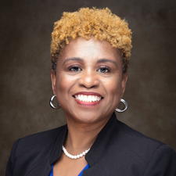

Dr. Sherree Davis
Assistant Professor
- sherree.davis@hamptonu.edu
- 757-727-5400
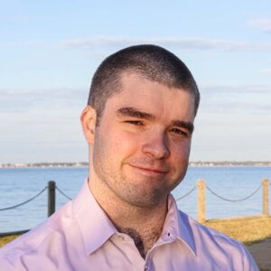

Dr. Daren Fisher
Assistant Professor
- daren.fisher@hamptonu.edu
- 757-727-5878
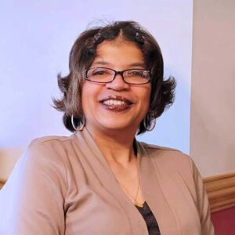

Dr. Zina McGee
Endowed Professor
- zina.mcgee@hamptonu.edu
- 757-728-6913
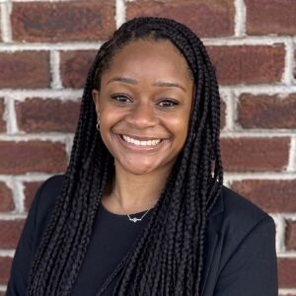

Dr. Briana Paige
Assistant Professor
- briana.paige@hamptonu.edu
- 757-727-5879
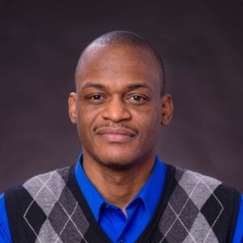

Dr. Kyshawn Smith
Associate Professor
- kyshawn.smith@hamptonu.edu
- 757-727-5348
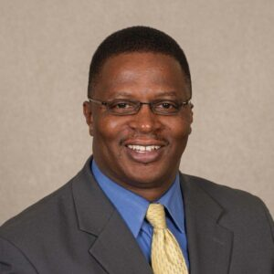

Dr. David P. Taylor
Assistant Professor
- david.taylor@hamptonu.edu
- 757-727-5648


Dr. Charlotte Winston
Assistant Professor
- charlotte.winston@hamptonu.edu
- 757-727-5467

J. SGT. REYNOLDS COMMUNITY COLLEGE
(804) 371-3000
Criminal Justice Certificate & Associates Degree
Dre’mon Miller Department Chair

LAUREL RIDGE COMMUNITY COLLEGE
(540) 351-1505
Criminal Justice/Law Enforcement – AAS Lisa Kara—Department Chair
LIBERTY UNIVERSITY

AAS, BS, MS and Doctorate Programs in Criminal Justice
1971 University Blvd. Lynchburg, VA 24515 (434) 582-2000
Faculty Members: Ben Rathsam, Amanda Trent, David Conn
LONGWOOD UNIVERSITY
Criminal Justice/Criminology (434) 395-2241
Professor, Criminal Justice
Department Chair
Criminal Justice Area Coordinator
West Rotunda 203
(434) 395-2273
beardvr@longwood.edu

Dr. Brian D. Bates
Professor, Anthropology & Archaeology
West Rotunda 222
(434) 395-2875
batesbd@longwood.edu

Dr. Lee M. Bidwell
Professor, Sociology, Sociology Program Coordinator
West Rotunda 208
(434) 395-2699
bidwelllm@longwood.edu

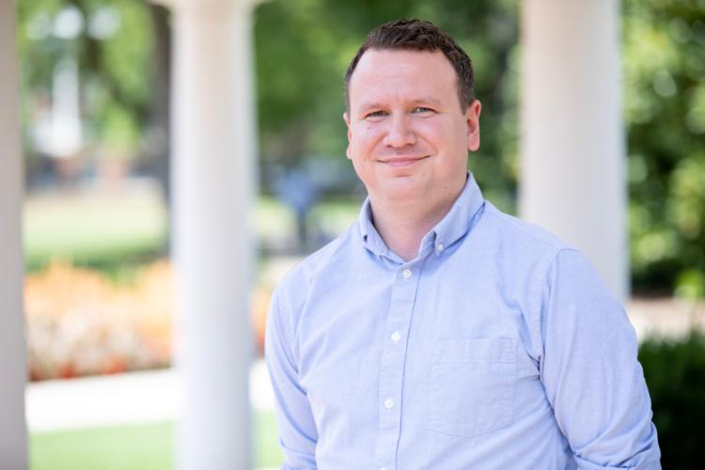Dr. Corey Call
Associate Professor, Criminal Justice
West Rotunda 204
(434) 395-2857
callcp@longwood.edu

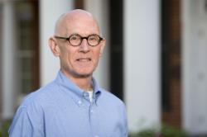Dr. Douglas M. Dalton
Professor, Anthropology
West Rotunda 205
(434) 395-2245
daltondm@longwood.edu

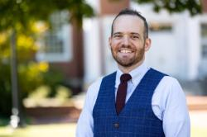Dr. Scott T. Grether
Associate Professor, Sociology
West Rotunda 201
(434) 395-2061
gretherst@longwood.edu

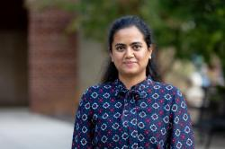Dr. Kruthi Jagadish Kumar
Assistant Professor of Criminal Justice
Rotunda 210
(434) 395-2247
jagadishkumark@longwood.edu

Dr. Mark Kostro
Associate Professor, Anthropology & Archaeology
Executive Director of the Dr. James W. Jordan Archaeology Field School
West Rotunda 218
(434) 395-2244
kostrom@longwood.edu

Dr. Hollie MacDonald
Assistant Professor, Criminal Justice
West Rotunda 209
(434) 395-2763
macdonaldh@longwood.edu

Dr. Brooke E. Mathna
Associate Professor, Criminal Justice
West Rotunda 202A
(434) 395-2027
mathnabe@longwood.edu

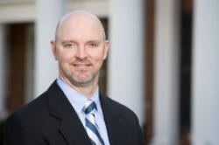Dr. Jason S. Milne
Professor, Sociology
Rotunda 202C
(434) 395-2531
milnejs@longwood.edu

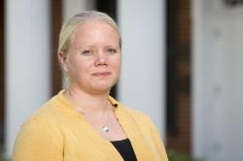Dr. JoEllen G. Pederson
Professor, Sociology
West Rotunda 207
(434) 395-2700
pedersonjg@longwood.edu

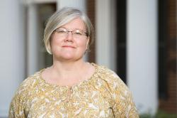Dr. Carl M. Riden
Associate Professor, Sociology
West Rotunda 210
(434) 395-2098
ridencm@longwood.edu

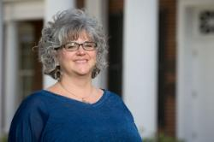

MARY BALDWIN UNIVERSITY
Stauton, VA (540) 887-7019
BA - Homeland Security & Criminal Justice
Faculty: School of Professional Studies Paige Reed pmreed@marybaldwin.edu
Andrew Raridon awraridon@marybaldwin.edu
Adjunct Faculty: Andrew Harding, Jared Browne, Jeffrey Czarnec, Tiffanie Hegerty and Timothy Martin
MARYMOUNT UNIVERSITY
2807 North Glebe Road Arlington, VA (703) 522-5600
Bachelors in Criminal Justice Cybersecurity—Graduate Certificate
(BS & MS degrees)
Full-Time Faculty
- Dr. Erik Alda: Associate Professor specializing in comparative criminology and police efficiency.
- Dr. Brooke D. Baker: Assistant Professor of Criminal Justice.
- Doshelle Miller: Lecturer in Criminal Justice.
Associated & Related Faculty
- Dr. Stephanie Ellis Foster: Professor and Interim Dean.
- Dr. Sarah Fischer: Associate Professor (focuses on juvenile justice).
- Dr. Holly Hargreaves-Cormany: Associate Professor.
- Dr. Courtney Porter: Assistant Professor (focuses on policing and juvenile justice).
Adjunct Faculty
- Kristi Shalton
- Kathy Kim
- Ina Kamenova
- Jason Kobes
- James McMichael

MOUNTAIN EMPIRE COMMUNITY COLLEGE
(276) 523-2400 AAS—Criminal Justice AAS—Correctional Services
Robert England Professor Administration of Justice
School of Health and Safety
rengland@mecc.edu
276-523-9084 | D210

NEW RIVER COMMUNITY COLLEGE

(540) 674-3600
CJ – AAS
Career Studies Certificate –CSC
Crime Scene & Criminal Investigations—CSC
Dublin - (540) 674-3600
Christiansburg - (540) 674-3610

Eric Snow—Associate Professor—esnow@nr.edu
D. Joe Davis—Adjunct Instructor—ddavis@nr.edu

NORFOLK STATE UNIVERSITY

(757) 823-8600 Department of Sociology
MA—Criminal Justice Undergraduate minor in Criminal Justice/Sociology

Carlene Buchanan Turner, Ph.D.
Professor and Graduate Program Coordinator-Urban Affairs, MA
Areas of Specialization: Sociology of Aging, Race, Quantitative Methodology, Immigration, GIS Mapping & Socio-Cybersecurity
Email: cmturner@nsu.edu
Phone: 757-823-9078

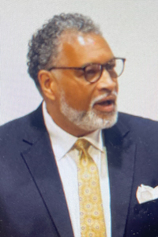Timothy D. Goler, Ph.D., MUPDD
Associate Professor & Chair, Department of Sociology
Research Director, Center for African American Public Policy (CAAmPP)
Email: tgoler@nsu.edu
Phone: 757-823-8023

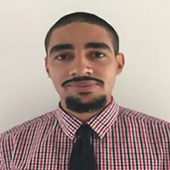Austin W. Ashe, Ph.D.
Associate Professor
Areas of Specialization: Race, Qualitative Methods, Policing, Law, Theory & Criminal Justice
Email: awashe@nsu.edu
Phone: 757-823-2144

James A. Curiel, Ph.D.
Professor
Areas of Specialization: Research Methods, Popular Culture, Race & Ethnic Relations, Urban Affairs
Email: jacuriel@nsu.edu
Phone: 757-823-8924

Michael Fischer, Ph.D.
Professor
Areas of Specialization: Criminal Justice, Juvenile Delinquency & Offender Rehabilitation
Email: mfischer@nsu.edu
Phone: 757-823-8708

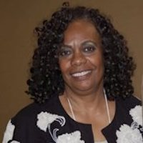Bernadette J. Holmes, Ph.D.
Professor
Areas of Specialization: Criminal Justice, Criminology, Gender, Community Development, Environmental Crime & Justice
Email: bjholmes@nsu.edu
Phone: 757-823-8263

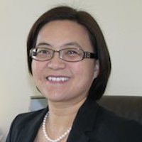Yuying Shen, Ph.D.
Professor
Areas of Specialization: Health & Health Care, Socio-Cybersecurity, Social Data Analytics, Environmental Sociology, Race/Ethnicity & Immigration, Social Organization
Email: yshen@nsu.edu
Phone: 757-823-2013
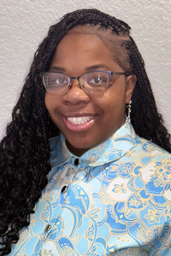Edishae L. Tyler, Ph.D.
Lecturer
Areas of Specialization: Juvenile Justice Policy and Reform; Corrections; Reentry Programs; Policy Analysis; Homeland Security; Research Methods
Email: elharris-tyler@nsu.edu

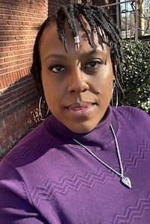Khiera Williams, M.A.
Lecturer
Areas of Specialization: Criminal Justice, Law Enforcement, Community Corrections & Juvenile Justice
Email: klwilliams@nsu.edu
Phone: 757-823-8436

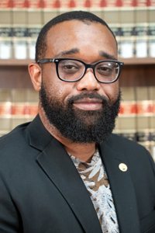Frank R. Wood Jr., Ph.D.
Assistant Professor
Areas of Specialization: Social Support, Female Drug Smuggling, Criminology Education, Quantitative Methods, Race & Inequality
Email: frwood@nsu.edu
Phone: 757-823-8931

Adjunct Faculty
Jasmine Albert, M.A.
Adjunct Professor
Email: jalbert@nsu.edu
Tishara L. Brown, M.A.
Adjunct Professor
Email: tlbrown@nsu.edu
Ricky Cabler, M.A.
Adjunct Professor
Email: rdcabler@nsu.edu
Nathaniel Chisolm, M.A., MS
Adjunct Professor
Email: nchisholm@nsu.edu
Holly E. Duckett, Ph.D.
Adjunct Professor
Email: heduckett@nsu.edu
Wynter Edwards, M.A.
Adjunct Professor
Email: weldwards@nsu.edu
Danielle Flipping, M.A.
Adjunct Professor/SSC Advisor
Email: dflipping@nsu.edu
Phone: 757-823-2094
Michael Gleaves, M.A.
Adjunct Professor
Email: mgleaves@nsu.edu
Vanessa C. Jenkins, Ph.D.
Adjunct Professor/Director of Health & Wellness
Email: vcjenkins@nsu.edu
Phone: 757-823-8173
Rhonda Moody, M.A.
Adjunct Professor
Email: rfmoody@nsu.edu
Mechelle Smith, Ph.D.
Adjunct Professor
Email: mbsmith@nsu.edu
Mykel Walton, M.A.
Adjunct Professor
Email: mkwalton@nsu.e

NORTHERN VIRGINIA COMMUNITY COLLEGE
Campuses: Alexandria, Annandale, Loudoun, Manassas, Woodbridge
Degrees: AAS & Certificate in Criminal Justice
Full-Time Faculty & Instructors
- Jo Ann Short: Professor of Administration of Justice (Contact: jshort@nvcc.edu)
- Stephen Wofsey: Professor of Administration of Justice (Contact: swofsey@nvcc.edu)
- Victoria Hill-Megginson: Criminal Justice Faculty at the Manassas Campus
- Kelly Hebron: Criminal Justice Instructor
- Sandra Sale: Criminal Justice Instructor

OLD DOMINION UNIVERSITY

(757) 683-3000 BA & BS in Criminal Justice

- Ruth Triplett: Professor and Department Chair
- Daniel Pryce: Associate Professor and Associate Chair [1]
Faculty & Instructors

Randy Gainey: Professor specializing in criminology and social policy


Mona J.E. Danner: Professor specializing in criminology, race, gender, and justice


Brian K. Payne: Professor and university administrator specializing in white-collar crime and elder abuse

PATRICK HENRY COMMUNITY COLLEGE
(276) 638-877
CJ—AAS also referred to as Administration of Justice (ADJ)
Justice Studies—CSC
Ronnie Wray (276) 656-0291 rwray@patrickhenry.edu
PAUL D. CAMP COMMUNITY COLLEGE
Franklin, VA Suffolk, VA and Smithfield, VA
AAS (ADJ) - corrections and police science
Joseph DeStefano jdestefano@pdc.edu
PIEDMONT COMMUNITY COLLEGE
(434) 977-3900
Program Faculty & Contacts
- Hillary White: Criminal Justice Technology Instructor
- George Pattishall: Director of Law Enforcement Training
- Alisa L. Montgomery: Dean of Health and Public Services

Radford University
801 East Main St., Radford, Virginia 24142
Major | CJ/Safety Studies
Riane Bolin
Acting Associate Dean, College of Humanities and Behavioral Sciences/Professor
Criminal Justice, Dept of
rbolin1@radford.edu
Hemphill Hall 5406
Stacey Clifton
Assistant Professor
Criminal Justice, Dept of
saclifton@radford.edu
Hemphill Hall 5403

Lori Elis
Professor
Criminal Justice, Dept of
lelis@radford.edu
Hemphill Hall 5028

Egan Green
Professor
Criminal Justice, Dept of
ekgreen@radford.edu
Hemphill Hall 5038

Nicole Hendrix
Professor
Criminal Justice, Dept of
pnhendrix@radford.edu
Hemphill Hall 5405

Donald Martin
Instructor, Special Purpose
Criminal Justice, Dept of
dwmartin1@radford.edu
Hemphill Hall 5401

Stephen Owen
Acting Chair, Criminal Justice/Professor
Criminal Justice, Dept of
ssowen@radford.edu
Hemphill Hall 5305
Rachel Santos
Professor
Criminal Justice, Dept of
rsantos5@radford.edu
Hemphill Hall 5311

Roberto Santos
Professor
Criminal Justice, Dept of
rsantos4@radford.edu
Hemphill Hall 5026

Lindsay Semprevivo
Assistant Professor
Criminal Justice, Dept of
lsemprevivo@radford.edu
Hemphill Hall 5403

Benjamin Wright
Instructor, FTT
Criminal Justice, Dept of
bwright59@radford.edu
Hemphill Hall 5401

Randolph-Macon College
114 College Ave, Ashland, VA 23005
Major | Criminology

Denise L. Bissler
Professor, Criminology Chair
Phone: (804) 752-7380
Email: dbissler@rmc.edu

John Carter
Adjunct Faculty, Criminology
Email: JohnCarter@rmc.edu

Brittany Freelin
Assistant Professor, Criminology
Email: BrittanyFreelin@rmc.edu

Regent University
1000 Regent University Dr, Virginia Beach, Virginia 23464
Major | CJ/Law Enforce Admin

Contact Info is not readily available on website
Stephen M. King, Ph.D. Professor, Government & Criminal Justice
Dan Koev, Ph.D. Department Chair; Professor, Government & Criminal Justice
Mary B. Manjikian, Ph.D. Professor, Government & Criminal Justice NSS Director
William T. Reddinger, Ph.D. Associate Professor, Government & Criminal Justice
Stephen A. Webb, M.S .Principal Lecturer, Government & Criminal Justice

Roanoke College
221 College Lane, Salem, Virginia 24153-3794
Major | Criminal Justice
Notes: We also have a concentration in “Crime, Deviance, and Social Control” that is out of the Sociology program. This program includes CJ classes and the CJ Department and Sociology are much intertwined--we also have a pre-law program that works closely with Political Science, all of which work directly with our CJ program.
Dr. Daisy Ball
Associate Professor, Henry H & Trudye H Fowler Associate Professor Public Affairs
Department: Criminal Justice
Phone: (540)375-5413
Location: 323 Francis T. West Hall
Email: dball@roanoke.edu

Dr. Beth Easterling, PHD
Lecturer
Department: Criminal Justice
Phone: (540)444-2042
Location: 212 Francis T. West Hall
Email: beasterling@roanoke.edu

Dr. Kristi Hoffman
Professor
Department: Sociology
Phone: (540)375-2027
Location: 201 Trout Hall
Email: khoffman@roanoke.edu

Dr. Sarah Murray
Assistant Professor
Department: Criminal Justice
Phone: (540)444-4708
Location: 307 Francis T. West Hall
Email: murray@roanoke.edu

Dr. Kristin Richardson
Lecturer
Department: Sociology
Phone: (540)375-2472
Location: 205 Trout Hall
Email: krlrichardson@roanoke.edu

Shenandoah University
1460 University Dr, Winchester, Virginia 22601-5195
Major | Criminology
Jon Gettman
Associate Professor of Criminology and Criminal Justice
Henkel, 216
jgettman@su.edu

Nicole Oehmen
Assistant Professor
Gregory 215
nicole.oehmen@su.edu
Sherie Sam
Assistant Professor
Gregory Hall, Room 202
sherie.sam@su.edu

Staci Strobl
Department Chair & Professor of Criminology and Criminal Justice
Davis 205
sstrobl@su.edu
(540) 665-5531

Southside Virginia Community College
109 Campus Drive, Alberta, Virginia 23821
Major | General CJ
Dr. Alfonzo Seward
Professor, Criminal Justice
Faculty: Career and Occupational Technologies
Phone: 434-949-1092
alfonzo.seward@southside.edu

Tidewater Community College - Virginia Beach
121 College Place, Norfolk, Virginia 23510
Major | General CJ

Albert J. Armstrong | Adjunct Faculty | Public and Professional Services and Education Pathway | Virginia Beach | aarmstrong@tcc.edu |  | ADJ
Julissa Armstrong | Adjunct Faculty | Public and Professional Services and Education Pathway | Norfolk | jarmstrong@tcc.edu |  | ADJ
Ian Bolling | Full-Time Faculty | Social Sciences Pathway | Chesapeake | ibolling@tcc.edu | (757) 822-5253 | SOC
Sadie Boone | Adjunct Faculty | Public, Professional Services & Education Pathway | Virginia Beach | srboone@tcc.edu |  | ADJ
James Cervera | Adjunct Faculty | Public and Professional Services and Education Pathway | Virginia Beach | jcervera@tcc.edu |  | ADJ
William Dean | Adjunct Faculty | Public and Professional Services and Education Pathway | Virginia Beach | wdean@tcc.edu |  | ADJ
Mary C DeLugo | Adjunct Faculty | Public and Professional Services and Education Pathway | Virginia Beach | mdelugo@tcc.edu |  | ADJ
Wallace R Driskell | Adjunct Faculty | Public and Professional Services and Education Pathway | Virginia Beach | wdriskell@tcc.edu |  | ADJ
Lisa Duez | Adjunct Faculty | Public, Professional Services & Education Pathway | Chesapeake Campus | lduez@tcc.edu |  | ADJ
Anthony Elder | Adjunct Faculty | Public and Professional Services and Education Pathway | Virginia Beach | aelder@tcc.edu |  | ADJ
Rachel Foster | Adjunct Faculty | Public and Professional Services and Education Pathway | Virginia Beach | rfoster@tcc.edu |  | ADJ
Patrick Gallagher | Adjunct Faculty | Public and Professional Services and Education Pathway | Virginia Beach | pgallagher@tcc.edu |  | ADJ
Brenda Gibbs | Adjunct Faculty | Social Sciences Pathway | Chesapeake Campus | bgibbs@tcc.edu | (757) 822-3795 | SOC
John Gregory | Adjunct Faculty | Public and Professional Services and Education Pathway | Chesapeake | jgregory@tcc.edu |  | ADJ
Don Haley | Full-Time Faculty | Public, Professional Services & Education Pathway | Virginia Beach | dhaley@tcc.edu | (757) 822-7451 | ADJ
Renee Hosang-Alleyne | Full-Time Faculty | Social Sciences Pathway | Norfolk | rhosang-alleyne@tcc.edu |  | SDV,SOC
Cassandra McDade | Adjunct Faculty | Social Sciences Pathway | Virginia Beach | cmcdade@tcc.edu |  | SOC,SSC
Leona Q McGowan | Adjunct Faculty | Social Sciences Pathway | Portsmouth | lmcgowan@tcc.edu |  | SDV,SOC
Antonio Passaro | Full-Time Faculty | Public, Professional Services & Education Pathway | Norfolk | apassaro@tcc.edu |  | ADJ
William Pearsall | Adjunct Faculty | Public, Professional Services & Education Pathway | Chesapeake Campus | wpearsall@tcc.edu |  | ADJ
Aaron Pomeranz | Adjunct Faculty | Public and Professional Services and Education Pathway | Norfolk | apomeranz@tcc.edu |  | ADJ
Allyson M Roberts | Adjunct Faculty | Public and Professional Services and Education Pathway | Portsmouth | aroberts@tcc.edu |  | ADJ
Jennifer Rouse | Full-Time Faculty | Social Sciences Pathway | Virginia Beach | jrouse@tcc.edu | (757) 822-7635 | SOC
Amy Ruedisueli | Full-Time Faculty | Social Sciences Pathway | Virginia Beach | aruedisueli@tcc.edu | (757) 822-7140 | SOC
Tiffanye Sledge | Full-Time Faculty | Social Sciences Pathway | Portsmouth | tsledge@tcc.edu | (757) 822-2400 | SOC
Brian (Kenneth) B. Strickland | Adjunct Faculty | Public and Professional Services and Education Pathway | Chesapeake | kstrickland@tcc.edu |  | ADJ
Rebecca Vonderhaar | Full-Time Faculty | Social Sciences Pathway | Portsmouth | rvonderhaar@tcc.edu | (757) 822-2365 | SOC

University of Lynchburg
1501 Lakeside Dr, Lynchburg, Virginia 24501-3113
Major | Criminology
Daniel Murphy, MJA
Assistant Professor of Criminology
434.544.8848
murphy.dg@lynchburg.edu
James Taylor, MSCJ
Assistant Professor of Criminology
434.544.8531
taylor_cj@lynchburg.edu
Kenneth Wagner, PhD, JD
Associate Professor of Humanities & Social Sciences
434.544.8465
wagner.k@lynchburg.edu

University of Management and Technology
1901 Fort Myer Drive, Suite 700, Arlington, Virginia 22209-1609

Could not find any faculty information

Virginia Highlands Community College
100 VHCC Drive, Abingdon, Virginia 24212-0828
Major | Other
Robin Widener
Professor of Criminal Justice
Criminal Justice, Arts & Sciences
276-739-2408
rwidener@vhcc.edu

Cory Lewis
Assistant Professor of Sociology
Sociology, Arts & Sciences
276-739-2559
clewis@vhcc.edu

Virginia Peninsula Community College
99 Thomas Nelson Drive, Hampton, Virginia 23666
Major | CJ/Law Enforce Admin

David Shield
Adjunct Faculty, Administration of Justice
shieldd@vpcc.edu
757-825-2808
Barry Doughty
Adjunct Faculty, Legal Studies
doughtyb@vpcc.edu
757-825-2808
Elizabeth Hansch
Adjunct Faculty, Legal Studies
hansche@vpcc.edu
757-825-2808

Kimberly Karle
Adjunct Faculty
KarleK@vpcc.edu

Kurt Mabis
Adjunct Instructor
MabisK@vpcc.edu

Virginia State University
1 Hayden Drive, Petersburg, Virginia 23806
Major | General CJ
Stephen Rockenbach
Professor of History
Interim Chair Dept. of Sociology & Criminal Justice
Assistant Dean of CHSS for Student Affairs
201F Colson Hall
P.O. Box 9036
Petersburg, VA 23806
Email: srockenbach@vsu.edu
Office: 804-524-5910
Fax: 804-524-6883

Ifeoma E. Okoye, Ph.D.
Associate Professor
202 Colson Hall
P. O. Box 9036
Virginia 23806
Phone: 804-524-2980
Fax: 804-524-6883
Email: iokoyel@vsu.edu

Virginia Tech
210 Burruss Hall, 800 Drillfield Dr., Blacksburg, Virginia 24061-0131
Major | Criminology

This list includes the entire sociology department. Bolded names include faculty who have an expertise in crime, law, and deviance.
Shannon Elizabeth Bell
sbell33@vt.edu

David L. Brunsma
brunsmad@vt.edu

Toni M. Calasanti
toni@vt.edu

Thomas Dearden
tdearden@vt.edu

Komal Dhillon
kdhillon@vt.edu

Selene Diaz
selene@vt.edu

Liora O’Donnell Goldensher
lodg@vt.edu

Laura Halcomb
lhalc@vt.edu

Anthony Kwame Harrison
kwame@vt.edu

James Hawdon
hawdonj@vt.edu

Sana Illahe
sanaillahe@vt.edu

Trevor Jamerson
wtjamers@vt.edu

Jennifer A. Johnson
jajohnson@vt.edu

Neal M. King
nmking@vt.edu

Zhuofan Li
zhuofan@vt.edu

Christine McCown
christinemccown@vt.edu

Andrew McCumber
ahmccumber@vt.edu

Sarah Ovink
sovink@vt.edu

Katalin Parti
kparti@vt.edu

Robert T. Perdue
perdue21@vt.edu

Paulo Polanah
ppolanah@vt.edu

Brittany Presson
bpresson@vt.edu

Ashley Veronica Reichelmann
avr@vt.edu

Liesel Ritchie
liesel14@radford.edu

J. Micah Roos
jmroos@vt.edu

Donna Sedgwick
sedgwick@vt.edu

Lowell Simmons
lesimmons@vt.edu

Jeff Stilley
stilley@vt.edu

Anastasia Vogt Yuan
avy@vt.edu

Heidi Williams
hmwill07@vt.edu

Dale Wimberley
dale.wimberley@vt.edu

Bonnie Zare
bonzare@vt.edu

Haiyan Zhu
zhuh09@vt.edu

Virginia Union University
1500 N Lombardy St, Richmond, VA 23220
Major | General CJ

Monekka L. Munroe
Associate Professor, Criminal Justice
804.257.5686
mlmonroe1@vuu.edu

Virginia Western Community College
3094 Colonial Ave, Roanoke, Virginia 24015
Major | General CJ
Jeff Dodson
Assistant Professor, Criminal Justice
jdodson@virginiawestern.edu
540-857-6014
Duncan D118

Wytheville Community College
1000 E Main Street, Wytheville, Virginia 24382-3308
Major | CJ/Law Enforce Admin
Jim Harrington
Associate Professor, Criminal Justice
126 Grayson Hall
(276) 223-4782
jharrington@wcc.vccs.edu

