NC OPEN PLEIN AIR EVENT
June 5, 6, 7 Workshop Paint Out 8, 9, 10
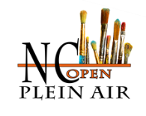 Registration Form 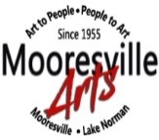
Mooresville / Lake Norman Area / North Carolina
Mooresville Arts
103 West Center Avenue
Mooresville, NC 28115

Please Print this page and mail to above address or use Pay Pal. *Required information
Name: Last_______________________ First:________________ Middle
City:___________________________ State ______________________Zip _______________
Phone (s): Home_________________ Work: ____________Cell:________________________
Any questions: Please contact us at Mooresvileartsnc@gmail.com or call 704-663-6661
Please check desired activity/activities and submit totals in space provided.
____Workshop June 5, 6, 7 with Greg Barnes $175.00
____Paint Out June 8, 9, 10 $ 25.00
Total $_________
Method of Payment:
Check______ (Make payable to Mooresville Arts)
Pay Pal_______ Date___________
Cash_____ Submit directly to Mooresville Arts at the address above with this form
Credit_____ Call or submit directly to Mooresville Arts at the above address with this form
Thank You

