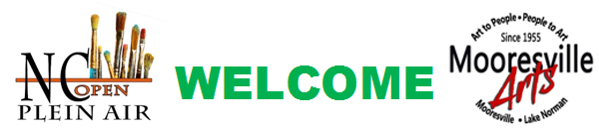

Welcome to the 4th Annual North Carolina Open Plein Air
Hosted by the Mooresville Arts, the North Carolina Open Plein Air Event, 2018, will be held
Tuesday June 5 – Sunday, June 10, 2018.
Greg Barnes will conduct a 3 – day Plein Air Workshop, June 5, 6, 7 in oils and pastels. Greg will select three sites, one for each day. A welcome after the workshop picnic will be held on Tuesday evening after the workshop.
Please see his workshop overview: The cost of the Workshop will be 175.00
Plein Air Paint Out well be June 8, 9, 10
Paint Out cost will be $25.00. Sunday will be a ½ day for painting, Preparation and an Exhibition/Reception.
(See framing opportunity at Four Corners Framing Gallery by clicking button.)
We have selected many painting sites throughout the Mooresville and Lake Norman area. A detailed list of the sites will be forthcoming. We will also have a list of restaurants and eateries, including special promotions for our visitors. The Marriott has arranged a special evening of refreshment and optional gallery display for our participants.
To be eligible for the Wet Hang Exhibition and Sale, works must have been completed during the paint out June 8—10. The canvases stamped with the official trademark, framed, wired for hanging and delivered to the Mooresville Arts Depot Gallery no later than 12:00 on Sunday, June 10.
All work must be hung by 1:00at the Mooresville Arts Depot. Judging and special purchase awards will be chosen from 1:00pm until 3:00pm. A special reception, honoring YOU, our artists and event sponsors, will be held on Sunday afternoon, June 10th, beginning at 3:00. Presentations and awards will be announced during the reception. The participating artists are invited and encouraged to leave their work for display and purchase June 10th to June 21st. People’s Choice Awards will be announced June15th
We are looking forward to this wonderful event. Thank You,
NC Open Plein Air Committee
Http://mooresvillearts.org

