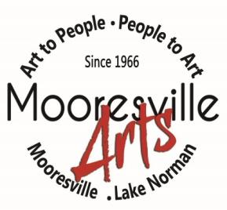Membership Application / Renewal
103 W. Center Avenue, Mooresville, NC 28115 704.663.6661 www.mooresvillearts.org
The Mooresville Arts is dedicated to the advancement of visual arts and art appreciation for the general public, through activities sponsored by the membership, to encourage and promote interest in the visual arts
Today’s Date__________________ Check#_______________________ New □ Renew □

(Please make check payable to: The Mooresville Arts)

1. Membership Type - Annual
____ $45 Regular |  |  |  | ____ $500 Corporate (2-100 employee)
____ $60 Family |  |  |  | ____ $1,000 Corporate (101+ employees)
- I would like to donate to the fundraising campaign Be a PART of Our heART $ ____________
- My employer/company has a matching gifts program. (MAG is a 501(c)(3) Organization) Yes No

2. Source of Membership
Referral – Name ______________________ |  |  |  | Workshop – Name ____________________
Competition – Show _____________________ |  |  |  | Other ______________________________

3. Member Information
Name
Street Address
City, ST, Zip
Phone
E-Mail Address
Web Address (MAG website will link to your site)
Employer

4. Art Interests
I am a WORKING ARTIST. Medium __________________________________________________________________
I am a PART-TIME ARTIST. Medium__________________________________________________________________
Art is my HOBBY. Medium__________________________________________________________________________
___ I would like to give a class. Topic: _______________________________________________________________
___ I would like to give a Demo. Topic: ______________________________________________________________

5. Volunteer Interests (we need your help!)
□ Docent | □ Building & Grounds |  | □ Fundraiser |  | □ Membership
□ Hospitality | □ Show / Set-up |  | □ other

6. Website Gallery

Your membership entitles you to a mini gallery on the MA website and each month MA selects a member to be featured as the web Member Artist of the Month. To take advantage of this benefit submit via email: your photo, brief bio and up to 6 photos of your work to: bruna@roadrunner.com

Thank you for completing this application and for joining The Mooresville Arts.

For office use only
Please date and initial: _________________________________________________________________
Membership Packet: Given to new/renew member□ __________________________________

