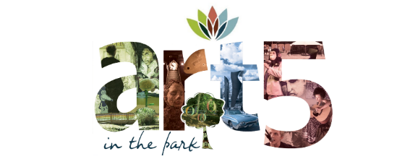

5th Annual Art in the Park
“Sculpture Art” Display & Competition

Our objective :
  - Create art based on personal expression and applied design.
  - Produce art by using a variety of processes appropriately, safely, and effectively.
  - Create a sculpture that highlights either the natural world, the waste generated by humans
using primarily recycled or waste materials.

All sculptures will be displayed on or directly around the pond at Martin Luther King Jr. Park. Your artwork will be entered in the park sculpture contest on site. We can assign an artist to help with the process either on installation day on June 1st or during your creative, brainstorming process prior to that. Please let us know if you would like artistic help. If you are an organization and want to set up a tent during the event you must produce a sculpture.

Your choice of exhibition spaces are:
a. on the ground or grass
b. hanging from a tree (must be quite light to not inflict damage to tree)
c. floating on the pond
d. hanging in or on the gazebo
e. hanging on or over the bridge over the pond

Any other locations ask the Iredell Arts Council Director.

The sites will be on a first come basis. Set up will start Saturday, June 1st at 8 AM. Sculptures on the water will need to be approved beforehand.

Consider your materials wisely for: sturdiness, opacity/translucency/transparency, hanging capabilities, weight, your message, availability, transportation. You must be able to transport your creation to the park or build on site. Consider making the sculpture in sections to be put together at the park.

Ideas to help stimulate creative process:

Discuss the themes: nature and waste that humans produce. Consider dumps, recycling bins, trash cans, waste clogging the ocean (plastics). Many are combating waste in unique ways. Look for inventive ways of people trying to solve the ocean trash problem, space waste, etc.
How can we protect nature?
What is your message? Are you trying to promote your organization or a specific thought?

The following information must be submitted to the Arts Council by May 20th if you intend to participate:

  - Artist’s name / Organization (that’s you)
  - Title of Sculpture
  - Any contact information you wish to share- may include business cards.

