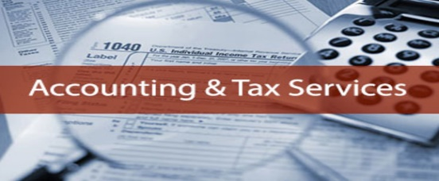
Client Information Sheet
Coupled
Smoky Lake Accounting, Bookkeeping, & Tax Services |  |  |  |  |  |  |  |  |  |  |  |  | Date: 8 April, 2020
Client Information Federal Government Protect B Form
Head of house |  | Last: |  |  |  |  |  |  | Middle: |  |  |  |  |  | First:
Address Po Box |  |  |  |  |  |  |  |  |  |  | SIN:
City, Postal code |  |  |  |  |  |  |  |  |  |  |  |  | Prov: |  |  | PC:
Date of Birth |  | Year: |  |  | Month: |  |  |  |  | Day:
Marital Status |  | Married: |  |  | Single: |  |  | Common law:
Home / Work Phone |  |  |  |  |  | Cell No: |  |  |  |  |  |  | Email:
Canadian: Y: N: |  |  | First Filing? Y: N: |  |  |  |  |  |  |  |  |  |  | Residency Change: AB. Y: N:
Volunteer Fire-Fighter: Y: N: |  |  |  | Prison Confinement: Y: N: |  |  |  |  |  |  |  |  |  | Disability Tax Credit: Y: N:
Elections Canada: Y: N: Sold Foreign Property: Y: N:
Sale of Personal Property: Y: N: Do you want to register with the CRA Online Email notification? Y: N:
Do You Authorize George B. Nylan, Accountant to file and retrieve information & Represent you with CRA? Y: N:
Partner/Spouse
Name
SIN |  |  |  |  |  |  |  |  |  |  |  | Notes:
Birth Date M/D/Yr
Home / Work Phone |  |  |  |  |  |  |  |  |  |  |  | Cell:
Email Address

Indicate here if you have any of the following
Medical receipts plus traveling more than 50klm Yes: No:
Donations to charities. Yes: No:
Other non-refundable tax deductions. Yes: No:
Note:
If you have any of these receipts you will need Total each type and text or email me your totals.

Children or other dependents you are looking after
Legal Name Birthdate S.I.N. Number Gender | Date of birth Birthdate S.I.N. Number Gender | S.I.N. number Birthdate S.I.N. Number Gender | Gender Male - Female Birthdate S.I.N. Number Gender
 |  |  | M: F:
 |  |  | M: F:
 |  |  | M: F:
 |  |  | M: F:
 |  |  | M: F:
 |  |  | M: F:
 |  |  | M: F:
 |  |  | M: F:
 |  |  | M: F:
Other information needed:
Accountability Clause
By signing this document, the are authorizing the firm of Global Office CA dba Smoky Lake Accounting, Bookkeeping, & Tax into a confidential agreement to work on your financial documents and report Tax earning and deductions to the cra on your behalf without audit.

Our firm cannot be held responsible for any Information exchanged by you the client in the accounting, bookkeeping, taxes that we process on your behalf and the client is responsible for making sure the information exchanged is correct. In Addition, our firm agrees with the Client that all information exchanged will be held in strict confidence and never divulged or released to anyone without your consent. All your information will be protected.

These agreements can be rescinded at anytime the client wishes by writing.
Please make all payments to: gbnylan@outlook.com Yes:
Head of House Print and sign: {{t:s;r:y;o:"Signer 1";}} 8 April, 2020
Spouse/Partner Print and Sign: {{t:s;r:y;o:"Signer 2";}} 8 April, 2020
Important, this is an official document. Keep a copy for yourself in a safe secured place.
Required documents need to be attached:
Two pieces of Identification: Driver’s License front & back. S.I.N. Card front & back

