Financial Statements
(Unaudited – See Notice to Reader)

26 February 2020

CONTENTS
Accounting Period:
Month Year - TO - Month Year

TABLE OF CONTENTS

NOTES PAGE NUMBER
Notice to Reader 3
Balance Sheet 4
Statement of Income 5
Statement of Retained Earnings 6
Final notes to Financial Statements 7

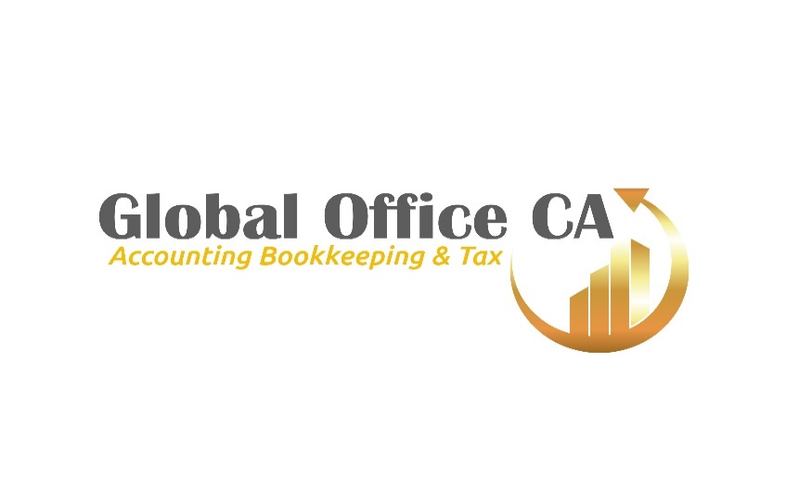

Prepared by,
George B. Nylan I.C.I.A.

___ _____

Notice to Reader(s)

The information was provided by;
the corporate management, corporation president, Treasurer/Secretary.
The following financial statements of income and retained earnings for;
Month Year - TO - Month Year
completed as per the request of the corporation.

Smoky Lake Accounting and Tax Services are not affiliated with this company and are an outside agency hired to complete these financial statements on the corporation’s behalf based on the corporation’s data. Only a compilation of data was performed.
We the agency named Smoky Lake Accounting & Tax Services have not completed any financial company audit in respect to the financial information. And accordingly express no assurance thereon and are not liable for any inaccuracies projected in these statements. Readers are cautioned that these financial statements may not be appropriate for their purpose without an audit.

George B. Nylan. I.C.I.A
Smoky Lake, AB Smoky Lake Accounting
February 26, 2020 Public Accountant

BALANCE SHEET
(Unaudited. See Notice to Reader)
Year, Month Year - TO - Month Year

ASSETS
Current Cash
Accounts Receivable
Inventory
Prepaid Deposits
Goods & Services Tax Recoverable
CAPITAL ASSETS
Buildings
Property, Land
Equipment and other assets
Vehicles
TOTAL ASSETS: | $ 0.00 | $ 0.00

LIABILITIES
CURRENT
Bank Loans
Accounts Payable and accrued liabilities
Goods & Services taxes payable
Corporate taxes payable
Payroll remittances
Property Tax payable
Short-Term & Credit Cards payable
LONG TERM LOANS
Bank 1
Bank 2
Due to shareholder loan payable
TOTAL LIABILITIES: | $ 0.00 | $ 0.00

SHAREHOLDERS EQUITY - CAPITAL
Share Capital (Deficit)
Retained / Deficit Earnings Current year
See Note 5
TOTAL: | $ 0.00 | $ 0.00

INCOME SHEET
(Unaudited. See Notice to Reader)
Month Year - TO - Month Year

REVENUE CURRENT YEAR
EXPENSES
Accounting & Legal
Advertising
Amortization Vehicles & Equipment
Bank charges, Interest, Fee’s
Bank charge backs
Equipment Rentals
Interest paid on loans
Interest Paid on Credit
Insurance Vehicles
Insurance - Life
Insurance Buildings
Permits, Fee’s, Licenses
Rent, Security, Janitor
Internet Fee’s
Insurance
License, Fee’s & Dues
Meals & Entertainment 50% allowed
Office Supplies
Postage
Property Taxes
Property Maintenance
Professional Fee’s
Tools & Supplies Mechanical
Telephone & Cell
Training
Travel, Hotels
Utilities
Electrical
Vehicle Repairs & Maintenance
Vehicle Registrations & Inspections
Wages & Benefits
Vehicle Parking
TOTAL EXPENSES:
NET INCOME/ LOSS FOR THE YEAR

Month Year - TO - Month Year

Statement of Retained Earnings
(Unaudited – See Notice to Reader)

Income / Loss
Income Tax Recovery
NET INCOME / LOSS
Deficit / Retained Earnings Beginning
Dividends Paid – Non Eligible
Dividends Paid Capital
Year End
Deficit / Income

FOOT-NOTES TO FINANCIAL STATEMENTS
- Accountant has a professional designation.
- Accountant is not connected with this corporation.
- Financial statements. conducted a compilation engagement.
- Accrual Method of Accounting used unless otherwise stated.
- Financial reporting of these statements are Unaudited, readers are cautioned.

1. Summary of accounting assets
a. Capital Assets
Capital assets are record at cost of purchase. Amortization is provided annually at rates calculate to write of these assets over the estimated useful life of the asset:
Vehicles -30% diminishing balance
Equipment -20% diminishing balance
Office Furniture & Equipment -20% diminishing balance

Questions regarding these notes:
Contact,
George B. Nylan, Accountant
Po box 312
Smoky Lake, Alberta T0A 3C0
TEL: 780-656-0551

