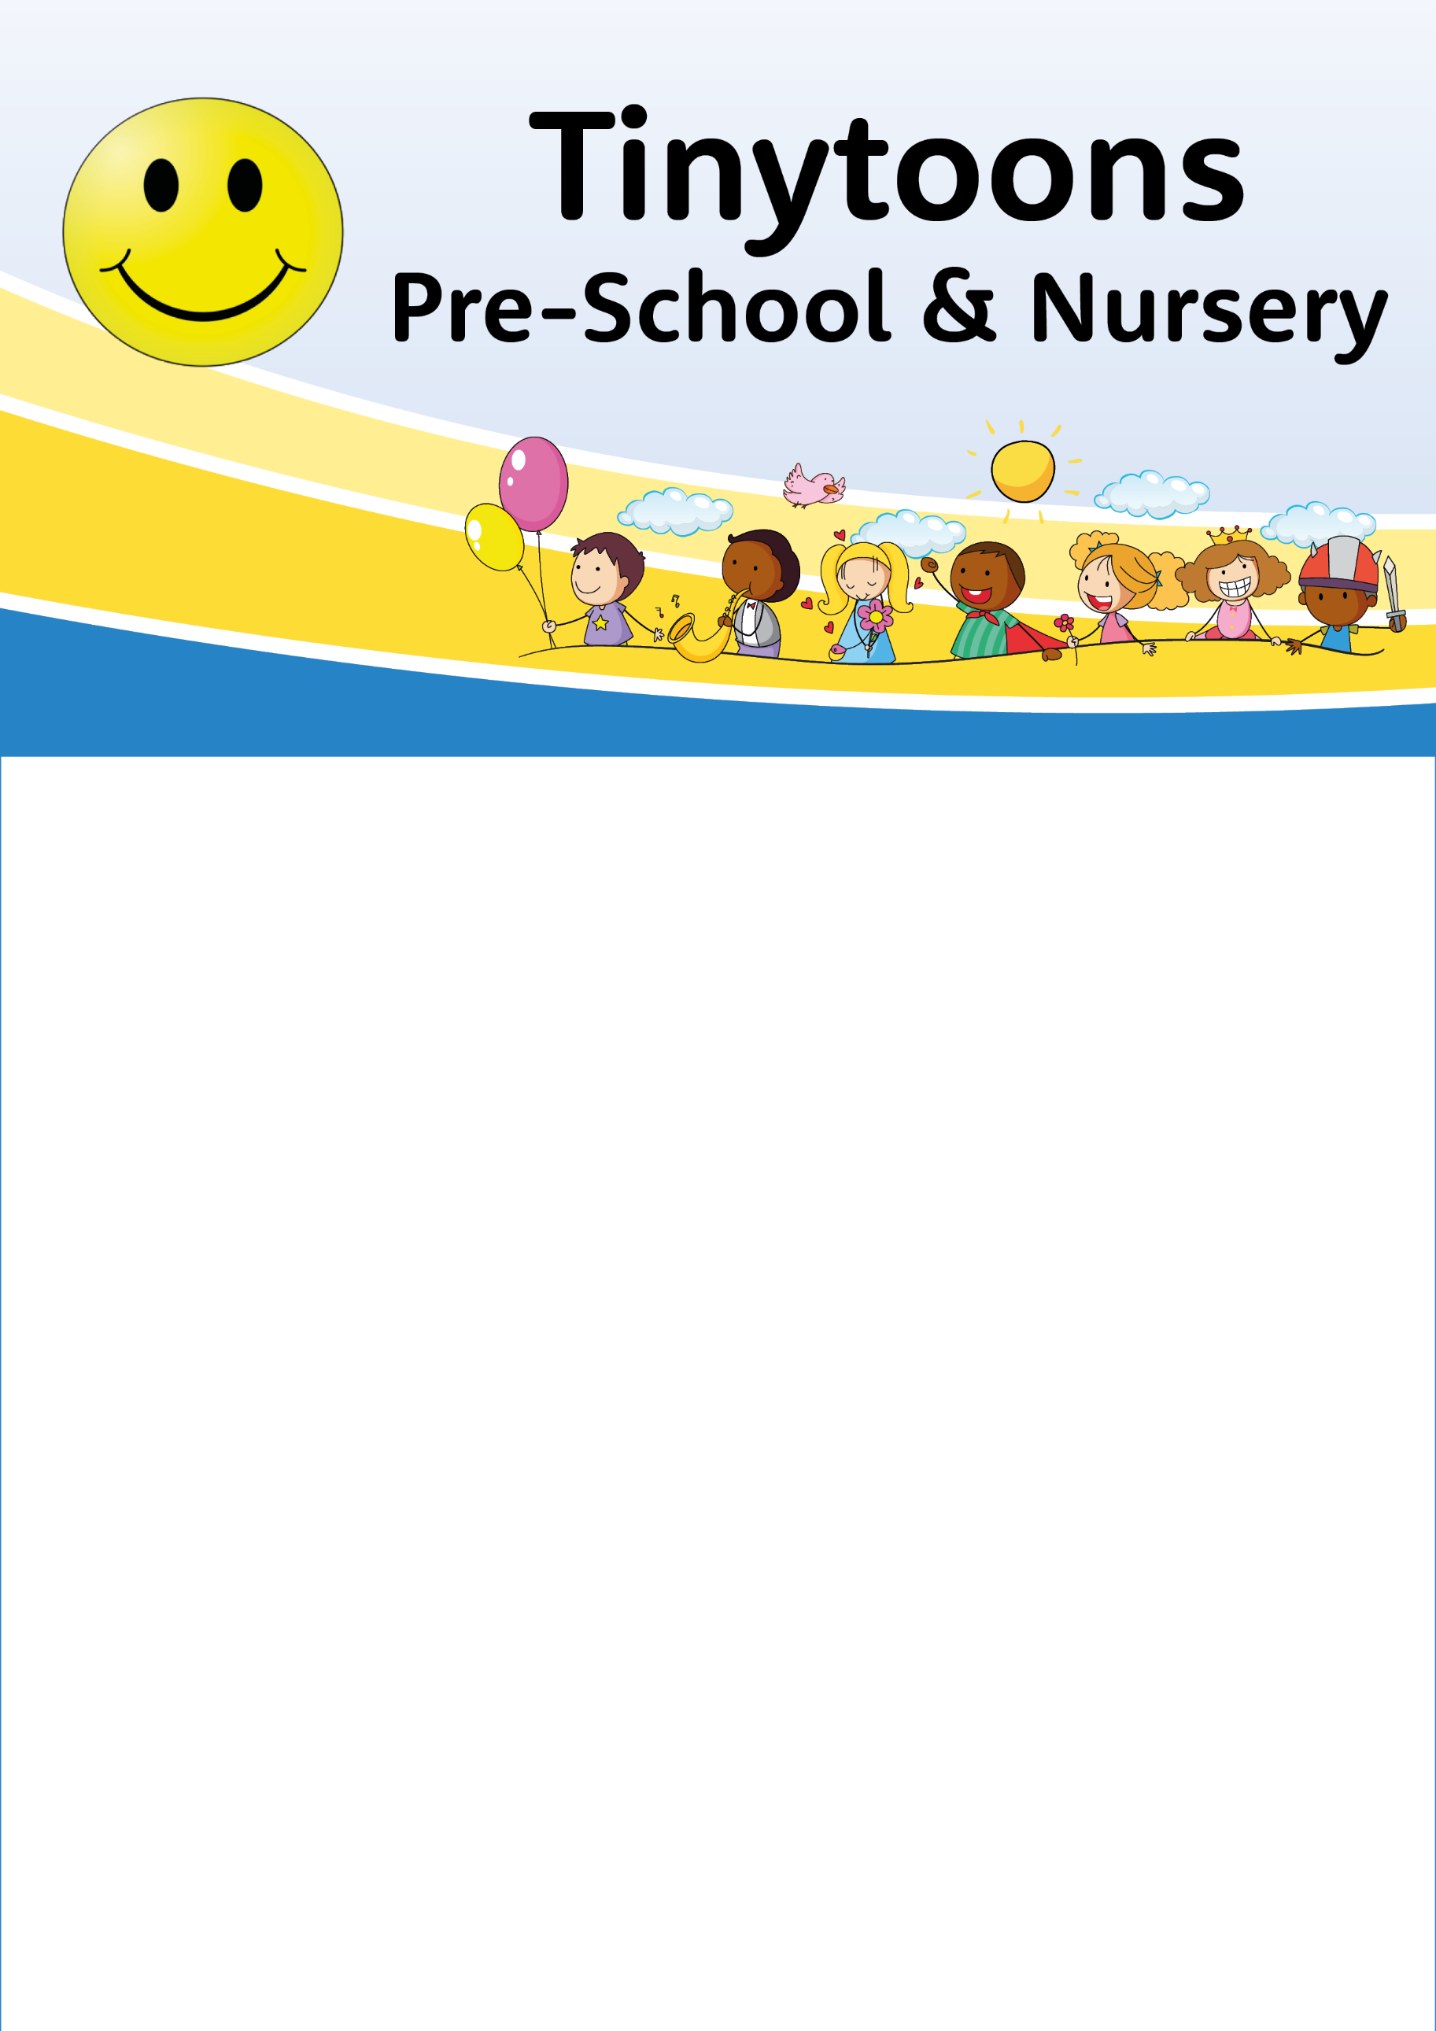

Whats on Toddlers
Monday 17th March 2025
St Patricks day
Green craft
Green activities
Outdoors - Sand play and ride ons

Monday 24th March 2025
Mothers day surprise!
Treasure basket

Outside – Sand with buckets and spades, Water buckets and brushes.

Monday 31st March 2025
Easter come and make an Easter egg picture
Find the easter egg in shredded paper.
Outside – Tents and tunnels.
07503 707153
Email tinytoonschildcare@gmail.com

