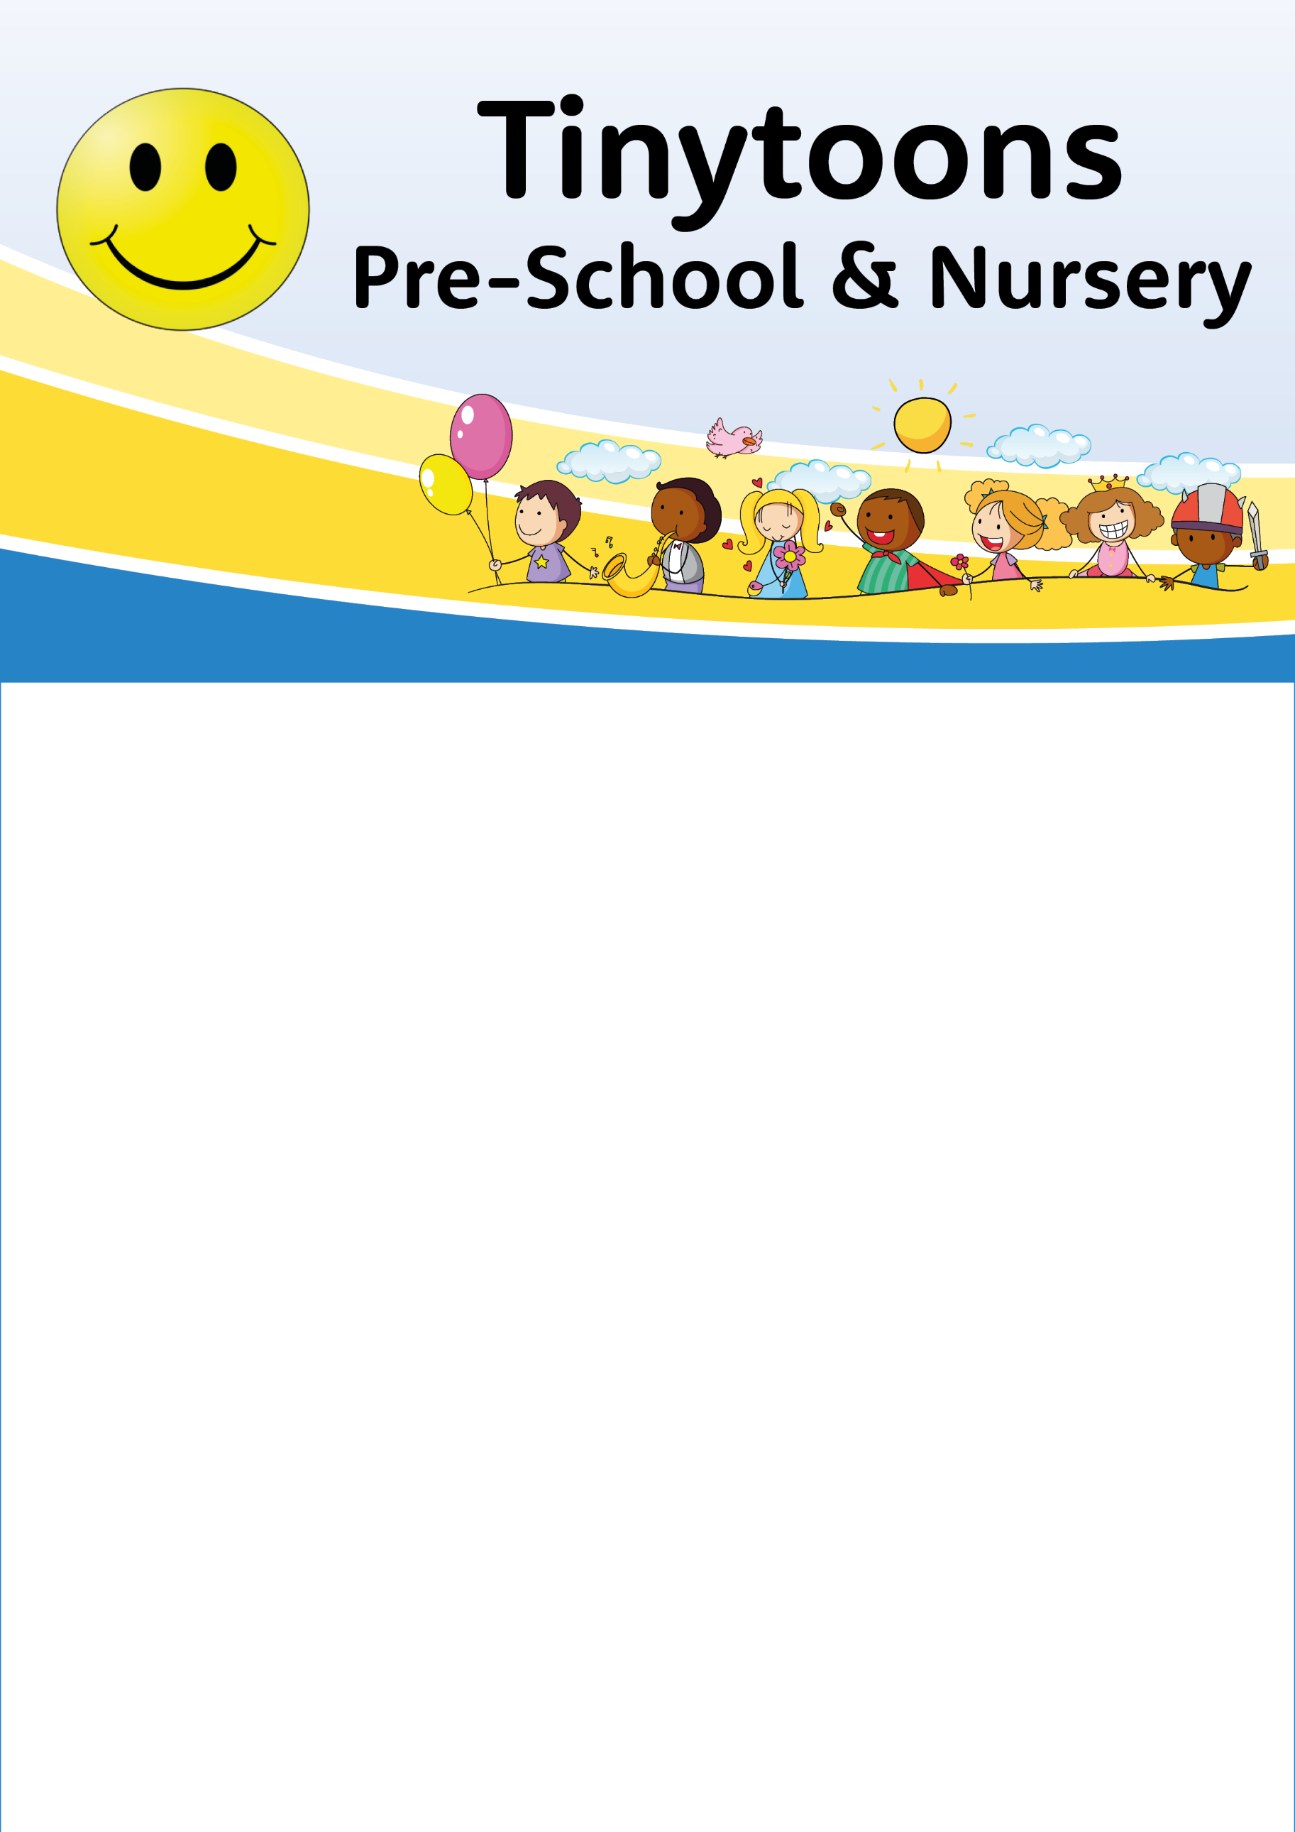

Whats on Toddlers
Monday 24th February 2025
Painting with toys, Car, bricks and animals.
Sensory toys
Puzzles
Outdoors - Sand play and ride ons

Monday 3rd March 2025
World book day!
Come along dressed as your favourite book character.
Bring you favoruite story to share.
Craft – decorate a tiger
Outside – Sand with Peppa Pig, Water buckets and brushes.

Monday 10th March 2025
Come and make a paper plate pirate ship
Tents and tunnels, Playdough
Outside – Water play, Ball games.
07503 707153
Email tinytoonschildcare@gmail.com

