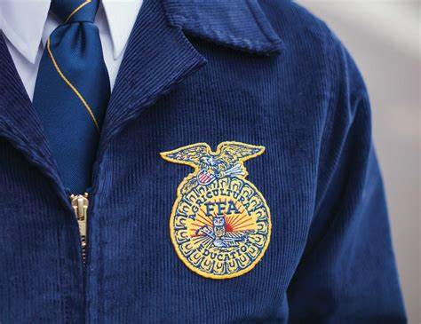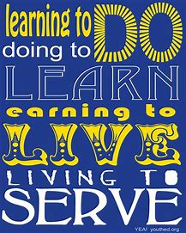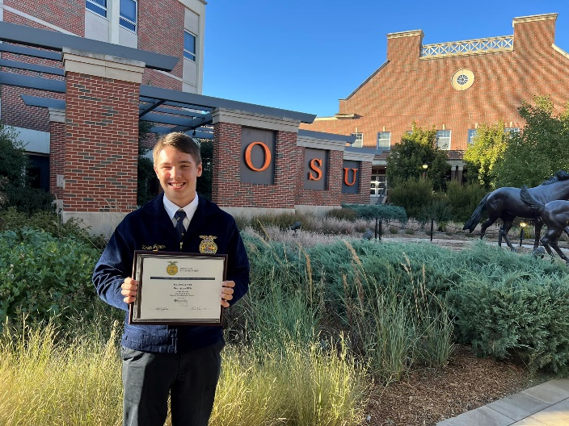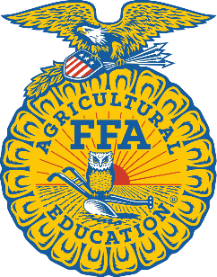

Name: Kaden James

Chapter: Wellston FFA

State: Oklahoma

Interests: Cattle, FFA, speeches

***I believe in the future of agriculture, with a faith born not of words but of deeds.***

From Agriculture to advocacy: spreading the message

Hello! My name is Kaden James, and I am from the Wellston FFA chapter in Oklahoma.

Agricultural Education and the FFA are some of the most important things to many of its members; striving for premier leadership, personal growth, and career success.

This newsletter will a communication method, in order to increase awareness about the agricultural industry, where we can believe in a faith born not of words but of deeds.

Any stories YOU want to share, send here, kadenlukejames@gmail.com

Advocate In Action

Kaden James

*“No race can prosper until it learns that there is as much dignity in tilling a field as in writing a poem”*

*-Booker T Washington*