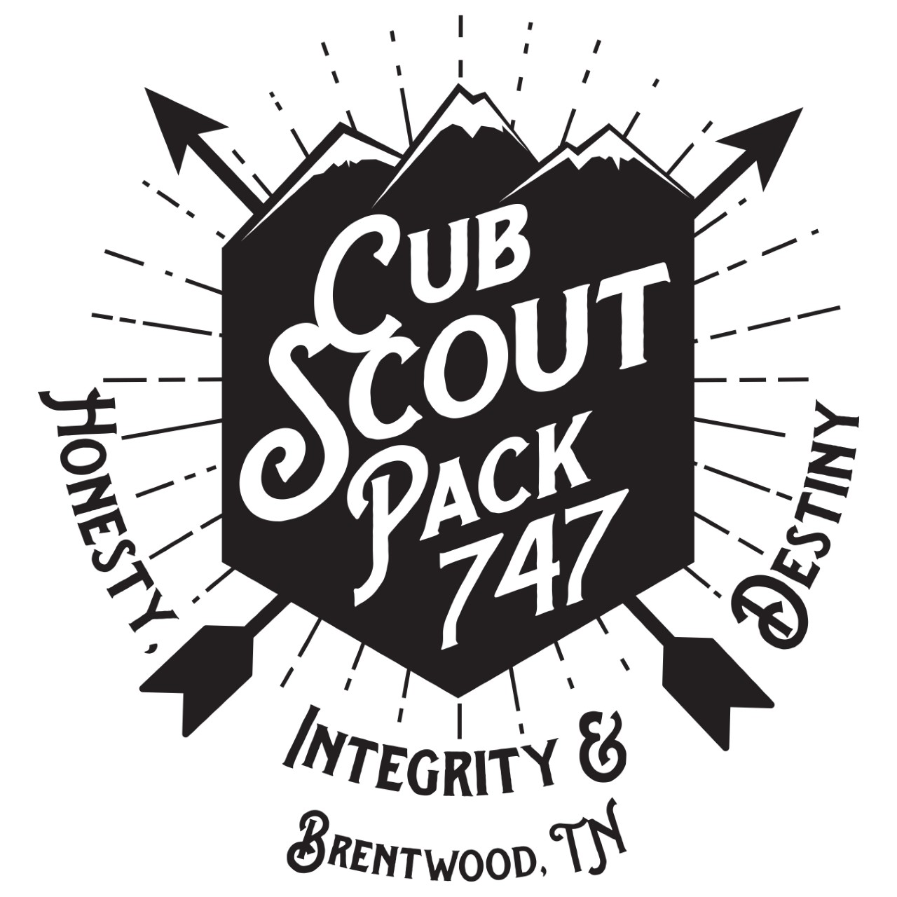

2019 Popcorn Fundraiser

Welcome to the Scout Pack 747 popcorn fundraiser for 2019. We hope this is a fun and rewarding experience for all scouts.

How does selling popcorn help the pack?
- Helps cover most of the camping costs and food.
- Covers most of the awards and supplies for scouts throughout the year.
- Provide pinewood derby cars and track rental.
- Keeps pack dues low. Dues = $80. Average cost per scout is $300-350

How does selling popcorn help the scout?
- Helps develop communication and sales skills.
- Helps develop confidence.
- Helps develop math skills, and handling money.
- Helps scout learn how to set and achieve goals.

Tips on How to Sell
- Wear class A uniform.
- Smile and introduce yourself – keep eye contact.
- Ask if they would like to support scouting through buying popcorn.
- Know the flavors, be ready to suggest a favorite.
- Tell them when orders will be delivered (November 11)
- Always say “Thank You”

Key Points
- Payments: Cash, Check (payable to “Pack 747”) and Venmo (scout-pack747-tn)
  - If paying by Venmo, please have them comment your name.
- Estimated Delivery: Monday, November 11

