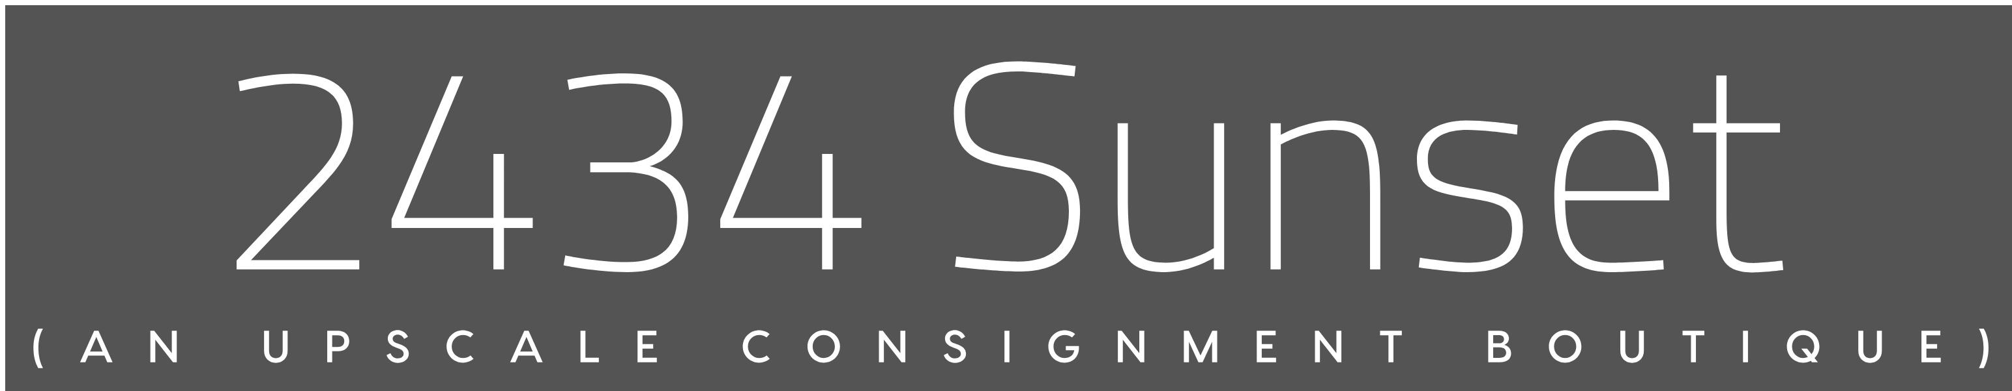

Thank you for your interest in consigning your designer items with 2434 Sunset. We look forward to working with you!

We accept contemporary and high-end designers. Our focus is on merchandise you would see at Neiman Marcus or Saks, including designers, such as Alexander Wang, Celine, Chanel, Chloe, DVF, Gucci, Hermes, Milly, Rag and Bone, Ulla Johnson, Valentino, Vince and more. We feature everything from clothing and handbags to shoes and accessories. We will be offering a selection of cocktail and black tie dresses as well so don’t forget them! We do not accept designer knockoffs.

We offer a 50% split of the final selling price. Items need to be current (usually 2 years or less), cleaned, pressed, in excellent repair and on hangers. Items should be free of pet hair, fragrance and/or smoke odors.

We select your items and then send pricing for your approval before they go onto the sales floor. Chanel and Hermes demand a higher return so we are open to discussing a different pricing structure for those items.

We want to make this process easy for you so email us to make an at-home pick-up appointment. Usually merchandise remains on the floor for 90 days at which point we either take a markdown with your approval or we can deliver the merchandise back to you. Due to our delayed opening, we are dating the merchandise for 120 days starting on June 1, 2018. Payments are made on a quarterly basis.

Please let us know if you have any additional questions about our consignment services. You can reach me at jennifer@2434sunset.com . Also be sure to visit our website www.2434sunset.com and subscribe. Thank you and we look forward to hearing from you!

Cheers,
Hollie + Jennifer

