# Core Values Work

**Instructions**

This journal is to support and help develop your individual and personalized treatment plan. This is information that is typically reviewed prior to CBT, EMDR and Hypnotherapy activities and discussions. Completing this journal mindfully will significantly shorten the time and cost of therapy. The pages below will ask you to reflect and identify recurring negative core values “intrusive negative thoughts”, feelings and emotions will provide a launch point for our work and journey together. Our work will be to identify these and change related habituated behavior associated with them.

This process will also provide a greater understanding of how working with core values + feelings + emotions collectively allow us to identify relevant memory networks. Memory networks then lead to touchstone memories, turning points that may have created early life coping strategies that worked well when we were 5 years old, 11 years old, or 16 years old that worked well then but no longer serve us well now. Again, to identify these and change related habituated behavior associated with them.

Think of this as a significant journaling exercise with a strategic purpose. This will also open opportunities for deeper psychoanalytical and philosophical conversations during therapy.

[When complete upload a copy of the finished document](https://my-therapist.na4.documents.adobe.com/public/esignWidget?wid=CBFCIBAA3AAABLblqZhA_F4vX1_FeR2d5DYS-86pDlYh7i98fi8B56z7rWmMeli8hz6v2oayn-WCJvyUD0FU*)

[using this link.](https://my-therapist.na4.documents.adobe.com/public/esignWidget?wid=CBFCIBAA3AAABLblqZhA_F4vX1_FeR2d5DYS-86pDlYh7i98fi8B56z7rWmMeli8hz6v2oayn-WCJvyUD0FU*)

[](https://my-therapist.na4.documents.adobe.com/public/esignWidget?wid=CBFCIBAA3AAABLblqZhA_F4vX1_FeR2d5DYS-86pDlYh7i98fi8B56z7rWmMeli8hz6v2oayn-WCJvyUD0FU*)

Step 1 of 3: What is My Negative Core Belief

Read all of the core beliefs below and highlight only **three** that you related to, meaning those that resonate with you the most. Hint, you can use the highlighter option or change the color of the font to indicate your choices.

|  |  |
| --- | --- |
| **Greatest Hits List of Negative & Positive Cognitions Negative Core Belief** | **Positive Future Belief** |
| **Self-Defectivemess (Self-Worth/Shame)** | |
| I am bad. | I am good / I am innocent. |
| I am unloveable. | I am loveable. |
| I am not good enough. | I am good enough. |
| I am incompetent. | I am competent. |
| I don't matter. | I do matter. |
| I am a bad person. I am terrible. | I am a good person. |
| I am defective. | I am whole. |
| I am worthless and inadequate. | I am worthy. |
| I am insignificant and not important. | I am significant and important. |
| I deserve to die. | I deserve to live. |
| I deserve only bad things. | I deserve only good things. |
| I am stupid. | I am smart. |
| I am different. | I am special. |
| I am a failure. | I am a success. |
| I am ugly, my body is ugly. | I am beautiful, my body is sacred. |
| Am alone. | I am supported. |
| **Responsibility Action (Action/Guilt)** | |
| It's my fault. | I learned I can learn from it. |
| I should have done something. | I did the best I could. |
| I am unforgivable. | I can forgive myself and move on. |
| I am a horrible person. | I am okay, inspired by my mistake. |
| I am inadequate and weak. | I am adequate and strong. |
| I should have known better. | I did the best I could. |
| I did something wrong. | I did do my best. |
| I am to blame. | I am blameless and not at fault. |
| I cannot be trusted. | I can be trusted. |
| My best is not good enough. | I am okay and will do my best. |
| **Safety Vulnerability** | |
| I am vulnerable. | It's over, and I am safe now. |
| I am going to die. | I am safe now. |
| I am not safe. | I am safe now and create my sense of safety. |
| I can't trust. | I can learn to protect myself. |

I have my own:

Step 2 of 3: What does it feel like?

When more than one negative core belief feels correct, think back to an earlier age or event that triggers the emotion you feel today. And calming close your eyes, do a body scan and describe where you feel it. Enter your response in the area with the purple text.

# Autonomic Nervous System

The autonomic nervous system is responsible for automatically controlling your body functions. It has three branches:

Figure 1 - Psychology Tools. (2020) Automic Nervous System

**Consider This Important**

1. The sympathetic nervous system is activated in response to stress. It controls 'the 'fight or flight'' responses.
2. The parasympathetic nervous system is activated during calm times. It is often considered the 'rest and digest' or 'feed and breed' system. It promotes growth and energy storage.
3. The enteric nervous system­ controls the gastrointestinal system.
4. It is possible that just a feeling can trigger an unconscious thought.

# Creative Ways to Describing Feelings

Part of this exercise is to bring awareness to your feelings connected to the memory network you are describing. And to build a vocabulary to describe feelings. You mustn't confuse emotions to express feelings. To better understand the difference between feelings and emotions, download the emotions wheel and avoid using those words. Then, use the exercise below to describe feelings. Enter your response in the area with the purple text.

Close your eyes and do a body scan and ask yourself.

Where is it in my body?

What size is it?

Can you imagine it in colour?

Does it have a size?

Does it have a shape?

Does it have a motion?

# EMOTIONS

Step 3 of 3: What emotions are involved?

When more than one negative core belief feels correct, think back to an earlier age or event that triggers the emotion you feel today. And calming close your eyes, do a body scan and describe where you feel it. Enter your response in the space for the text below the emotions wheel.

# Consider This Important

1. For purposes of reflecting and healing it is important to distinguish the difference between a feeling above and an attached or related emotion.
2. It is possible that just a feeling can trigger an unconscious thought along with an emotion. Along with the emotion a memory network may mesh together.
3. Use the chart below to describe the emotional involvement that are paired with the body feelings above.

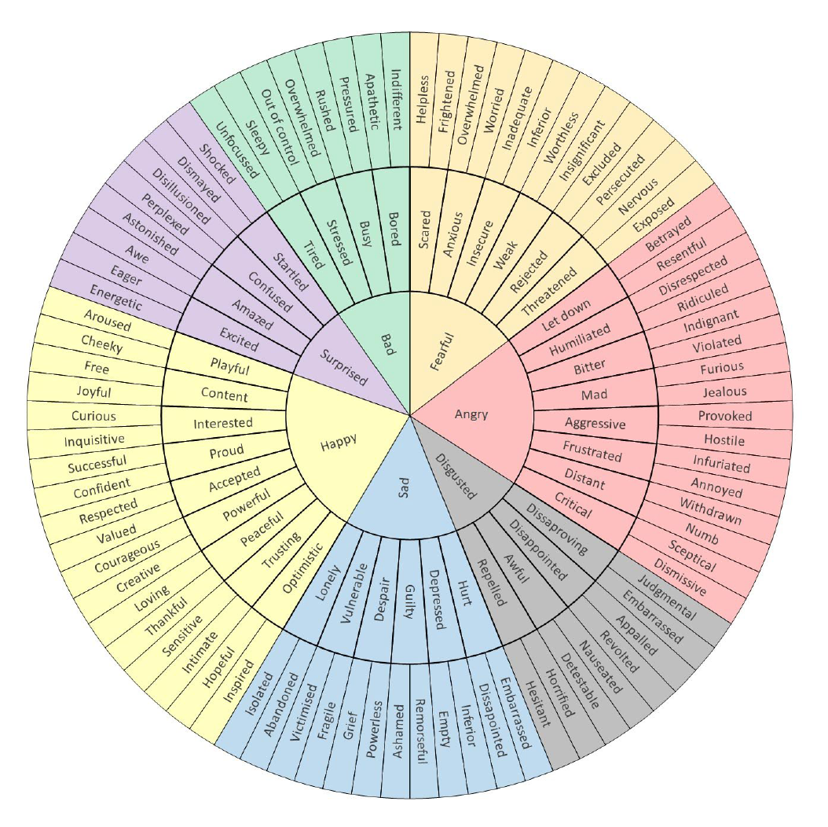

Close your eyes and do a body scan and ask yourself.

What emotion(s) are paired with the feelings noted above? Example, when I feel my throat constrict, I feel sad, guilty and fragile.

What are the emotions you experience?

Congratulations you are done, now upload the document using the link on page 1 of this document.