

Contractor Foreman & QuickBooks Intersystem Workflow (After Integration) - Estimate, Project, Expenses, Invoicing and Payment Management. Best Practices.
1. Creating and Managing Estimates
- Create all Estimates in Contractor Foreman.
- Set the estimate title as If it was the project name.
- Add items from the cost items database (materials, labor, etc.) or create manual item. *Make sure that every item on an estimate has a dedicated cost code assigned to it. If a cost code is not assigned to each item on the estimate, it will not sync correctly to QuickBooks and it will likely affect things from syncing throughout the project process. QuickBooks will sign a generic cost code “Sales” to any missing cost codes on any transactions which will sink back into Contractor Foreman.
- Set markup prices to determine profit margins.
2. Approving and Converting Estimates into Projects to Sync to QuickBooks Online
- Send the estimate for customer approval.
- If the estimate is “Approved”, it automatically creates a project in Contractor Foreman and simultaneously syncs to QuickBooks. If the project is denied it will not sync anything to QuickBooks Online.
  - Note: You should never see an unapproved estimate sync into QuickBooks unless a project gets created first and estimate approved manually. The recommended workflow is to let the approval process create the project then sync it to QuickBooks or you will end up having to go back into QuickBooks Online to delete the Project later if the customer denies the estimates created later.
- The project will then appear as a sub-customer to start in QuickBooks, linked to the estimate. (Any time a project gets created in Contractor Foreman it will create a sub customer in QuickBooks Online.
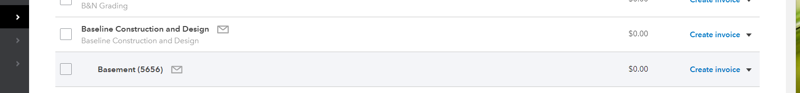

- You will then need to convert the sub customer to the “Projects” module by going to the “Projects” module in QuickBooks and in the right top corner under New Project drop down arrow select “Convert from sub customer.”
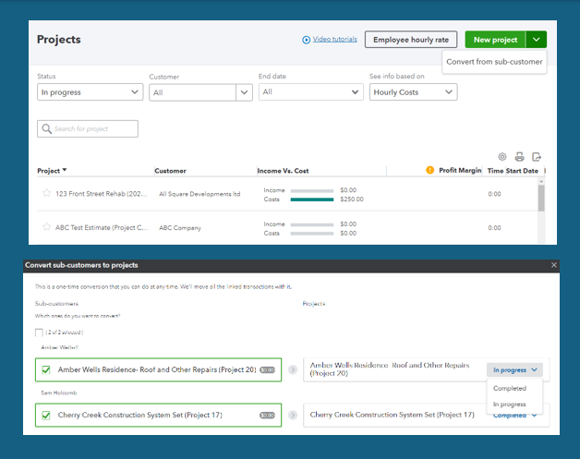
Select the sub customer you want to convert, select the status and hit convert. Once this is done everything going forward on this project will sync between projects in Contractor Foreman and QuickBooks.

As explained in the video above any projects that remain a sub-customer will force all expenses and bills in QuickBooks Online to be marked billable regardless of project type. This is a QuickBooks Online system default and can’t be changed. Converting them to projects prevents this from being forced.

3. Tracking Project Related Costs via Bills and Expenses
  - Enter each project’s related bills and expenses in Contractor Foreman, assign cost codes (Required to Sync to QuickBooks). However, once these bills sync you can still pay a vendor through the pay bills module in QuickBooks by selecting the multiple bills to create one check or scheduled payment.
Note: Vendor Credits applied to Invoices from a supplier should be entered into QuickBooks Online through the Vendor credits module and these will sync to CF as a credit against the projects. You can’t enter a negative expense into QuickBooks Online so any vendor credits entered CF first or especially a negative expense entered CF will not sync to QuickBooks Online because QuickBooks Online does not except negative values.
  - Contractor Foreman does not support Bills from QuickBooks that are associated with multiple projects (i.e., split transactions are not supported). This means if a single bill in QuickBooks is split between more than one project, it will sync back into Contractor Foreman as one lump sum bill to ONLY the first project listed on that split bill from QuickBooks.
  - If you choose to still enter bills into QuickBooks after integration, then these must be entered as multiple bills on a per project basis to sync successfully to Contractor Foreman.
  - QuickBooks Online Bank Transactions (feeds) in QuickBooks: When categorizing transactions in QuickBooks; for it to sync to Contractor Foreman and apply to a project it must be assigned to a project not just the customer for it to sync. Overhead expenses will not sync if you do not assign a project to the expense in QuickBooks.
4. Timecards
  - Use timecards in Contractor Foreman to log hours and labor costs based on gross wage or burden rates assigned in each employee’s directory card in CF.
  - Timecards in Contractor Foreman do not reflect true financials in QuickBooks. Only payroll will reflect true financials in QuickBooks. Payroll taxes and wages do not sync back into CF.
  - Note that Journal Entries do not sync to Contractor Foreman. Never enter payroll details from a third-party payroll vendor as a bill or expense in QuickBooks with multiple projects or they will sync and lump all to one project in CF (see bill and expenses)
  - For Timecards to sync correctly to QuickBooks Online reports there must be three factors connected between systems. The employees, the projects, and the cost codes are connected, assigned, and linked between systems or that timecard will not sync and throw the reporting off in QuickBooks Online

6. Create all invoices in Contractor Foreman
  - After integration, QuickBooks will no longer house any cost items such as your materials, equipment, and labor items. Therefore, all estimates/invoices should be created in Contractor Foreman. Then, they can sync to QuickBooks Online to be invoiced if customer is using QuickBooks Online payments or invoicing from QuickBooks Online.
  - Invoices will sync to QuickBooks once an invoice hits the “Submitted” stage in Contractor Foreman.

5. Receiving Payments in Contractor Foreman
  - Always mark invoice payments in CF as "Verified" to mark the invoice paid in QuickBooks.
  - Or confirm payment in QuickBooks, and it will sync back to Contractor Foreman as verified, avoiding payment duplicates on projects.
Any other status will not alert QuickBooks Online, and this can lead to double payments applying to CF projects.

8. Handling Change Orders & Work Orders
- Create change orders/work orders only in Contractor Foreman
- Assign change orders/work orders to the project’s SOV in Contractor Foreman.
- Change Orders and Work Orders need to be invoiced through the Schedule of Values to sync to QuickBooks financial reports.
9. Troubleshooting & Best Practices Recap
- 90% of all syncing and integration related problems are tied to either cost codes not being assigned to ALL cost items on transactions in Contractor Foreman or intersystem workflow and not understanding the different system rules and best practices.
- When entering any transactions into Contractor Foreman before leaving the page verify that it syncs to QuickBooks at the bottom of the page where the transaction log information is recorded. Make sure that if you anticipate any transaction to sync to QuickBooks that the transaction is in the correct stage to sync and/or that all Cost codes are assigned. If you do not see synced to QuickBooks time stamp after refreshing the screen, then check the transaction log under the menu in Contractor Foreman.
- It’s best practice to enter all project related expenses and bills in Contractor Foreman and allow them to sync to QuickBooks to where you can then send them out for payment or make payments.
- If using bank transactions in QuickBooks, make sure that anything entered in Contractor Foreman and syncs to QuickBooks has a matching bank feed to avoid duplicating transactions in bank reconciliations.
- Always check the transactions in Contractor Foreman before confirming transactions in QuickBooks as allocating the wrong payment method in Contractor Foreman can create a non-match in the bank feeds of QuickBooks.
- Avoid using “Rules” in QuickBooks on anything that can be tied to a project in Contractor Foreman. This will cause the bank feed to automatically categorize transactions that might otherwise match what comes over from Contractor Foreman and creates double expensing.

