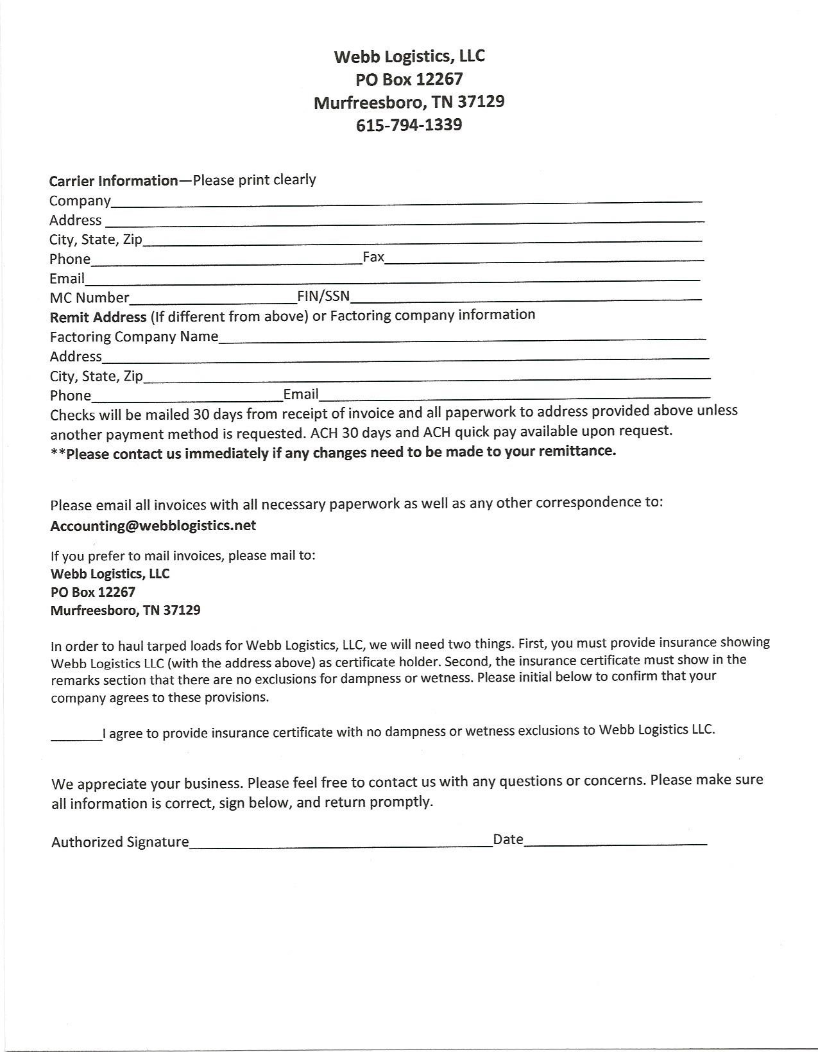

**Webb Logistics LLC**

**PO Box 12267**

**Murfreesboro, TN 37130**

Broker arranging for the transportation of freight by motor vehicle

**Agent Information**

**Mike Webb**: 615-794-1339; mobile 615-400-8195

Email: mike@webblogistics.net

**License Number:**

529905

**Surety Bond:**

Aspen American Insurance Company

Bond # SU62433

**Please send all invoices to:**

Accounting@webblogistics.net

Or

Webb Logistics LLC

PO Box 12267

Murfreesboro, TN 37130

**Banking:**

Franklin Synergy Bank

One East College Street

Murfreesboro, TN 37133-7100

615-278-7100

Carrier References available upon request.

***Webb Logistics LLC***

***6852 Pulltight Hill Rd***

***College Grove, TN 37046***

# Brokerage Agreement

This agreement is made and entered on this _______ day of ____________________20______ for and between WEBB LOGISTICS LLC, MC-529905. (“Broker”) and _________________________________, MC_________________(“Carrier”).

Carrier warrants that it is fully insured with no exclusions for damage or loss due to wetness or dampness. Please initial below:

**\*\*____________INITIALS in agreement that there will be no exclusions in insurance coverage for damage or loss due to wetness or dampness.**

**WITNESSETH**

WHERAS, Broker is a licensed property broker authorized to arrange for interstate motor carrier services at Docket #MC529905; and

WHERAS, Carrier warrants that it is licensed, authorized, and insured by FMCSA to conduct interstate motor carrier service pursuant to Docket Number MC-___________________; and

WHERAS, Carrier warrants that it is insured fully with no exclusion for wetness or dampness

WHERAS, Broker desires to retain from time to time carrier services to meet the distinct needs of its customers; and

WHERAS, the Parties desire to establish this Agreement as a contractual protocol pursuant to which services will be rendered by Carrier; and

NOW, THEREFORE; the Parties agree as follows:

## 1. TERM

The term of this Agreement shall be one (1) year commencing on the execution date below and shall automatically renew for successive one (1) year terms unless cancelled by either party on thirty (30) days written notice.

## 2. RATES AND PAYMENT

All Rates shall be agreed to in a signed written statement prior to dispatch. The signed rate confirmation and this contract shall constitute all the terms and conditions. Broker shall endeavor to pay Carrier within thirty (30) days after submission by Carrier and receipt by Broker of signed rate confirmation accompanied by original proof of delivery showing delivery in good order.

## 3. OVERCHARGE/UNDERCHARGE

Overcharge and undercharge claims shall be subject to the provisions of 49 C.F.R.378 and must be filed within one hundred eighty (180) days.

## 4. INSURANCE

Carrier warrants that it shall maintain the following insurance insuring to the benefit of Broker and its customer. A. General liability insurance in the amount of one million dollars ($1,000,000.00) per occurrence.

1. Bodily injury and property damage insurance in the amount of one million dollars ($1,000,000.00)_ (Form BMC91X on file with FMCSA).
2. Worker’s compensation insurance as required by applicable state law.
3. All risk motor cargo insurance in the amount of not less than one hundred thousand dollars ($100,000.00) per occurrence, with no restriction or limitation as to equipment used, nature of damage or loss.

BROKERAGE AGREEMENT—WEBB LOGISTICS LLC INITIALS_________

1. Trailer interchange endorsement of applicable broker owned or leased trailer equipment: covering physical damage up to replacement costs in the amount of not less than thirty thousand dollars ($30,000.00) per trailer. F. Carrier shall have no exclusions for any damage or loss due to wetness or dampness.

G. Carrier shall name Broker as an additional named insured on A, B, E, and F above and as a loss payee on D above. Carrier shall provide Broker with suitable evidence of coverage.

## 5. INDEMNIFICATION

Carrier shall release, defend, indemnify, and hold harmless Broker against all loss, liability, damage, claim, fine, cost, or expense, including reasonable attorneys’ fees, arising out of its negligent or willful acts in the performance of this Agreement or arising out of breach of any warranty contained herein.

## 6. FREIGHT LOSS OR DAMAGE

1. Carrier shall be liable for cargo loss or damage in accordance with the Carmack Amendment, 49 U.S.C. 14706, subject to a maximum liability of $100,000 per occurrence unless otherwise agreed in writing. Carrier agrees to pay, contest, or settle all claims within 30 days of submission and agrees to binding arbitration of claims at Broker’s request.
2. All shipments shall be loaded and counted by Carrier unless otherwise agreed in writing.

## 7. SERVICE PERFORMANCE AND FAILURES

Carrier shall provide reasonable dispatch in accordance with the terms and conditions of the Uniform Bill of Lading. Upon breach of this duty, Broker, at its sole election, may arrange for substituted service with respect to shipments in transit. Carrier agrees to reimburse Broker for any and all reasonable costs and expenses.

## 8. ACCIDENTS

Carrier shall immediately notify Broker if its equipment is involved in an accident under load and shall assume all costs of recovery for cargo and Broker’s trailers.

## 9. RECEIPTS AND BILLS OF LADING

Carrier shall issue or execute a Uniform Standard Bill of Lading showing the kind, quantity, and condition of shipment accepted for transit, which shall clearly show Carrier as the party in possession and control of the shipment and shall reflect Broker in its capacity as a third party payor of freight charges. All bill of ladings must be signed and returned to Broker.

## 10. CARRIER’S OPERATIONS

Carrier shall, at its own expense, furnish all equipment and personnel necessary to perform the contracted services and shall not hire other carriers, whether by interline brokerage or use of substituted service by rail without prior written consent of Broker. If Carrier breaches this obligation it shall remain liable for the performance of all representations and warranties in this Agreement subject to liquidated damages of $5,000 per occurrence and other equitable remedies including offset and direct payment of charges to subcontracted carriers.

## 11. FREIGHT CHARGE COLLECTION RIGHTS

Broker warrants it will pay Carrier as stated in this BROKERAGE AGREEMENT. Accordingly, Carrier appoints Broker as its sole collection agent and waives the lien which Carrier might otherwise have on any goods by Broker without Broker’s express written consent.

## 12. ACCOUNT PROTECTION AND CONFIDENTIAL INFORMATION

Carrier agrees during the term of this Agreement for a period of one year termination that it will not directly or indirectly solicit or attempt to perform freight services for any customer of Broker with respect to traffic first made known or handled by Carrier as a result of Broker’s efforts. Any violation shall constitute a breach of this Agreement and shall entitle Broker to injunctive relief and liquidated damages in the amount of 20% of all amounts billed by Carrier to customer in violation of this section.

BROKERAGE AGREEMENT—WEBB LOGISTICS LLC INITIALS________

## 13. INDEPENDENT CONTRACTOR

Carrier warrants that it is in all respects an independent contractor and not an agent or representative or Broker for any purpose. Carrier warrants that it is solely responsible for compliance with all federal and state safety and employment laws.

## 14. TRAILER INTERCHANGES

In the event Carrier uses Broker’s trailer for any movement it will (1) issue equipment interchanges in compliance with 49 C.F.R. 376; (2) fully indemnify and hold Broker harmless from any liability or damage arising out of its use; and (3) use the equipment only for the purposes specified by Broker.

## 15. MISCELLANEOUS

This agreement may not be assigned by either Party without the express written consent of the other. The agreement may be amended or modified ONLY by written agreement duly authorized and signed by the Parties.

## 16. GOVERNING LAW: SUBMISSION TO JURISDICTION

This agreement shall be construed in accordance with general principles of federal transportation law, the Uniform Bill of Lading, and the laws of the State of Tennessee. In the event of a dispute, either party may request binding arbitration before the Transportation Lawyers Association Alternative Dispute Resolution (ADR) Council. The parties agree that venue and jurisdiction is proper before this state and applicable federal courts located in Tennessee.

## 17. ENTIRE AGREEMENT

This Agreement constitutes the entire understanding between the Broker and the Carrier regarding its subject matter and may be executed by an exchange of electronic or scanned signature pages executed by representatives with apparent authority.

IN WITNESS WHEREOF, Carrier and Broker have caused this Agreement to be executed on the date first above written.

Carrier Broker

BY______________________________________ BY____________________________________

|  |  |
| --- | --- |
| PRINT NAME______________________________ | PRINT NAME_Michael S Webb_____________ |
| TITLE____________________________________ | TITLE__Chief Manager_____________________ |
| DATE____________________________________ | DATE September 27, 2020__________________ |

