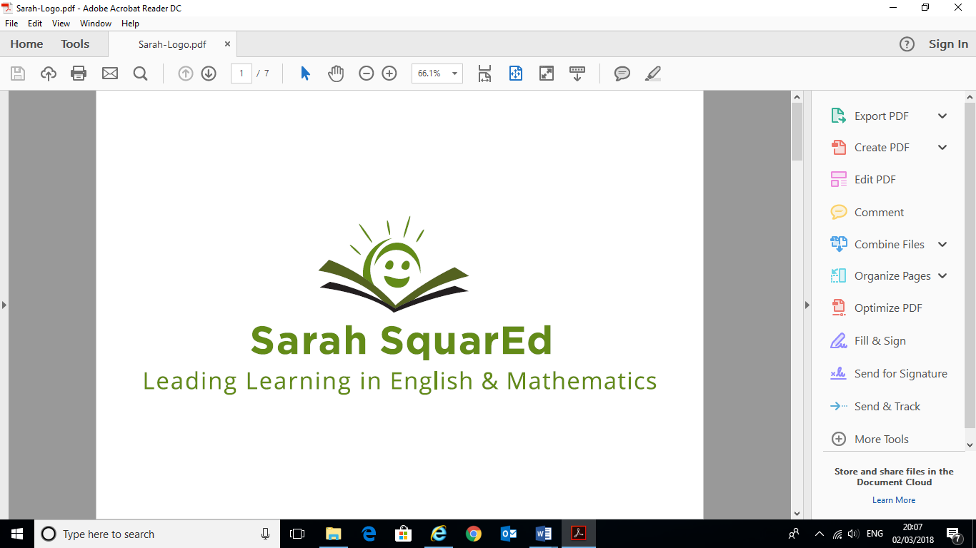

# Sarah SquarEd Ltd Terms and Conditions

This Agreement is made and entered into by the undersigned parties:

**The School/Academy/MAT** and **Sarah SquarEd Ltd**.

In consideration of the promises, rights and obligations set forth below, the parties hereby agree as follows:

**1. Services**

The Contractor will provide the following services:

***English and/or mathematics consultancy/training as outlined in the SLA or schedule of work provided and accepted.***

Sarah SquarEd Ltd shall take direction from the ***CEO, Headteacher, Subject Leader or Project Leader*** in developing the focus of the English/mathematics support. Additional services or amendments to the services described within the SLA/schedule of work may be agreed upon between both parties with sufficient notice.

**2. Fees and Payment**

Subject to providing the services as outlined within the schedule of work, Sarah SquarEd Ltd will be paid the sum agreed per activity within the schedule upon completion of the services. The School will be invoiced upon completion of the services, with **payment due within 28 business days of receipt of the invoice**. Service Level Agreements (SLA) will be invoiced in advance of the services outlined, with **payment due within 28 business days of receipt of the invoice**.

Sarah SquarEd Ltd retains the right to claim statutory interest and debt recovery costs incurred for late payment of services. Overdue payment will result in the remaining schedule of work being terminated, cancellation fees will remain as laid out in the agreement.

***Cancellation of Booking***

A cancellation charge of 100% will be applied for any service booking cancelled with less than 24 hours’ notice. If more than 24 hours’ notice is given of cancellation, a cancellation charge of 50% will be charged unless, at the discretion of Sarah SquarEd Ltd, the booking is re-arranged and delivered within one month of the initial booking date.

Should cancellation occur due to Contractor illness, acts of God or events beyond our reasonable control in-school work will be rescheduled on the return to work at the nearest convenience. Where this impacts on training, as much notice will be given as possible and the date rescheduled accordingly.

**3. Confidentiality and Intellectual Property**

Sarah SquarEd Ltd hereby acknowledges that it agrees to be bound by confidentiality in all activity related to the school, unless there is a safeguarding concern which will be reported accordingly as per professional duty of care.

All data and information made available to Sarah SquarEd Ltd by the MAT/School/Academy, unless otherwise publicly available, shall be utilized by Sarah SquarEd Ltd in connection with the schedule of work only and shall not be made available by Sarah SquarEd Ltd to any other person.

Sarah SquarEd Ltd will retain all design rights, patents and other intellectual property rights created during the course of the provision of the Services outlined within the schedule of work.

**4. Termination**

The School/MAT/Academy agrees that Sarah SquarEd Ltd may terminate this Agreement at any time without notice or any further payment if the School/MAT/Academy is in breach of any of the terms of this Agreement.

The School/MAT/Academy may terminate this Agreement at any time at its sole discretion, upon providing Sarah SquarEd one month advance written notice of its intention to do so.

**5. Liability**

Sarah SquarEd Ltd undertakes and agrees to take out Employer’s Liability insurance, Public Liability Insurance and Professional Indemnity cover with an insurance office of repute and agrees to produce a copy of the insurance policy upon request. Claims are limited to that covered by the insurance policy.

**6. Governing law and Jurisdiction**

This Agreement will be governed by and construed in accordance with the laws of the United Kingdom and shall be subject to the non-exclusive jurisdiction of the court of Great Britain.

Sarah SquarEd Ltd Representative School/Academy/MAT Representative

By: ________________________ By: __________________________

Name: ______________________ Name: ________________________

Date: _______________________ Date: ________________________