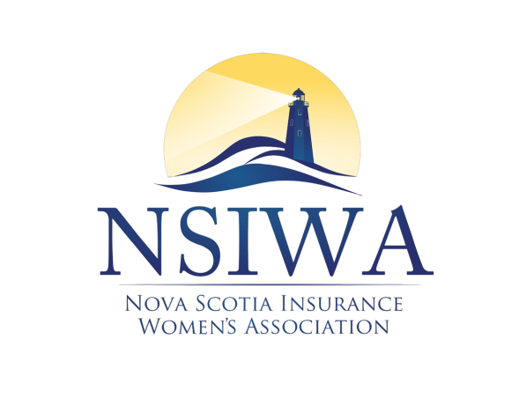

Will Be Hosting Their
32nd ANNUAL WINE & CHEESE

DATE: THURSDAY, FEBRUARY 12, 2026


PLACE: The Westin Nova Scotia
1181 Hollis Street, Halifax NS B3H 2P6

Direct hotel room booking link: Rate $139
Book your room NSIWA - 32nd Annual Wine & Cheese

PRICE: $65.00

TIME: 5:30 PM TO 9:30 PM
ENTERTAINMENT, HORS D'OEUVRES, CASH BAR, DJ @ 10PM

Please complete the registration and send via email to nsiwawineandcheese@outlook.com

Payment Options available:

Cheque: Payable to NSIWA
Send to Cheryl Pope, c/o Intact Insurance Company, 20 Hector Gate, Suite 200,
Dartmouth, NS B3B 0K3

Credit card payments – www.nsiwa.ca
**Only 4 registrants per credit card transaction. If more than 4 required, email:
nsiwawineandcheese@outlook.com for a special credit card payment link

E-transfers to: treasurer.nsiwa@gmail.com

All registrations must be received no later than February 6, 2026.
**No refunds after February 6, 2026

Registration Form below:
Page 1 of 2

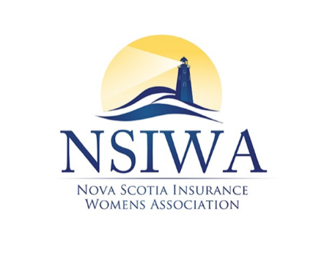

32nd ANNUAL WINE & CHEESE

Please complete the fields below. You may add more registrants by inserting additional rows in the Registrants table.
Name
Employer
Email
Cheque to Follow (Yes/No)
Payment Method (if not cheque)

Registrants
Registrant Name | Email

Page 2 of 2

