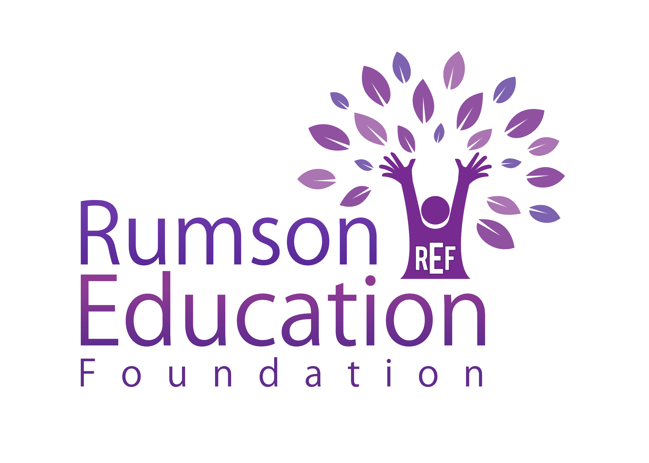
Grant Progress Report

The completion of the following report is required for all grant recipients within 1 year of approval of REF funds.

If you were a 2021-2022 REF Grant Recipient, you must complete this Grant Progress Report to be eligible for consideration the 2022-2023 grant cycle (if you haven’t done so already).

If you are not submitting for the 2022-2023 grant, your Grant Progress Report is due by January 15, 2023.

If you are submitting a Grant Progress Report MAKE A COPY to save it as a unique file with your first and last name in the new file copy. Ex. Grant Progress Report for 2023-JANE DOE.

Part A Overview

- Grant Title & Number:___________________________________________________

- Amount Granted:_________________________________________________________

- Name of Primary Grant Recipient:___________________________________________
Primary Applicant Email Address:____________________________________________

Co-Recipient Name (if applicable):___________________________________________
Co-Recipient Name (if applicable):____________________________________________

- Grade Levels of Targeted Students:__________________________________________
Number of Students who were involved in the project:__________________________
Curriculum Areas:_________________________________________________________

- Approximate Date Project Began:___________________________________________

Part B PROGRESS REPORT CHECKLIST

- Was the original objective of the project met and how? Please include date of completion or projected dates of completion, if applicable.

- Please outline how the grant money was spent.

- Was the grant successful? Why? How do you measure its impact?

- How have you shared the results of the grant with other members in the district (such as the appropriate supervisor and/or other similar grade level teachers?)

Please email your completed grant to Lauren Salata and Ciara Dagostino at rumsoneducationfoundation@gmail.com

