

Mission Community Weekend Away
Friday 15th – Sunday 17th May 2026

'Breaking New Ground'
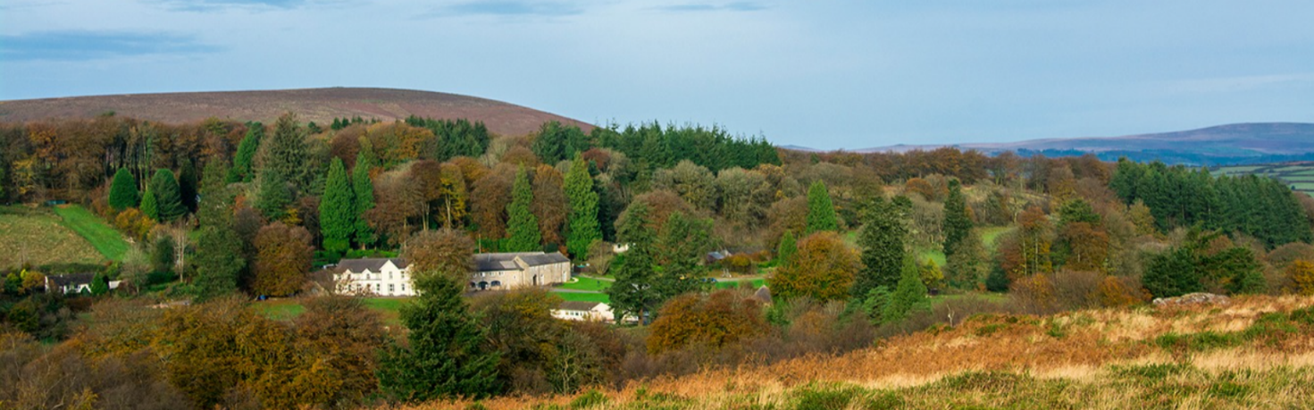
Becoming Pioneering Churches
Heatree Activity Centre, near Manaton, TQ13 9XE

Information & Booking Form
(Booking deadline: 8th May 2026)



About the Weekend
Do please join us for this weekend of inspiration and worship, fellowship and fun, as we come together as a mission community. Rev’d Greg Bakker from the Church Mission Society, co-creator of the Pioneering Parishes project, will help us in Breaking New Ground to become pioneering churches.
In our interactive sessions, we will consider together:
- Do you believe that God has more for our mission community? Drawing on the story of Abraham and Sarah, we will explore how our openness to God raises our aspiration for mission.
- Jesus the Pioneer Jesus constantly generated newness in his life. We take him as our model and explore common characteristics found in pioneering individuals and congregations.
- Pioneering Values We will explore how shared values can help a congregation answer the question 'Who do we want to be for God and our community?'
- Pioneering Abundance We will consider ways to nurture a sense of God's abundance.

About our Guest Speaker – The Reverend Greg Bakker
Greg is an experienced parish priest of 30 years and ‘thought leader’ in the skill of advocating for pioneers. He is committed to creating space for both pioneers and parish churches to thrive in the work of developing new Christian communities. Greg was previously pioneer development officer for the Diocese of Portsmouth. He is also married to an Archdeacon, but we won’t hold that against him!

Programme
Time | Activity | Children/YP
Friday 15th May
From 5pm | Arrival and drinks/snacks
6:30pm | Supper
7:30pm | Intro & Worship
8:30pm | Games / Light Fun | Hot chocolate
9:30pm | Night Prayer
10pm | Chill / Sleep
Saturday 16th May
8-9am | Breakfast
9:30am | Worship
10am | Session 1: Jesus the Pioneer | Kids session
11am | Coffee break
11:30am | Session 2: Pioneering Values | Kids session
12:30pm | Free time
1pm | Lunch
2-5pm | Free time / games / crafts / walking
3-5pm | Drinks available
6-7pm | Supper
7:30pm | Entertainment | Youth session
9pm | Free time | Hot chocolate
9:30pm | Night Prayer
10pm | Chill / Sleep
Sunday 17th May
8-9am | Breakfast
Rooms clear by 12pm
10am | Worship leading into Session 3: Pioneering Abundance | Kids session
11:30am | Coffee
12pm | Family Communion
1:30pm | Lunch
2:30pm | Depart

Activities
The Heatree Estate spans 180 acres, so there is no shortage of space for people to find peace and tranquility, or to explore the wildlife habitats on offer. Hound Tor and other walking routes are readily accessible from the centre, so the more adventurous can head out exploring. If you want something more social, then the house and its grounds provide plenty of opportunities for fellowship, games and activities.

Children and Youth Activities
During the sessions, there will be provision for primary-aged children and younger, so that parents/carers can participate in the weekend’s discipleship. We would encourage teenagers to be part of the main sessions, as we will be thinking about what sort of churches we want to be, and we would value the voices of our young people contributing to these sessions. On the Saturday night, there will be a Youth Hangout in the Roundhouse especially for our young people to have their own space in the weekend.

Heatree Accommodation
Bedrooms in the Heatree Wing where we will be staying are all en-suite. Beds are mostly bunk beds in the rooms, with a few having a single and a bunk, but this means families can be together in one room. Room capacities vary between 3 and 8 people, but we don’t expect people to have to share with someone outside of their own household – though friends are welcome to ‘buddy up’ in a room if they would like to! There are a limited number of adjoining rooms if people require two rooms, but need to have a connecting door between them. Travel cots are available upon request.
Bedding provided consists of a fitted sheet, pillows and pillowcases, and duvets. They ask all guests to bring their own duvet cover and towels.
Only official assistance dogs are permitted on the site.

Day Visitors
While we would love it if you can stay with us for the whole weekend, we understand that some people’s needs or circumstances are such that staying on-site may not be their preferred option. You can come from home each day if staying isn’t an option for you, and meals can be booked by day visitors too. Having you with us for as much of the weekend as you can manage is what we would love.

Catering
Please be very clear about any dietary requirements when booking – it isn’t fair to ask the catering volunteers to whisk up a different menu at the start of the weekend, or worse, at the point of serving up.
Day visitors must book their meals if they wish to join us for food. If you haven’t booked meals, please don’t expect or accept food while with us, as if you haven’t booked the meal then you are eating someone else’s, as well as stressing out our cooks when they’re having to stretch the portions! We want to be generous in sharing meals together, but we have to be fair too.

Generosity and Mutual Flourishing
As with the last weekend away, we are running the ‘Godparent Donation’ scheme again, whereby you can contribute some or all of the cost of a place(s) on the weekend in order to help other people attend when they might otherwise be unable to. You can do this via the booking form below, or contact the weekend organisers directly to arrange a donation.

Contact Details
If you have questions about the weekend away, please contact:
Rev’d Phill Parker – rector@moorlandteam.org.uk or
Rev’d Canon John Bennett – jsbkbennett@btinternet.com

Booking Form
Name: | Address:
Tel: | Email:

Names of others in booking group | Adult or Age if under 18?
Dietary Requirements?

Willing to volunteer as part of a team?

Costs
Requirements | Rate | Number | Cost
Adult full weekend | £80
Child full weekend | £40
Saturday day including meals – Adult | £20
Saturday day including meals – Child | £10
Friday evening meal | £5
Sunday lunch – Adult | £10
Sunday lunch – Child | £5
Children age 3 and under | Free
 | Total £
* ‘Godparent Donation’ | Optional addition
 | Total £
* If you are able to support someone who is struggling to afford the cost, please add a Godparent Donation. Thank you.

Please pay by bank transfer to:
Account Name: Moorland Team Council
Sort Code: 30-96-06
Account Number: 02358469
Reference: Away [followed by surname]

Please send or email this form by 8th May 2026 to:
- St Andrews Church Hall, West Street, Ashburton, Newton Abbot, TQ13 7DT
- admin@moorlandteam.org.uk

Please don’t let cost be a barrier to you coming. If you need some financial help for the weekend or have any questions please email Rev’d Phill Parker – rector@moorlandteam.org.uk

