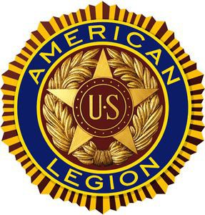**AMERICAN LEGION CONTINENTAL POST #1424 **

**FOREST HILLS MEMORIAL DAY WEEKEND PARADE**

**SUNDAY, MAY 25, 2025 at 12 pm**

**Welcome, your organization is invited as a participant in the parade, please answer the questions below the best you can and return this form NO LATER THAN Thursday, May 1, 2025 to:**

[americanlegionforesthills1424@gmail.com](mailto:americanlegionforesthills1424@gmail.com)**.**

1. **Organization Name:**
2. **Name of Point of Contact:**
3. **Email Address:**
4. **Cell Phone Number:**
5. **How many participants are in your group:**
6. **Is your group a marching band or other music band: Yes/No**
7. **Will your group perform (i.e. dance): Yes/No**
8. **Does your group consist of a Color Guard (uniforms & flags): Yes / No**
9. **Will your group use a Vehicle(s) (if yes, what type): Yes / No**
10. **Do you need transportation to and from the Parade route: Yes / No**
11. **Do you need the American Legion to fund your participation, if yes, please state a recommended $ amount:**

**Yes/No, $ Amount -**