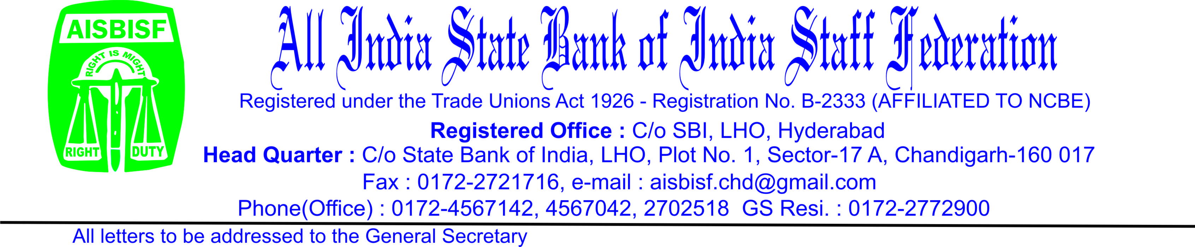

**CIRCULAR NO.09 Date: 09.11.2023**

**TO ALL AFFILIATES:**

Dear Comrades,

**BIPARTITE TALKS WITH IBA ON WAGE REVISION**

We reproduce hereunder the Circular No.08 Dated 09.11.2023 by Com.Sanjeev K. Bandlish, General Secretary, National Confederation of Bank Employees(NCBE) appending therein the UFBU Circular No.17 Dated the 09.11.2023 issued by Com.Sanjeev K. Bandlish, Convenor-UFBU for information of all affiliates and members.

With revolutionary greetings,

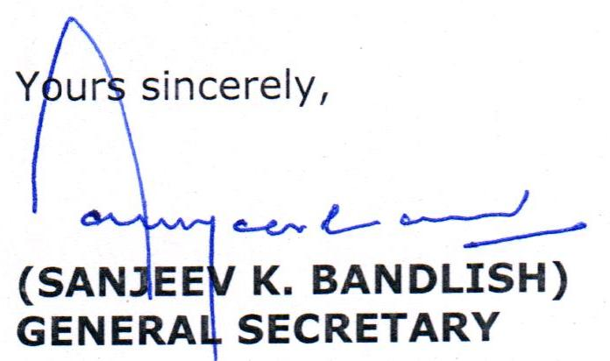

**---------------------------------------------------------------------------------**

Further to the last round of discussions held with IBA’s Negotiating Committee on 27-10-2023, one more round of discussions was held with the main Negotiating Committee today. IBA’s team was led by Mr. M V Rao (MD & CEO, Central Bank of India) who is the Chairman of the Negotiating Committee. UFBU was represented by our constituent unions.

We had already informed that in the last round of discussions, IBA had made the offer of 15% increase in the payslip cost. Continuing the discussions, after a lot discussions IBA improved their offer to 16%. They further stated that after merger of DA upto 8088 points with the existing basic pay, there can be a loading of 2.5% on the same while constructing the revised pay scales.

We could not agree to the revised offer and these proposals and urged upon the IBA to further improve their offer both on percentage increase in payslip cost as well as the loading factor. But IBA did not agree to improve their proposal. Hence during the day-long discussions, we could not come to any amicable understanding on these issues. Further discussions are necessary in this regard.

During today’s meeting, we also took up with IBA, the issue of introduction of 5 Day’s Banking per week and its early implementation. IBA informed that they are fully seized of the matter and assured to follow up the matter with the concerned authorities.

Regarding updation of pension, IBA explained the cost implications of the same but indicated that they are trying to work out some possible solution to improve the pension of all past retirees post-1-1-1986 till 31-10-2022. The issue needs to be discussed further.

**MoU signed on option for resigned employees to join the Pension Scheme**: During the last round of discussions, IBA had expressed their inclination to agree to our request to extend an opportunity for resigned employees to join the Pension scheme. We are happy to inform that during the meeting today, the issue was further discussed and an MoU has been signed between IBA and UFBU in this regard. This MoU is subject to approval by the Government. The text of the MoU is furnished herein.

Comrades, the negotiations have entered a crucial stage and we would like to arrive at amicable understanding acceptable to both the sides. While efforts are on towards the same, the need of the hour is unity of our members and to scotch all types of rumours. Further developments will be informed in due course.

With greetings,

                                      Yours comradely,

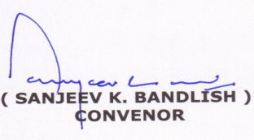

**Memorandum of Understanding between Indian Banks’ Association and United Forum of Bank Unions in the matter of extending an option to the Officers/ Employees who had resigned to join the Pension Scheme under the Bank Employees Pension Regulations, 1995/1996.**

1. Whereas pursuant to the provisions of the Bipartite Settlement/ Joint Note signed by Indian Banks’ Association with the Unions on 29-10-1993 on introduction of pension scheme in Banks, Pension Regulations were framed by member Banks in the year 1995/1996, which provided for an option to the employees and officers who were in service/who died while in service on or after 1st January, 1986 to join the Pension scheme by surrendering the Banks’ contribution to Provident Fund along with the accumulated interest thereon, and
2. Whereas one more option to join the pension scheme was given to the employees and officers by Bi-partite Settlement/ Joint Note dated 27-04-2010, which also provided that the employees and officers who had ceased to be in bank’s service on account of Voluntary Retirement would be covered and eligible for such option to join the pension scheme, and
3. Whereas representations have been received from some former employees and former officers that even though they were otherwise eligible, but were not offered second option to join the pension scheme as they had resigned from the service of the bank, at the relevant time as envisaged in the settlement dated 27-04-2010.
4. Whereas though the Pension Regulations framed in 1995/1996 do not provide for pension to those employees and officers who have resigned from the services of the banks, purely from a humanitarian perspective the management of the banks have taken a sympathetic and lenient view of the representations made by the former employees and former officers referred in point number 3 above, and after discussions between IBA and United Forum of Bank Unions, a broad consensus has been arrived at, which the parties have decided to record as under:-
5. The following categories of former employees and former officers, who satisfy all the conditions stated in sub-clauses (a) to (c) appearing herein below, would be eligible for exercising an option to join the Pension Scheme within ninety days of announcement of such option as one time measure only.
6. Employees and officers who were in service of the Banks on or after 1-1-1986 and had joined the Banks before 1-4-2010 and who have resigned from the service of the Bank on or before 26-04-2010 and who were otherwise eligible to join the pension scheme while in service and
7. Who agree to refund to the Bank the entire Bank’s contribution to Provident Fund (along with accumulated interest thereon) received by them at the time of their resignation or later from the Bank, and
8. Who agree to execute an undertaking as per draft provided in the Annexure.
9. All such eligible former employees and former officers as mentioned in point 3 and 5 above and their surviving spouse or eligible family member shall be entitled for pension / family pension, if they exercise the option, subject to the following conditions
10. That the pension will be paid prospectively from the month following the month in which the Bank receives the Bank’s contribution towards PF (along with accrued interest thereon) received by the former employee/former officer at the time of resignation or later.
11. The commutation of pension will not be extended to them and they will not demand.
12. Pension shall be computed as per the applicable provisions of the Pension Regulations, as applicable to relevant Bi-partite settlement / Joint Note in which he / she resigned.
13. This understanding shall be effective only if the same is approved by the concerned Ministry of Govt. of India.
14. The Associations / Unions of employees or former employees / former officers who have initiated any pending legal proceedings for and on behalf of the former employees/officers wherein the right of the former employees or former officers, who have resigned from the service of the Bank, to opt for pension is directly or indirectly one of the issues for consideration by the concerned Court or Authority, having jurisdiction and powers to adjudicate or decide, unequivocally agree to unconditionally withdraw such proceedings or take necessary steps to ensure that the right of the former employees / former officers who have resigned from the services of the bank, to opt for pension is no longer Res Integra in such proceeding and also agree not to initiate any proceedings concerning such right in future.