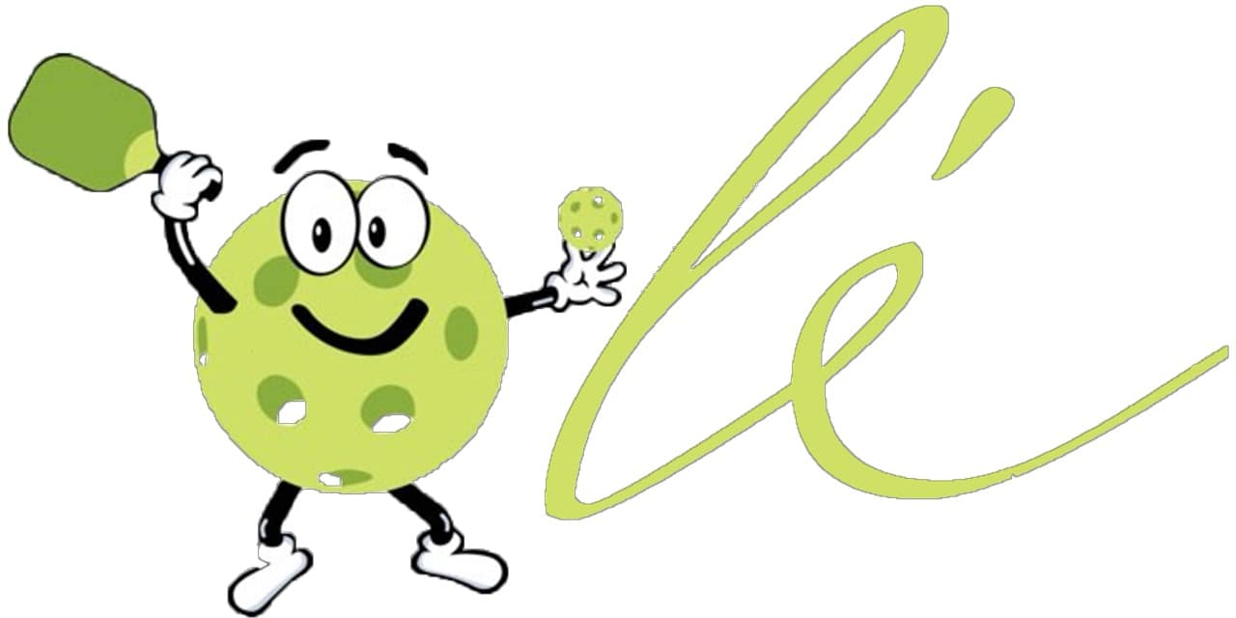

Summary of Results
End of Season Survey 2024

You will see in this summary, as we did, that there is a high level of satisfaction with most of what is happening in our Ole PB community. We also realized that as a first attempt to evaluate a broad number of topics, there were some design flaws in the questions that we posed. These areas have been noted for edit in any upcoming solicitation. The cmte discussed the comments that we received and grouped and addressed them here, with explanations. In some areas we realized we needed to request for further input but, did not. Again, this has been noted for correction in the future.
These results were collected from under 60 players. Unfortunately, we experienced email glitches and bulk mailing limitations that we could not resolve in a timely way. We hope to have resolved this issue for future mailings.

Question/Response summary: we eliminated the outliers but where we had them, we addressed them in the comments section below

 | Satisfied | Somewhat Satisfied | Did not participate
Glowoozas | 64.2 | 11.3 | 10.7
March Tournament | 45.3 | 11.3 | 24.5
Court Condition | 71.2 | 28.8
Clinics | 55.8 | 15.4 | 25
Player Rotation | 51.9 | 36.5
Music | 66.7 for speakers, 21.6 no opinion, very small %-age for live music
Food Truck | Overwhelmingly in favor of keeping food trucks
PB End of Season Award | 55.8 let the PB Cmte decide | 15.4 Nomination form | 17.3 No preference
Preferences for end of season venue | 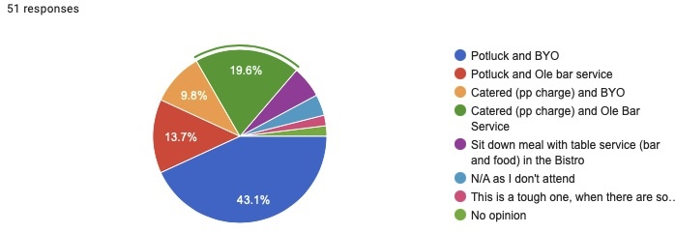

Summary of Comments:

Court use, rotation, paddle placement:
South courts seem to have a system in place that the players are satisfied with but, the committee has struggled to come up with a system that the north courts can successfully integrate. There were no complaints in the survey except for the fact that unfortunately, there is no way for players to easily line up paddles on the north courts. There is no place to mount a paddle rack on the outside of the fence and no place to store a standing rack inside or outside of the fence. In informal discussions with north court players, they rejected a white board system but even if they had not, there is no covered area to mount a board. Lining up paddles on the ground is not ideal and based on the number of players on the court, rotation systems are fluid and sometimes frustrating. Having exhausted our own ideas (and purchases that had to be returned), we would appreciate any input for paddle systems that are accessible given the court layout and/or take into consideration our storage limitations.

Some comments focused on the use of courts by residents who repeatedly bring guests, sometimes on a daily basis. Of course, guests are welcome in Ole but especially as we approach our busiest months, we ask our players to be mindful of the breach of etiquette it poses when repeatedly inviting friends from neighboring communities to play on our courts under the guise of being “guests”.

Another comment in this area, which mostly effects North court play, had to do with latecomers placing paddles ahead of waiting players who have been there for a while. If any player wants to make an accommodation to a person who arrives late, they should give up their own spot and take the end of the line position.

Court Condition: This is an area where the survey needs revision. Since we did not require comments, we have no idea what drove the “somewhat satisfied’ responses. We wished to gather input that would help direct our attention to these areas of need but the question was inadequate.

Clinics: We have previously stated that there is a “cap” to the number of players that can be accommodated on a Monday morning but since the clinics have become exponentially popular, very often the group exceeds that number and denying participation to people is uncomfortable at best. The donations that are made to participate in the Ole clinics are made on a volunteer basis and are not intended to replace much higher priced lessons that are available in other types of venues. For now, we will monitor during the 24/5 season and try to keep the numbers as welcoming as is reasonable.

Yes, we are getting a new ball machine thanks to your continued generosity and participation.

Award:
It was suggested that this does not have to be a ritualized yearly award. That in fact it might have more merit if it were saved for those times when a person clearly rose to the top in terms of the parameters set forth for the award. The cmte. agreed

End of Season Event:
There was not a huge difference in responses between a catered event and a potluck event. One of the comments addressed sanitary concerns when having such a huge potluck event and another questioned the ability of our wait staff to manage the size of our group in terms of food/bar service. The committee will dive deeper into this and will very likely send out a follow up survey as the season progresses in order to get input from attendees.

Excellent Ideas that we will attempt to incorporate with volunteer assistance:
- Open Play evenings for social and competitive play. Monday Funday was popular until it wasn’t. But Open Play should be very easy to implement and add to our Ole master calendar
- Round Robin style event and a ‘Progressive Courts” event (winners move up a court/losers move down).
- Afternoon Happy Hour (who’s gonna say not to that!) and a luncheon picnic
- Valentine PB Play.

