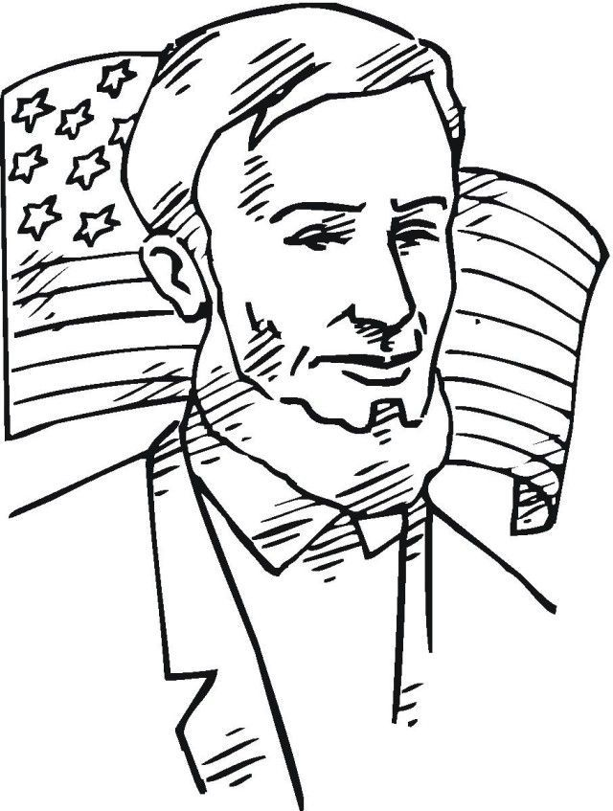

Child’s Name: __________________________________________________ Age: ___________
*Parents: Please put YOUR first and last name on the BACK of this coloring sheet. Also include a way to contact you (email or phone) in the case that your child is selected as the winner.

Age Group: 7 – 10 year olds Photo Credit: bestcoloringpagesforkids.com
Return to the museum by May 3rd 18 S Janesville Street – PO Box 245 – Milton WI 53563

