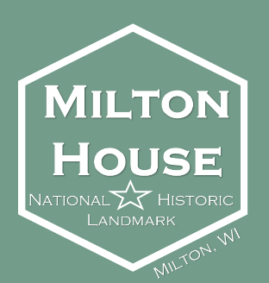Milton Historical Society & Milton House Museum

18 S Janesville Street

Milton WI 53563

[www.miltonhouse.org](http://www.miltonhouse.org)

608.868.7772

**CIVIL WAR LIVING HISTORY DAYS SPONSORSHIP FORM**

Name of Business/Organization: ______________________________________________________________________

Address: _________________________________________________________________________________________

City: _________________________________ State: ________ Zip Code: _________________

Phone Number: _______________________________________

Name of contact: _______________________________________ Title: _________________________________

Email Address: ____________________________________________________________________________________

Business Website: _________________________________________________________________________________

**Sponsorship Opportunities**

*Each level of sponsorship includes business name/logo on our CWD event website page*

_______ $50 **Abraham Lincoln Coloring Contest**

*Designed for ages 3 -18, this contest allows kids to bring out their creative side to color pictures of Abraham Lincoln. Winner of each age group gets a Lincoln themed prize, along with their photo with our Abraham Lincoln Reenactor.*

_______ $75 **Historic Presentations**

*Offered throughout the day, these presentations allow guests a more in-depth look at topics such as women’s clothing and historic weaponry*

_______ $150 **Living Cemetery Tours**

*Guests will meet residents of Milton’s cemetery to hear about their life and experiences during the Civil War era.*

_______ $250 **Wine and History Trivia Night**

*Being held at the beautiful Fermenting Cellars Winery, this is sure to be a fun night of wine, socializing, and testing guest’s history knowledge. Business will be highlighted at the event.*

_______ $500 **Cannon/Artillery Demonstrations**

*A guest favorite, the cannon and artillery demonstrations draw crowds on Saturday and Sunday of the event. Business name/logo will be included on a sign by the demonstration area*

*_______ ______* **General Donation**

*We/I would like to donate to the general operation of the event*

**\*Please continue to the next page\***

**Payment Information**

Amount enclosed or to be charged to my credit card: ________

**Payment type**

*(Please circle one)*

Cash Check Credit Card

*Checks can be made payable to: Milton Historical Society*

Credit Card Information: _______ Visa ______ MasterCard _______ Discover _____ Am Ex

Card # ___________________________________________________________________

Expiration: _____/_______ Billing Zip Code _________

**Please complete this portion with how you would like your business/organization listed in our marketing materials.**

Business Name: ____________________________________________________________________________________

Address: ____________________________________________________ City: ____________________________

Phone Number: ________________________________________________

Website: __________________________________________________________________

**If you would like to include your business logo, please email the image to our Executive Director Keighton Klos at** [**kklos@miltonhouse.org**](mailto:kklos@miltonhouse.org)**.**

Please return the sponsorship information, along with your donation to:

Milton House Museum

Attn: Civil War Days

PO Box 245

18 S Janesville Street

Milton WI 53563

**Thank you for supporting the mission of the Milton Historical Society and Milton House Museum. We could not put on these types of events without the support of generous sponsors like you!**