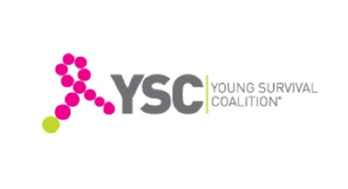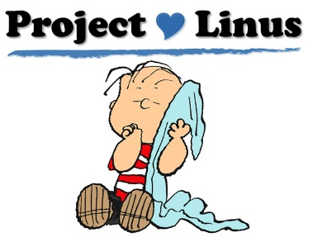Blanket Making Project!!

(Patient Comfort Committee)

We have been gifted with a large quantity of fleece and want to use it to make blankets for Project Linus and for the Young Survival Coalition (a breast cancer support group for young adults).

Worried that you don’t have the skills? Don’t!

NO SEWING NEEDED!

We will be assembling at the Old West Masonic Lodge approximately once a month.

Next meeting: Thursday, October 16

4:30pm – 9pm Come by anytime!

19310 Avenue of the Oaks, Newhall, CA

(within the Friendly Valley Housing Community)

Organized by the Patient Comfort Committee of Old West Chapter, Order of the Eastern Star. Contact info: Laura Kelley 661/400-2686, lewlew4444@yahoo.com.

**Tentative 2026 Calendar: Jan 15, Feb 19, Mar 19, Apr 16, May 15, Jun 18, July 16, Aug 20, Sep 17, Oct 15**