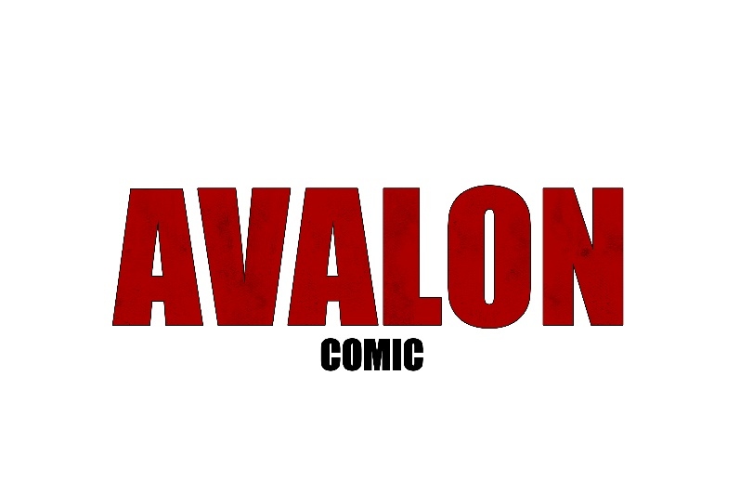

Sponsorship Proposal

Avalon Comic takes you on an exhilarating journey through a post-apocalyptic landscape set in Erie, PA.

It’s not just any comic – it’s a captivating exploration of diverse themes, from the bonds of family to the intricacies of mental health, navigating physical setbacks, gripping drama, and even a dash of noir. In Avalon, our mission is to carve out a distinct, unparalleled niche in the world of comics. We’re not just another entry – we’re a bold statement of originality. Our stunning art style is a visual feast, characterized by a striking black, white, and grayscale palette, punctuated with vibrant splashes of red throughout. But that’s not all – we’ve made an intriguing choice to present every last page in full color, enticing readers to full immerse themselves in both the art and the story, ensuring an unforgettable experience with each page turn.

We’re on the lookout for sponsors to enhance our bond with our dedicated fans. The future of Avalon shines bright, and with your support, we can expand our reach, attend more comic events, and most importantly, foster an incredible connection with our beloved audience. Together, we’ll make Avalon’s journey even more unforgettable for fans old and new alike.

Sponsorship Opportunities

**Bronze Sponsor $250**

* Advertisement Page in Avalon: Issue 6
* Social Media Promotion during Avalon: Issue 6 campaign
* Sponsor mentioned in all interviews in 2024

☐ **Silver Sponsor $500**

* Advertisement Page in Avalon: Issue 6
* Social Media Promotion during Avalon: Issue 6 campaign
* Advertisement Page in Avalon: Volume 1
* Advertisement Page in Avalon: Issue 1 Remake
* Social Media Promotion during Avalon: Volume 1 campaign
* Social Media Promotion during Avalon: Issue 1 Remake campaign
* Sponsor mentioned in all interviews in 2024

☐ **Gold Sponsor $750**

* Advertisement Page in Avalon: Issue 6
* Social Media Promotion during Avalon: Issue 6 campaign
* Advertisement Page in Avalon: Volume 1
* Advertisement Page in Avalon: Issue 1 Remake
* Social Media Promotion during Avalon: Volume 1 campaign
* Social Media Promotion during Avalon: Issue 1 Remake campaign
* Sponsors flyers, merchandise, promotional items at all the vendor events we accompany in 2024
* Sponsor listed on website
* Sponsor logo and acknowledgment in newsletters
* Sponsor mentioned in all interviews in 2024

Sponsorship Details

|  |  |  |  |
| --- | --- | --- | --- |
|  | **Gold** | **Silver** | **Bronze** |
| Advertisement Page in Avalon: Issue 6 |  |  |  |
| Social Media Promotion during Avalon: Issue 6 Campaign |  |  |  |
| Advertisement Page in Avalon: Volume 1 |  |  |  |
| Advertisement Page in Avalon: Issue 1 Remake |  |  |  |
| Social Media Promotion during Avalon: Volume 1 campaign |  |  |  |
| Social Media Promotion during Avalon: Issue 1 Remake campaign |  |  |  |
| Sponsors flyers, merchandise, promotional items at all the vendor events we accompany in 2024 |  |  |  |
| Sponsor listed on website |  |  |  |
| Sponsor logo and acknowledgment in newsletters |  |  |  |
| Sponsor mentioned in all interviews in 2024 |  |  |  |

Organization Details

|  |  |
| --- | --- |
| **COMPANY NAME** | Contact Name: |
| Business Number: | Mobile Number: |
| Postal Address: |  |
| State: | Post Code: |
| Email: |  |

Sponsorship Opportunity Selected: ______________________________

Signature: ______________________________

Date: ______________________________

In Summary

This sponsorship is an opportunity for those who want to support Avalon, gaining clients, and an opportunity for networking. For more information, please *contact* [contact@twelveeightytwo.com](mailto:contact@twelveeightytwo.com) **OR** visit [www.avaloncomic.com](http://www.avaloncomic.com)

The production deadline is at the end of 2024.