
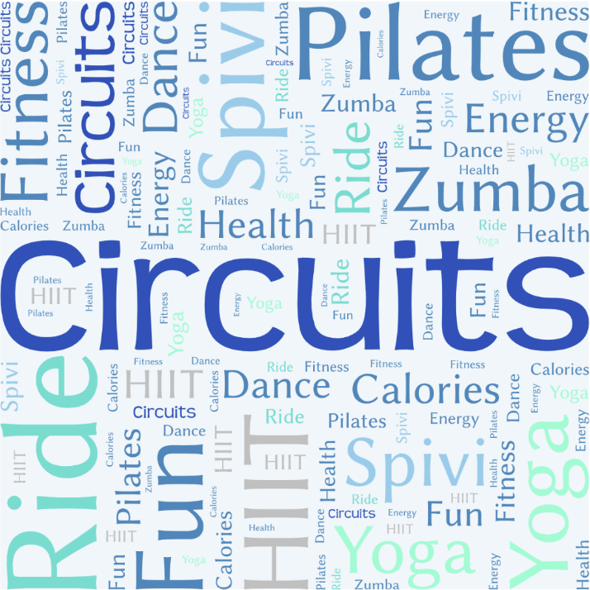
Strength, Tone & Endurance
Mind & Body
Cardio

Class Prices (Pay as you go prices)
GymPlus Membership – Includes all classes unless stated.

Pay as you go prices:

30 minute classes £4.00
45 minute classes £5.00
60 minute classes £6.00
Clinical Pilates £6.00
Booking
We operate a 6-day advanced booking system for classes.. Members can book classes via the GymMaster app.

Health Screening
If you are concerned that you have a medical condition that might interfere with you exercising safely you should obtain advice from a relevant medical professional. Please disclose any appropriate medical or health information to the instructor prior to the class.

Membership Prices (monthly unless stated)
ClubAZ Membership £2.50
Gym Membership £15.00
GymPlus Membership £20.00
Lottery Membership (10 shares) £4.33
Junior Gym (per session) £3.00
Childcare Membership (£5 for link members) £2.00

Scan this QR code and click ‘sign up’ to join

Hulley's Facility Opening Times
Mon – Fri - 6am-9pm; Sat & Sun - 8am-4pm
Tel: 01625 512929 (ext. 22929)
www.clubaz.co.uk

Class Descriptions

ClubRide
Classic instructor-led indoor cycling class simulating hills, intervals, sprints
and flat terrain tempos.

ClubSpivi
Interactive Instructor-led cycling class using our unique Spivi system and free downloadable app incorporating intervals, hills and challenges along the way.

Virtual Velo (No Instructor)
Virtual cycling class following an on-screen structured workout. Participants are advised to have an active and up to date Spivi profile for this class.

FitDance
An energetic, up-beat dance fitness class featuring all of your favourite strictly dances. You don’t need a partner! Intermediate to advanced class.

ClubBarre
A ballet inspired toning and core workout helping postural muscles.

ClubStep
Back to old school with high tempo aerobics using a step platform.

ClubCircuit
Designed to improve strength, stamina and mobility using a large variety of upper & lower body exercises in a circuit format.

Total Tone/Total Body Blast/ClubTone/Fusion Tone
All over body toning and strength classes using alternate techniques with resistance from weights or your own body weight.

Tabata Tone
Interval based toning class working with the ancient Tabata principle of 20 secs work followed by 10 secs rest for 8 sets.

Circuit Tone
A 30-minute circuit with a standard format incorporating controlled toning exercises. The circuit is changed monthly allowing for weekly progression.

Boxing Bootcamp
A mix of boxing pad work and bodyweight exercises for a total body workout.

Express Rig
Functional circuit training using the rig and equipment on the gym floor.

ClubHIIT
Toning and Cardio based session focusing on a total body workout.

Sports Conditioning
Joint stability, muscular strength and imbalance work with a focus on injury prevention specific to sport movements.

ClubYoga/Yoga 4 All
A spiritual and aesthetic discipline focusing on specific bodily postures, breathing and meditation.

Clinical Pilates – Physio Led
Improvement and maintenance of spinal health, posture, core and flexibility. Compliments sports & fitness activities as well as everyday function.

Pilates
Focuses on improving the body’s core strength and posture.

Modern Pilates
Modern Pilates designed to improve physical performance focusing on strength, balance, co-ordination and dynamic movement.

Sept - Dec 2024

Class Timetable

Sep – Dec 2025

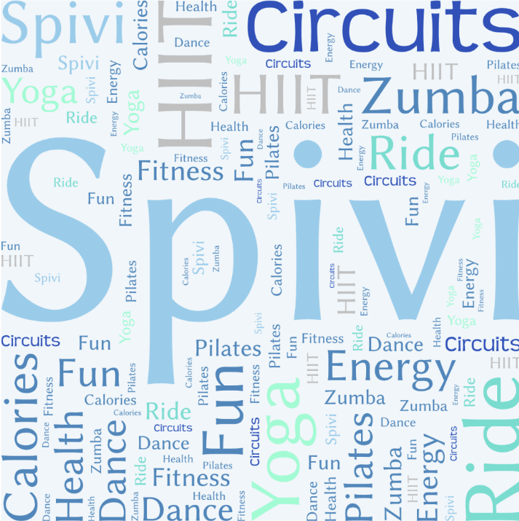


Friday
Time | Class | Instructor
07.15 – 07.45 | Tabata Tone | CAZ Instructor
10.15 – 10.45 | Circuit Tone | CAZ Instructor
12.15 – 13.00 | Total Body Blast | Fran Wyly
12.15 – 12.45 | Virtual Velo | No Instructor
13.15 – 14.15 | Clinical Pilates | ClubPhysio
16.15 – 17.00 | ClubBarre | Isabelle Capper
Saturday
Time | Class | Instructor
09.15 – 09.45 | ClubSpivi | CAZ Instructor
09.45 – 10.30 | Pilates | Lisa Williams
Sunday
Time | Class | Instructor
09.15 – 09.45 | Express Rig | CAZ Instructor
10.00 – 11.00 | Yoga 4 All | Various
Black text denotes classes in the aerobics studio
Red text denotes classes in the cycling studio
Green text denotes classes that are off site

Wednesday
Time | Class | Instructor
07.00 – 08.00 | ClubYoga | Stephanie
12.15 – 12.45 | Fusion Tone | David Bailey
13.15 – 14.15 | Modern Pilates | Steve Hardy
16.15 – 16.45 | Sports Conditioning | Chris Dawson
17.15 – 18.00 | ClubCircuit | CAZ Instructor
18.45 – 19.45 | FitDance | Fiona Walton
Thursday
Time | Class | Instructor
07.15 – 07.45 | ClubHIIT | CAZ Instructor
12.15 – 13.00 | Spin / Circuit | Nick Taylor
16.30 – 17.00 | ClubTone | Lisa Williams
17.00 – 17.30 | ClubStep | Lisa Williams
17.15 – 17.45 | ClubSpivi | David Bailey
17.45 – 18.30 | Pilates | Beth Allcock

Monday
Time | Class | Instructor
07.15 – 07.45 | Fusion Tone | David Bailey
10.00 – 11.00 | ClubYoga | Stephanie
12.00 – 13.00 | Clinical Pilates | ClubPhysio
12.15 – 12.45 | Express Rig CAZ Instructor
12.15 – 12.45 | Virtual Velo | No Instructor
16.30 – 17.10 | Total Tone | Carla Gilder
17.30 – 18.00 | ClubSpivi | Nick Taylor
17.30 – 18.30 | Clinical Pilates | ClubPhysio
Tuesday
Time | Class | Instructor
07.00 – 07.45 | ClubRide | Chris Dawson
12.15 – 12.45 | ClubSpivi | David Bailey
12.15 – 13.00 | Total Tone | Fran Wyly
13.15 – 14.15 | Clinical Pilates | ClubPhysio
16.15 – 16.45 | Boxing Bootcamp | Tony Harrison
17.00 – 18.00 | ClubYoga | Janet Dean

