JULY 2026
Sun | Mon | Tue | Wed |  | Thu | Fri | Sat
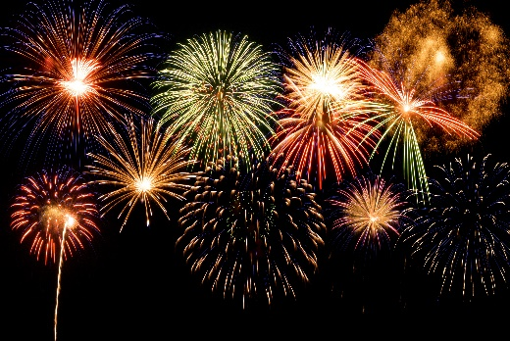 |  |  |  | 1  Bocce 10am  Pool Exercise 10am  Bridge 1pm  Ping Pong 2pm  Line Dancing 2-3:30pm | 2  Shuffleboard 10am  Canasta 2pm  Bingo 6:30 pm | 3  Pool Exercise 10am  Potluck 5-7pm | 4  Canasta 2pm  4th Cook-out  12-4pm
5  Dominos 2pm | 6  Bocce 10am  Pool Exercise 10am  Ping Pong 2pm  Bunco 6pm | 7  Shuffleboard 10am  Mahjong 11am  Nimble Fingers 2pm  Poker 6pm | 8  Bocce 10am  Pool Exercise 10am  Bridge 1pm  Ping Pong 2pm  Line Dancing 2-3:30pm |  | 9  Shuffleboard 10am  Ceramics 10am  Canasta 2pm  Bingo 6:30 pm | 10  Pool Exercise 10am  Potluck 5-7pm | 11  Canasta 2pm
12  Dominos 2pm | 13  Bocce 10am  Pool Exercise 10am  Ping Pong 2pm  Bunco 6pm | 14  Shuffleboard 10am  Mahjong 11am  Nimble Fingers 2pm  Poker 6pm | 15  Bocce 10am  Pool Exercise 10am  Bridge 1pm  Ping Pong 2pm  Line Dancing 2-3:30pm |  | 16  Shuffleboard 10am  Canasta 2pm  Bingo 6:30 pm | 17  Pool Exercise 10am  Potluck 5-7pm | 18  Canasta 2pm
19  Dominos 2pm | 20  Bocce 10am  Pool Exercise 10am  Ping Pong 2pm  Bunco 6pm | 21  Shuffleboard 10am  Mahjong 11am  Nimble Fingers 2pm  Poker 6pm | 22  Bocce 10am  Pool Exercise 10am  Bridge 1pm  Ping Pong 2pm |  | 23  Shuffleboard 10am  Ceramics 10am  Canasta 2pm  Bingo 6:30 pm | 24  Pool Exercise 10am  Potluck 5-7pm | 25  Canasta 2pm
26  Dominos 2pm | 27  Bocce 10am  Pool Exercise 10am  Ping Pong 2pm  Bunco 6pm  Board Meeting 6pm | 28  Shuffleboard 10am  Mahjong 11am  Nimble Fingers 2pm  Poker 6pm | 29  Bocce 10am  Pool Exercise 10am  Bridge1pm  Ping Pong 2pm |  | 30  Ceramics 10am  Shuffleboard 10am  Canasta 2pm  Bingo 6:30pm | 31  Tennis 8:15  Pool exercise 10am

